

PROJECT TOPIC :

COMMUNICATION

(INTERNET, MOBILE PHONE, LAPTOP, SATELLITE, TV)

**Programming 1 (STIA1113)**

PROVIDED BY:

|  |  |
| --- | --- |
| **NAME** | **MATRIC NUMBER** |
| **Wan Aysha Sofea binti Wan Hadzli** | **286628** |
| **Toh Vin Ping** | **286681** |
| **Goh Koon Long** | **286712** |
| **Zafirah Nuraina binti Mohd Naziar** | **286724** |
| **Intan Syamimi binti Saharim** | **286735** |
|  |  |
|  |  |

PROVIDED FOR:

PROF. MADYA DR. AZMAN BIN YASIN

DUE DATE:

6th FEBRUARY 2022

**TABLE OF CONTENT**

1. Background of the Project
   1. Understand the Problem…………………………………………………….1-4
      1. Internet
      2. Mobile Phone
      3. Laptop
      4. Satellite
      5. TV
   2. Identify the Problem………………………………………………………...4-6
      1. Internet
      2. Mobile Phone
      3. Laptop
      4. Satellite
      5. TV
   3. Alternative Ways……………………………………………………………6-7
      1. Internet
      2. Mobile Phone
      3. Laptop
      4. Satellite
      5. TV
   4. Best Ways…………………………………………………………………...7-8
      1. Internet
      2. Mobile Phone
      3. Laptop
      4. Satellite
      5. TV
   5. Evaluate Solution……………………………………………………………8-10
      1. Internet
      2. Mobile Phone
      3. Laptop
      4. Satellite
      5. TV
   6. Calculation Table……………………………………………………………10-20
      1. Internet
      2. Mobile Phone
      3. Laptop
      4. Satellite
      5. TV
   7. Instructions For the Solution……………………………………………...21-25
2. Program Description
   1. Algorithm…………………………………………………………………25-31
   2. Pseudocode……………………………………………………………….32-69
   3. Flow Chart………………………………………………………………..70-105
3. Coding……………………………………………………………………………105-120
   1. Main Menu
   2. Internet
   3. Mobile Phone
   4. Laptop
   5. Satellite
   6. TV
4. Sample Run………………………………………………………………………120-129
   1. Main Menu
   2. Internet
   3. Mobile Phone
   4. Laptop
   5. Satellite
   6. TV
5. **BACKGROUND OF THE PROJECT**
   1. **Understand The Problem**
      1. **Internet**

The Internet protocol suite (TCP/IP) is used to communicate between networks and devices in a global system of interconnected computer networks. It is a community of network made up of neighborhood to world private, public, academic, business and government networks linked through range of electrical, wireless and optical networking technologies. The Internet has reshaped, redefined or even bypassed most regular conversation media such ad telephone, radio, television, paper mail, and newspapers, resulting in new services such as email, smartphone, smart TV, online music, digital newspaper and video streaming websites. Newspapers, books and other forms of print media are adapting to website technological know-how or converted into blogging, network feeds and online new aggregators. Internet is used for communications which in general, Internet users hold the Internet in high regard as a communication tool; 85% of men and women agree that the Internet is a good means to engage or communicate with others in their daily lives. However, that’s where the parallel end. Men and women engage in other way online, in terms of how they communicate, what they communicate about and how essential their online communications are to them. Besides, all Internet customers maintain their net in excessive regard as a source of fact. Internet is the right supply of information for day-today pursuits like news, weather reports and sport activities score, in accordance to nearly all Internet customers. The identical variety of people say they assume to discover statistics about unique products they choose to buy, with men (82%) outnumbering women (77%0 in this category. 1/3 web customers say they expect to find sincere information about people on the Internet.

* + 1. **Mobile Phone**

Mobile phone is a compact phone that can settle on and get decisions over a radio recurrence interface while the client is moving inside a telephone utility region. The radio recurrence interface sets up an association with the exchanging frameworks of a mobile phone administrator, which gives admittance to the public exchanged phone organization (PSTN). Current mobile phone administrations utilize a phone network engineering and in this manner, mobile phones are called cellular telephones or cell phones in North America. Notwithstanding communication, computerized cell phones (2G) support an assortment of different administrations, for example, message informing, MMS, email, Internet access, short-range remote correspondences (infrared, Bluetooth), business applications, computer games and advanced photography. Mobile phones offering just those capacities are known as element telephones; mobile phones which offer extraordinarily progressed figuring abilities are alluded to as mobile phones. Mobile phones were invented as early as the 1940s when engineers working at AT&T developed cells for mobile phone base stations. The first mobile phones were not really mobile phones at all. They were two-way radios that allowed people like taxi drivers and the emergency services to communicate. Mobile phones are important today because they are efficient communication devices and more appearance in our life to make life easier. We can contact our family members or friends in the other places through the mobile phone. We can also use a mobile phone to do other things such as entertainment, doing the job and others. Nowadays, new mobile phone models are constantly engineered to satisfy the needs of consumers and now have multifunctional tools that may be useful in everyday life. So that, the features or configuration in a mobile phone is very important to satisfy the consumers. The accessories of mobile phone also important nowadays. The main purpose of buying cell phone accessories is safety. They also help us take full advantage of our mobile phones. So that, a mobile phone with the best features or configuration and accessories needs to be produced by the factories to the consumers.

* + 1. **Laptop**

A laptop company made an agreement with Company A to sell their laptop to Company A. Company A decided to change all their old laptops in the company because all of them have been used for at most 5 years. This is because the laptops started to have slow performance and were not able to run multiple tabs to complete their everyday task which caused many projects of the company to not finish in time. Hence, the laptop company plan to trade in their old laptops and deduct the cost of their new laptops based on the value of old laptops from Company A. They are facing difficulty in calculating the depreciation of their old laptop and the amount of money they will receive from Company A after knowing the value of the old laptops. The laptop company requested us to create a program to calculate total depreciation of the old laptops and the amount of money they will received. The laptop company also allow Company A to pay in installment for 5 years with an interest of 5% each year.

* + 1. **Satellite**

A satellite is an object in space that orbits or circles around a bigger object. There are dozens of natural satellites in the solar system, and even more artificial ones. Saturn, for example, has at least 53 natural satellites, and between 2004 and 2017, it also had an artificial one. Satellites must be small, lightweight, and durable to survive in the harsh conditions of space. They must operate at very high reliability of more than 99.9 percent in the vacuum of space with no prospect of maintenance or repair. In addition, they must be light, as the cost of launching a satellite is based on weight. A communications satellite is an artificial satellite that relays and amplifies radio telecommunication signals via a transponder; it creates a communication channel between a source transmitter and a receiver at different locations on Earth. Communications satellites are used for television, telephone, radio, internet, and military applications. Most communications satellites are in geostationary orbit 22,300 miles (35,900 km) above the equator, so the satellite appears stationary at the same point in the sky.

* + 1. **TV**

Astro is a Malaysian satellite television and IPTV provider doing business as All-Asian Satellite Television and Radio Operator. It operates in Malaysia, Brunei through Kristal-Astro and Indonesia through Astro Nusantara. It broadcasts from Kuala Lumpur's All Asia Broadcast Centre and Cyberjaya's MEASAT. In Malaysia, the corporation was reported to have 71% home penetration in 2016. The Malaysian federal government granted an exclusive licence to Astro as the exclusive pay-television provider till 2017. MEASAT Broadcast Network Systems Sdn. Bhd. operates Astro, which is a wholly-owned subsidiary of Astro Malaysia Holdings Berhad. Astro Malaysia Holdings Bhd is Southeast Asia’s leading integrated media group with key operations in pay-TV, radio, content and digital. It is founded on June 1st 1996 by Ananda Krishnan. Astro broadcasts 183 channels including 54 HD channels, delivered via DTH satellite TV via the Measat satellite network, IPTV and OTT platforms. Its operating income decrease RM777.71 million (2014) and net income increase RM447.95 million (2014).

* 1. **Identify The Problem**
     1. **Internet**

A slow connection makes it harder for people to upload file or even to surf the Internet. This might happen because they did not notice that they have insufficient amount of Internet usage. Connection velocity is principally decided by using the kind of Internet connection human have. There are numbers of common techniques for connecting to the Internet. For example, Internet connection via Wireless Network (WIFI) which is a wireless networks use frequencies like those used by other devices such as microwave ovens and cordless phones. FiOS (Fiber Optic Service) connects to the Internet via an optical network. FiOS is more likely to be available in densely populated areas. This sort of trouble gets worse especially in a household with quite a lot of family members with the usage of only one Wi-Fi, village, or rural area. Students with online lessons have a hard time to have exact Internet connections. Even people who have proper Internet connections have issues to do work when tons of Internet data drainage happen again.

* + 1. **Mobile Phone**

The best features of configuration of a mobile phone need to has the best processor, RAM (Random Access Memory), storage, camera, screen technology and battery. The processor is the central hub of mobile phone such as Snapdragon 888, Snapdragon 855, Exynos 2100 and Kirin 9000. It receives and executes every command, performing billions of calculations per second. RAM is storage used for a place to hold data and the RAM has different type of storage such as 4, 6 and 8 GB RAM. The storage is like the hard drive in computer to help us to keep our information such as 32 GB, 64 GB, 128 GB, 256 GB and 256 GB storage. The camera can capture photographs and often record video such as 16 MP, 32 MP and 64 MP Camera. The screen technology is enabling the user to interact directly with what is displayed such as AMOLED and IPS. The battery is a small container of chemical energy that support electric to the mobile phone such as 4300 mAh, 5000 mAh and 6400 mAh battery. The accessories like earbuds, screen protector, power bank, charger, and phone case are created to satisfy the consumers. Earbuds such as Jabra Elite 75t Earbuds can help consumers to focus on the listening to the voice message or music when they are using mobile phones. Screen protector like Maxboost Tempered Glass Screen Protector can help consumers to protect their mobile phones’ screen safety. Power bank such as iMuto 20,000mah power bank can help consumers to have a moving battery and can use it when their mobile phones are out of battery. So that, a mobile phone accessories and repair shop need to purchase all above things to satisfy consumers when they are visiting to their shop and the consumers can choose the best accessories and configuration by themselves.

* + 1. **Laptop**

Depreciation is the process of allocating the expenses of tangible and intangible assets over time and use. To expense their assets, both public and private companies employ depreciation techniques that follow generally recognized accounting rules. Before determining an asset's depreciation, it's necessary to determine the asset's total cost, the length of time it'll be in use, and the asset's residual value, the amount it may be sold or transferred for after its usage period has ended. The residual value is the amount for which management believes the asset can be sold or transferred after it has been decommissioned. For instance, the maximum depreciation that can be expensed during the asset's life is $8,800 if it costs $10,000 and has an estimated residual value of $1,200. The asset is never depreciated to the point of being worthless.

* + 1. **Satellite**

Satellites are operated by systems based on earth, which are key targets of cybercriminals who look for security loopholes as a potential for hacking into the satellite system. Satellite problems sometimes cause our data to be exposed and used for the benefit of others. This is because it is easy to access by hackers. This will make their data no longer secure and a danger to their safety.

* + 1. **TV**

New customers of Astro service are planning to purchase the Astro package but they are having problem to make a decision while choosing package offered. The customer wants to know the information related to Astro and want to seek for further information using the right path to reach for Astro. The customer needs some help from the Astro promoter but during the pandemic, it is a bit risky to go to the Astro centre.

* 1. **Alternative Ways**
     1. **Internet**

1.Use data saver to prevent consuming too much Internet data.

2. Disconnect any unactive devices to prevent Internet from stuck or factor in future growth in bandwidth requirements.

3. to get information on your daily data usage to control your data usage efficiently.

* + 1. **Mobile Phone**

1. A program that can help shop owner to purchase the accessories and configurations quickly and calculate the instalment is important that can let the shop owner to save their time. The program will total up the price, calculate the shipping fee and give a discount and then will calculate the instalment for customer for 1 year or 12 months or 2 year or 24 months for paying the payment with the interest rate if customer choose to pay with instalment.

2. The shop owner goes to the factories to purchase the accessories and configurations by himself.

* + 1. **Laptop**

1. A program created based on declining balanced method.

2. A program created based on straight-line method.

3. A program created based on units of production method.

4. A program created based on sum of years’ digits method.

* + 1. **Satellite**

Create a new high-security system for communications satellites to not intrude on the privacy of others. The public can use this system to gain security access that can secure their information data. Therefore, they do not have to worry about their data security.

* + 1. **TV**

1. A program that can serve the customer.

2.The customer need to go to Astro centre to reach for help.

3. The customer need to find the nearest kiosk that have Astro promoter.

4. A phone call to the Astro hotline.

5.Customer need to search for the information online.

* 1. **Best Ways**

A multifunctional system is created for communication system which are separated into five systems namely Internet Usage Calculation System, Mobile Accessories System, Laptop Depriciation System, Detecting Risk System, and TV Package System. All of the systems are created based on the solution as stated below :

* + 1. **Internet**

A system is created to show users how much data they have been using in their daily lives. By entering the amount of data in megabytes, the user can access information on how much data has been used per minute, hour, and month. The user is also given the option of either getting extra information on how much data has been used for various activities such as uploading or downloading photos, streaming videos, listening to songs, and many more, or skipping the extra information and reviewing the system again with a different amount of data.

* + 1. **Mobile Phone**

A program that can help shop owner to purchase the accessories and configurations quickly and calculate the instalment is important that can let the shop owner to save their time. The program will total up the price, calculate the shipping fee and give a discount and then will calculate the instalment for customer for 1 year or 12 months or 2 year or 24 months for paying the payment with the interest rate if customer choose to pay with instalment.

* + 1. **Laptop**

A program will be created to record the usage years of the laptop, the depreciation percentage, the purchase price of the old laptops, and the price of the new laptops. The program will arrange all the laptops of the Company A from the oldest to the latest. At the end of the coding, we will be able to know the residual value after minus the depreciation value and the money they will receive each month together with the interest. The coding will be created based on one of the methods in calculating depreciation value which is the declining balance method. Furthermore, the system will also calculate the cashback following the policy from Laptop Company provide to Company A if they are able to fulfill the requirement for cashback.

* + 1. **Satellite**

Users use security systems that can help them keep their data safe from being compromised by hackers. Users must be careful in choosing a security system so that they can protect their data. With the existence of this security system, they no longer have to be afraid of their data as it uses a very strict security system.

* + 1. **TV**

Online customer service programs can help customers with their problems related to packages offered. A program will provide information related to package offered such as number of channels, price, installation fee, discount and payment details. This program will guide customers to purchase the package and calculate the total payment.

* 1. **Evaluate Solution**

The system will be a lot convenient for user to choose any of the system to solve their problem. All of the system can be evaluate as stated below :

* + 1. **Internet**

Based on the solution given, user need to control their Internet usage to maintain a good Wi-fi connection where they can do lots of activities without needing to be frustrated for having a weak Wi-fi connection. It is also more convinient for user to choose the option given without any problem to check out the data usage.

* + 1. **Mobile Phone**

The program is easier use by the consumers and they can know how much they should pay and they know they pay for what and this program is saving their time. They will not worry about the performance of the mobile phone because the configuration and the accessories are the best and chosen by them. Besides that, they will also satisfy to their own choices and make a mobile phone’s best features or configurations by themselves.

* + 1. **Laptop**

A business recognizes an equal amount of depreciation expenditure for each year an asset is in service under straight line depreciation. The reducing balance technique, also known as the declining balance method, twofold declining balance method, or accelerated method, accelerates depreciation in the early years of an asset's life. This is useful if the company needs a higher immediate tax benefit, but it limits future depreciation tax savings. The asset is depreciated at a higher percentage rate under the declining balance approach than it would be under straight line depreciation.

* + 1. **Satellite**

Regarding this solution, users need to follow the procedure to obtain this security system. Aside from that, the problem of information leakage no longer endangers users due to the security measures provided by us.

* + 1. **TV**

An online customer service programme makes it more convenient for the customer as they will feel comfortable making decisions because there is no line they need to wait for or an Astro worker waiting for them. They can take as much time as they want to think first before making any purchases and feel less burdened. Also, with online customer service, there will no longer be any hold time, as that is usually what happens in call centres. This programme will respond to the customer immediately. Besides, they can grab the opportunity to reach out to this online customer service at any time they are free to do so to save their time and money. This programme can also help them make price comparisons and make it easier for them to understand the information given to them. Plus, during the pandemic, this online customer service is a great idea for them to avoid the crowds and stay safe from the spread of the COVID-19 virus.

* 1. **Calculation Table**
     1. **Internet**

|  |  |  |  |  |
| --- | --- | --- | --- | --- |
| No. | Type of Calculation | Formula | | Example |
| 1. | To calculate the data usage per minutes, data usage per hour and data usage per months | Data usage = data / time  (Data in Megabytes) | | Data usage = 5000 / 45  = 111.11 |
| 2. | To calculate total data usage | Total data usage = data usage per minutes + data usage per hour + data usage per months | | Total data usage = 111.11 + 416.67 + 833.33  = 1361.11 |
| 3. | To calculate average data usage | Average data usage = (data usage per minutes + data usage per hour + data usage per months) / 3 | | Average data usage = (111.11 + 416.67 + 833.33) / 3  = 453.70 |
| 4. | To calculate data usage to upload and download photo | Data usage = 5MB * photo | Data usage per photo = 5 * 350  = 1750 | |
| 5. | To calculate data usage for streaming video | Data usage = 750MB * hours of streaming standard definition video  Data usage = 2000MB * hours of streaming high-definition video | Data usage = 750 * 4  = 3000  Data usage = 2000 / 6  = 12000 | |
| 6. | To calculate data usage for streaming music | Data usage = 6.5MB * total every 4 minutes of songs | Data usage = 6.5 * 12  = 78 | |
| 7. | To calculate data usage for emailing | Data usage = 0.02MB * email | Data usage = 0.02 * 100  = 2 | |
| 8. | To calculate data usage for web surfing | Data usage = 18MB * hours of web surfing | Data usage = 18 * 6  = 108 | |
| 9. | To calculate data usage for online gaming | Data usage = 20MB * hours of online gaming | Data usage = 20 * 16  = 320 | |
| 10. | To calculate data usage for social networking | Data usage = 51MB * hours of social networking | Data usage = 51 * 8  = 408 | |

* + 1. **Mobile Phone**

|  |  |  |  |  |  |  |  |  |  |  |  |
| --- | --- | --- | --- | --- | --- | --- | --- | --- | --- | --- | --- |
| Accessories | Price | Weight | Quantity | | Formula Price | | Formula Weight | | Total Price | | Total Weight |
| Snapdragon 888 | RM 2000 | 0.02 Kg | 100 | Price of Snapdragon 888 * Quantity  2000 * 100 | | | Weight of Snapdragon 888 * Quantity  0.2 *100 | | RM 200000 | | 2 Kg |
| 16 GB Ram | RM 500 | 0.01Kg | 200 | Price of 16 GB Ram * Quantity  500 * 200 | | | Weight of 16 GB Ram * Quantity  0.01 * 200 | | RM 100000 | | 2 Kg |
| 256 GB Storage | RM 400 | 0.01Kg | 150 | Price of 256 GB Storage * Quantity  400 * 150 | | | Weight of 256 GB Storage * Quantity  0.01 * 150 | | RM 60000 | | 1.5 Kg |
| 64 MP Camera | RM 300 | 0.005Kg | 200 | Price of 64 MP Camera * Quantity  300 * 200 | | | Weight of 64 MP Camera * Quantity  0.005 * 200 | | RM 60000 | | 1 Kg |
| AMOLED | RM 1000 | 0.015Kg | 70 | Price of AMOLED * Quantity  10000 * 70 | | | Weight of AMOLED * Quantity  0.015 * 70 | | RM 70000 | | 1.05Kg |
| Battery 6000 mAh | Rm 300 | 0.02Kg | 250 | Price of Battery 6000 mAh * Quantity  300 *250 | | | Weight of Battery 6000 mAh * Quantity  0.02 * 250 | | RM 75000 | | 5 Kg |
| Earbuds | RM 100 | 0.01Kg | 200 | Price of Earbuds * Quantity  100 * 200 | | | Weight of Earbuds * Quantity  0.01 * 200 | | RM 20000 | | 2 Kg |
| Screen Protector | RM 50 | 0.005Kg | 50 | Price of Screen Protector * Quantity  50 * 50 | | | Weight of Screen Protector * Quantity  0.005 *50 | | RM 2500 | | 0.25 Kg |
| Power bank | RM 100 | 0.5Kg | 100 | Price of Power bank * Quantity  100 *100 | | | Weight of Power bank * Quantity  0.5*100 | | RM 10000 | | 50 Kg |
| Charger | RM 50 | 0.002Kg | 200 | Price of Charger * Quantity  50 * 200 | | | Weight of Charger * Quantity  0.002 * 200 | | RM 10000 | | 0.4Kg |
| Phone Case | RM 10 | 0.001Kg | 100 | Price of Phone Case * Quantity  10 * 100 | | | Weight of Phone Case * Quantity  0.001 * 100 | | RM 1000 | | 0.1Kg |
| Total Price of Accessories / Total Weight of Accessories | | | | | | | | | | RM 608500 | 65.3 Kg |
| Shipping Fee | | RM 5/Kg | | Price of Shipping Fee * Total Weight of Accessories  5 * 65.3 | | | | RM 326.50 | | | |
| Total Price | | Total Price of Accessories + Shipping Fee | | | | RM 608826.50 | | | |

* + 1. **Laptop**

|  |  |  |
| --- | --- | --- |
| Groups | Details | Formula |
| Group A | Useful life: x years  Depreciation percentage (%):  y  Initial purchase price (RM): z  Number of laptops in group A:  50 | $$\text{B}\text{efore Depreciation = z }\text{×}\text{ 50}$$ $$\text{A}\text{fter depreciation (a) = (100\% - y) }\text{× z ×}\text{ 50}$$ |
| Group B | Useful life: x years  Depreciation percentage (%):  Y  Initial purchase price (RM): z  Number of laptops in group B: 45 | $$\text{B}\text{efore Depreciation = z }\text{×}\text{ 45}$$ $$\text{A}\text{fter depreciation (b) = (100\% - y) }\text{× z ×}\text{ 45}$$ |
| Group C | Useful life: x years  Depreciation percentage (%):  Y  Initial purchase price (RM): z  Number of laptops in group C: 40 | $$\text{B}\text{efore Depreciation = z }\text{×}\text{ 40}$$ $$\text{A}\text{fter depreciation (c) = (100\% - y) }\text{× z × }\text{40}$$ |
| Group D | Useful life: x years  Depreciation percentage (%):  Y  Initial purchase price (RM): z  Number of laptops in group C: 35 | $$\text{B}\text{efore Depreciation = z }\text{×}\text{ 35}$$ $$\text{A}\text{fter depreciation (d) = (100\% - y) }\text{× z ×}\text{ 35}$$ |
| Group E | Useful life: x years  Depreciation percentage (%):  Y  Initial purchase price (RM): z  Number of laptops in group C: 30 | $$\text{B}\text{efore Depreciation = z }\text{×}\text{ 30}$$ $$\text{A}\text{fter depreciation (e) = (100\% - y) }\text{×}\text{ z }\text{×}\text{ 30}$$ |
| Total salvage value | Group A: a  Group B: b  Group C: c  Group D: d  Group E: e | $$\text{Total s}\text{alvage value = a + b + c + d + e}$$ |
| New Laptop Information | Amount  Price | $$\text{T}\text{otal price = Amount }\text{×}\text{ Price}$$ |
| Instalment | Deposit  Account receivable  Instalment  Instalment period (years): w  Interest | $$\text{D}\text{eposit = 20\% }\text{×}\text{ Total price}$$ $$\text{A}\text{ccount receivable }$$ $$\text{= Total price - total salvage value }\text{–}\text{ deposit}$$ $$\text{I}\text{nstalment = Account receivable }\text{÷ w}$$ $$\text{Interest = 5\% × Instalment}$$ |
| Cashback | Cashback (%) = q  Cashback (RM) |  |

* + 1. **Satellite**

For Threat: -

|  |  |  |  |
| --- | --- | --- | --- |
| Threat | Amount | Formula | Probability of Occurrence |
| Hijack your usernames and passwords. | 90 | P (A) = n (A)  n (S)  = 90  6  = 15 | 15 |
| Steal your money and open credit card and bank accounts in your name. | 85 | P (A) = n (A)  n (S)  = 85  6  = 14 | 14 |
| Ruin your credit. | 60 | P (A) = n (A)  n (S)  = 60  6  = 10 | 10 |
| Request new account Personal Identification Numbers (PINs) or additional credit cards. | 50 | P (A) = n (A)  n (S)  = 50  6  = 8 | 8 |
| Use and abuse your Social Security number. | 86 | P (A) = n (A)  n (S)  = 86  6  = 14 | 14 |
| Sell your information to other parties who will use it for illicit or illegal purposes. | 90 | P (A) = n (A)  n (S)  = 90  6  = 15 | 15 |
| TOTAL | 461 |  | 76 |

For Vulnerability: -

|  |  |  |  |
| --- | --- | --- | --- |
| Vulnerability | Amount | Formula | Probability of Occurrence |
| Broken authentication | 60 | P (A) = n (A)  n (S)  = 60  4  = 15 | 15 |
| Cross-Site Scripting | 77 | P (A) = n (A)  n (S)  = 77  4  = 19 | 19 |
| Cross-Site Request Forgery | 70 | P (A) = n (A)  n (S)  = 70  4  = 17 | 17 |
| Security Misconfiguration | 89 | P (A) = n (A)  n (S)  = 89  4  = 22 | 22 |
| TOTAL | 296 |  | 73 |

|  |
| --- |
| The formula is:  risk = (threat x vulnerability x probability of occurrence)  risk = (6 x 4 x 149)  = 3576 |

* + 1. **TV**

|  |  |  |  |
| --- | --- | --- | --- |
| **TYPE OF PACKAGES** | **PAYMENT METHOD** | **FORMULA** | **TOTAL PAYMENT** |
| ASTRO PRIMARY PACK  *Price = RM 60.00  *Installation fee  = RM 99.00  *24 months subscription contract  *Up to 90+ Channels  *Astro Go accessible  *Support HD Channel  *Free Ultra box  Decoder Set | 1.Deposit & Monthly Payment | -Actual price = package price * 24 + installation bill  (Actual price= 60.0 *24+ 99.0)  -Discount1=0.10 *package price  (Discount1=0.10 *60.0)  -Price = package price - discount1 + (package price* 23) + installation bill  (Price = 60.0 – 6.0 + (60.0* 23) + 99.0)  -Deposit = package price - discount1 + installation bill  (Deposit = 60.0 – 6.0+ 99.0)  -Balance = 23* package price  (Balance = 23* 60.0)  -Monthly payment= Package price | Actual price  = RM1 539.0  Discount1  =RM 6.0  Price  =RM 1 533.0  Deposit  =RM 153.0  Balance  =RM 1 380.0  Monthly payment  =RM 60.0 |
| 2.Fully Payment | -Actual price = package price * 24 + installation bill  (Actual price= 60.0 *24+ 99.0)  -Discount1=0.10 *package price  (Discount1=0.10 *60.0)  -Discount2 = 0.15* price  (Discount2= 0.15 *(60.0 – 6.0 + (60.0* 23) + 99.0)  -Total price = Actual price – discount1-discount2  (Total Price= 1 539.0 -6 .0 -229.95) | Actual price  = RM1 539.0  Discount1  =RM 6.0  Discount2  =RM 229.95  Total Price  =RM 1 303.05 |
| ASTRO ENTERTAINMENT PACK  *Price = RM 90.00  *Installation fee  = RM 99.00  *24 months subscription contract  *Up to 105+ Channels  *Astro Go accessible  *Support HD Channel  *Free Ultra box Decoder Set | 1.Deposit & Monthly Payment | -Actual price = package price * 24 + installation bill  (Actual price= 90.0 *24+ 99.0)  -Discount1=0.10 *package price  (Discount1=0.10 *90.0)  -Price = package price - discount1 + (package price* 23) + installation bill  (Price = 90.0 – 9.0 + (90.0* 23) + 99.0)  -Deposit = package price - discount1 + installation bill  (Deposit = 90.0 – 9.0+ 99.0)  -Balance = 23* package price  (Balance = 23* 90.0)  -Monthly payment= Package price | Actual price  = RM 2 259.0  Discount1  =RM 9.0  Price  =RM 2 250.0  Deposit  =RM 180.0  Balance  =RM 2 070.0  Monthly payment  =RM 90.0 |
| 2.Fully Payment | -Actual price = package price * 24 + installation bill  (Actual price= 90.0 *24+ 99.0)  -Discount1=0.10 *package price  (Discount1=0.10 *90.0)  -Discount2 = 0.15* price  (Discount2= 0.15 *(90.0 – 9.0 + (90.0* 23) + 99.0)  -Total price = Actual price – discount1-discount2  (Total Price= 2 259.0 -9.0 -337.5) | Actual price  = RM 2 259.0  Discount1  =RM 9.0  Discount2  =RM 337.5  Total Price  =RM 1 912.5 |
| ASTRO BROADBAND PACK  *Price = RM 140.00  *Installation fee  = RM 99.00  *24 months subscription contract  *Up to 90+ Channels TV and Radio  *Unlimited HighSpeed Internet  *Astro Go accessible  *Support HD Channel  *Free Ultra box Decoder Set, Modem and Router | 1.Deposit & Monthly Payment | -Actual price = package price * 24 + installation bill  (Actual price= 140.0 *24+ 99.0)  -Discount1=0.10 *package price  (Discount1=0.10 *140.0)  -Price = package price - discount1 + (package price* 23) + installation bill  (Price = 140.0 – 14.0 + (140.0* 23) + 99.0)  -Deposit = package price - discount1 + installation bill  (Deposit = 140.0 – 14.0+ 99.0)  -Balance = 23* package price  (Balance = 23* 140.0)  -Monthly payment= Package price | Actual price  = RM 3 459.0  Discount1  =RM 14.0  Price  =RM 3 445.0  Deposit  =RM 225.0  Balance  =RM 3 220.0  Monthly payment  =RM 140.0 |
| 2.Fully Payment | -Actual price = package price * 24 + installation bill  (Actual price= 140.0 *24+ 99.0)  -Discount1=0.10 *package price  (Discount1=0.10 *140.0)  -Discount2 = 0.15* price  (Discount2= 0.15 *(140.0 – 14.0 + (140.0* 23) + 99.0)  -Total price = Actual price – discount1-discount2  (Total Price= 3 459 .0 -14.0 -516.75) | Actual price  = RM 3 459.0  Discount1  =RM 14.0  Discount2  =RM 516.75  Total Price  =RM 2 928.25 |
| ASTRO PLATINUM PACK  *Price = RM 195.00  *Installation fee = RM 99.00  *24 months subscription contract  *Up to 145+ Channels  *Astro Go accessible  *Support UHD/4K Channel  *Free Ultra box Decoder Set | 1.Deposit & Monthly Payment | -Actual price = package price * 24 + installation bill  (Actual price= 195.0 *24+ 99.0)  -Discount1=0.10 *package price  (Discount1=0.10 *195.0)  -Price = package price - discount1 + (package price* 23) + installation bill  (Price = 195.0 – 19.5 + (195.0* 23) + 99.0)  -Deposit = package price - discount1 + installation bill  (Deposit = 195.0 – 19.5+ 99.0)  -Balance = 23* package price  (Balance = 23* 195.0)  -Monthly payment= Package price | Actual price  = RM 4 779.0  Discount1  =RM 19.5  Price  =RM 4 759.0  Deposit  =RM 274.5  Balance  =RM 4 485.0  Monthly payment  =RM 195.0 |
| 2.Fully Payment | -Actual price = package price * 24 + installation bill  (Actual price= 195.0 *24+ 99.0)  -Discount1=0.10 *package price  (Discount1=0.10 *195.0)  -Discount2 = 0.15* price  (Discount2= 0.15 *(195.0 – 19.5+ (195.0* 23) + 99.0)  -Total price = Actual price – discount1-discount2  (Total Price= 4 779.0 -19.5 -713.925) | Actual price  = RM 4 779.0  Discount1  =RM 19.5  Discount2  =RM 713.925  Total Price  =RM 4 045.575 |

* 1. **Instructions For The Solution**

1. A main menu is created namely Technology System where user will be given options to choose either five of the technology system which are Internet Usage Calculation System, Mobile Accessories System, Laptop Depriciation System, Detecting Risk System and TV package System.
2. For the first part, user is required to enter their informations such as name, IC number and phone number. Then, a menu will showed up with the list of the 5 services given where user can choose any option by entering either number 1-5.
3. If user enter 1 which is Internet Usage Calculation System :
4. A method named *mainMenu*() is used to represent a quick instruction which will appear on the main menu where the user can check daily data usage and also get additional information below.
5. User need to enter the data in megabytes and fill in the times in minutes, hours, and months.
6. Using the formula provided, the programme will calculate the amount, total, and average of data usage that has been entered.
7. Control structure selection (if and else statement) is used in which a message is presented and the user is given the option of receiving extra information or not by entering 'Y' which defines yes and 'N' which defines no. If the user enters 'N,' the system will end with the message "Thankyou!". This statement is included in a method called *extraInformation*().
8. If the user enters 'Y,' the system provides various activities in accordance with the arrangement illustrated below:
9. Uploading and dowloading photo
10. Streaming videos (standard definition and high definition)
11. Listening to songs
12. Sending emails
13. Web surfing
14. Online gaming
15. Social networking
16. All of the activities given are separated into different methods.
17. If and else statement is also used, allowing the user to can choose whether or not gain knowledge about the data usage for the specified activity. If  user enters 'Y,' the system will prompt the user to enter the quantity of the item. If the user enters 'N,' the system skips the activity and asks the same question to the next one.
18. Array is used to show the list of data usage calculated based on the activities above.
19. The do..while loop is used to determine whether or not the user want to try again . If the user enters 'Y,' the system restarts and the user can enter a different amount of data. If the user enters 'N,' the system will end with the message "Thankyou."
20. If user enter 2 which is Mobile Accessories System :
21. The consumers key in all the information detail such as name, ic, phone number and address.
22. The program will come out the configuration and accessories flow by flow for consumers to key in the accessories and configurations they want to purchase from the supplier.
23. The configurations and accessories have processor, RAM, storage, camera, screen technology, battery, earbuds, screen protector, power bank, charger, and phone case.
24. The program will get the configuration and accessories that choose by the customers.
25. The program will calculate the price accessories and configuration base on the choose that customer key in on each configuration and accessories.
26. The program will calculate the total price for the consumers.
27. The program will calculate the total price after discount.
28. The program will calculate the fees that consumers should pay every month if customer choose to pay with instalment
29. The program will print out a receipt for the consumers as the reference.
30. If user enter 3 which is Laptop Depriciation System :
31. The old laptops in the company will be categorized in groups according to their useful life of assets and the depreciation percentage.
32. After arranging all the laptops in Company A, we discover there are five types of laptop so they categorized according to their brand which is Asus, Apple, Acer, HP and Dell.
33. In the system, user will input the initial cost of laptop, depreciation percentage, and the usage life of laptop and the amount of laptop.
34. The system will calculate the salvage value of the laptop from each group and then total them up.
35. The price of the new laptop we sold to Company A is RM 6000 and we sold 200 of the laptops to their company.
36. After all the information has been input, the coding will show the instalment policy of Laptop Company. Company A will pay 20% deposit to fulfill the requirement of installment the coding will calculate the money owed by Company A after deducting the salvage value and the deposit in section 1. They are required to input the instalment period as well.
37. In section 2, the coding will loop and show the instalment Company A need to pay each year with the interest and also the balance remain after they pay.
38. In the cashback section will show the cashback policy and calculate the cashback they will get according to the rules of cashback.
39. If user enter 4 which is Detecting Risk System :
40. User needs to fill in personal information such as name and age.
41. After that, users can create an account and enter new password validation for security. If the user enters the wrong answer, the system will tell the user, they have only two chances to try again. After that, if still wrong, they have to wait five minutes to enter a new password.
42. Users have to remember keywords and identify to make sure that is the user. The user has to enter the correct keyword, but if the user enters the wrong keyword system will tell the user only have one chance to enter the correct keyword.
43. If someone wants to log in but that was not the user, a warning text will be given. Control structure selection (if and else statement) is used in which is the user has to choose two options which are Yes or No.
44. It will reduce the risk of being hacked.
45. This system will calculate by using this formula:

The formula is:

risk = (threat x vulnerability x probability of occurrence)

1. If user enter 5 which is TV Package System :
2. The program will ask user to key in their name and phone number.
3. The program will display the options of packages from an array:

No 1 Astro primary pack

No 2 Astro entertainment pack

No 3 Astro broadband pack

No 4 Astro platinum pack.

1. Ask the user to key in their preference by entering the number of the package selected.
2. The program will call certain method for every package based on the key in package number as control selection using if/else statement.
3. The program will display the package information, calculate the total payment, and display payment details for a 2 years subscription contract with 2 payment option (deposit and monthly payment or fully payment) based on the number entered by user.
4. After user has choose one of the service, user can try again with other services given. But if user want to end, user can enter number 6 to stop the program.

**2.0 PROGRAM DESCRIPTION**

**2.1 Algorithm**

1. Program will display a message to greet customer in the main menu.

2. User is required to enter their informations such as name, IC and phone number.

3. Program will display user’s personal information on the output.

4. program will display a message that ask user to choose one of the services given.

5. if user choose Internet Usage Calculation System :

a) User enter data in megabytes, time in minutes, hours, and months.

b) Calculate data usage per minute = data (megabytes) / minutes

Calculate data usage per hours = data (megabytes) / hours

Calculate data usage per months = data (megabytes) / months

Total data usage = data per minutes + data per hours + data per months

Average data usage = (data per minutes + data per hours + data per months) / 3

c) Output will display data usage per minutes, hours and month, total data usage and average data usage.

d) Program will display a message for extra informations.

e) User enter ‘Y’ or ‘N’ to know about first activity. If ‘Y’, user enter number of photo. If ‘N’, system will skip the activity and will repeat the same statement until last activity.

f) Calculate data usage per photo = 5 x photos

Calculate data usage per hours of standard definition video = 750 x hours

Calculate data usage per hours of high-definition video = 2000 x hours

Calculate data usage per total amount of every 4 minutes of songs = 6.5 x total 4 minutes

Calculate data usage per emails = 0.02 x emails

Calculate hours of web surfing = 18 x hours

Calculate hours of online gaming = 20 x hours

Calculate hours of social networking = 51 x hours

1. Output will display data usage for downloading and uploading photos, streaming standard, and high-definition video, listening to songs, sending emails, web surfing, online gaming, and social networking.
2. User enter ‘Y’ or ‘N’ either to try again or end the system. If ‘Y’, program will start again from above. If ‘N’ program will end.

6. If user choose Mobile Accessories System :

a) Totalprice = processor + ram + storage + camera + screen technology + battery + earphone + power bank + phone case + screen protector + shippingfee

b) Discount = totalprice * 0.10

c) Total price after discount = totalprice – discount

d) Change = Amount tendered - Total price after discount

e) Instalment amount if 12 months = Total price after discount * 0.04

f) Instalment amount if 24 months = Total price after discount * 0.05

g) Total should pay if instalment is 12 months = Instalment amount if 12 months + Total price after discount

h) Total should pay if instalment is 24 months = Instalment amount if 24 months + Total price after discount

i) Total should pay monthly if instalment is 12 months = Total should pay if instalment is 12 months / 12

j) Total should pay monthly if instalment is 24 months = Total should pay if instalment is 24 months / 24

7. If user choose Laptop Depriciation System :

a) This program calculates the depreciation of old laptop and cash needed to trade in the new laptop.

b)Initialize double salvage_value, double salvage_values, double salvage_valueAsus, double salvage_valueApple, double salvage_valueAcer, double salvage_valueHp, double salvage_valueDell and double totalprice to 0. Initialize String laptops to “ASUS”, “APPLE”, “ACER”, “HP”, “DELL”.

c) Call method to main method

Welcome()

Asus(Laptops)

DepreciationAsus(salvage_value)

Apple(laptops)

DepreciationApple(salvage_value)

Acer(laptops)

DepreciationAcer(salvage_value)

Hp(laptops)

DepreciationHp(salvage_value)

Dell(laptops)

DepreciationDell(salvage_value)

Salvage(value)

sv(salvage_valueAsus,salvage_valueApple,salvage_valueAcer, salvage_valueHp, salvage_valueDell, double salvage_values)

Newlaptop()

newLaptop(totalprice)

Instalrules()

is(totalprice,salvage_values)

CashRules()

cashback(totalprice)

Thankyou()

d)Method Welcome(), Asus(laptops), Apple(laptops), Acer(laptops), Hp(laptops), Dell(laptops), Salvage(value), Newlaptop(), Instalrules(), CashRules() used to print user information.

e) Declare variables int amount, double purchase_price, double total_price, double year, double depreciation, double value and input the amount into the variables using scanner in method :

DepreciationAsus(salvage_value)

DepreciationApple(salvage_value)

DepreciationAcer(salvage_value)

DepreciationHp(salvage_value)

DepreciationDell(salvage_value)

1. For loop will calculate salvage_value of all the depreciation method and return it to the main method.
2. Method sv will calculate the t_salvage_value and return it to main method.
3. User input value for variable newlaptop and pricelaptop. Return totalprice.
4. Declare double deposit, double receivable, int instalperiod, double instalment and input the amount into variables using scanner in method is.
5. Declare int duration, int cashback, double penalty, and initialize double money to 0.
6. User input the duration and selection if else will use to determine the value of cashback and penalty.
7. The method cashBack used to save this method and return value of money.
8. If user choose Detecting Risk System :
9. User has to insert personal information such as name, age, phone number, email address, and password.
10. After that, the user inserts the same password same as personal information. Users have only two chances to enter the correct password. If still wrong, they have to wait five minutes to enter a new password.
11. User enters the validation such as password, and keyword.
12. User enters the keyword. Users only have one chance to enter the correct keyword.
13. Warning text. The user has to choose two option which is Yes or No. If click Yes, the system will print out the block and report meanwhile if click No system will print out everything will be at your own risk.
14. Calculate risk = (threat x vulnerability x probability of occurrence).
15. Calculate the total each threat probability:

int p1 = p1 = a1 /s

int p2 = p2 = a2 /s

int p3 = p3 = a3 /s

int p4 = p4 = a4 /s

int p5 = p5 = a5 /s

int p6 = p6 = a6 /s

int a1

int a2

int a3

int a4

int a5

int a6

int s = 6

**Switch**

**case 1:**

Print: Hijack your usernames and passwords.

P1 = 15

**break;**

**case 2:**

Print: Steal your money and open credit card and bank accounts in your name.

P2= 14

**break;**

**case 3:**

Print: Ruin your credit.

P3 = 10

**break;**

**case 4:**

Print: Request new account Personal Identification Numbers (PINs) or additional credit cards.

P4 = 8

**break;**

**case 5:**

Print: Use and abuse your Social Security number.

P5 = 14

**break;**

**case 6:**

Print: Sell your information to other parties who will use it for illicit or illegal purposes.

P6 = 15

**break;**

Total amount

total1 = a1 + a2 + a3 + a4 + a5 + a6;

Total probability

total2 = p1 + p2 + p3 + p4 + p5 + p6;

1. Calculate the total each vulnerability probability:

int p7 = p7 = a7 /s

int p8 = p8 = a8 /s

int p9 = p9 = a9 /s

int p10 = p10 = a10 /s

int a7

int a8

int a9

int a10

int s = 4

Total amount

total3 = a7 + a8 + a9 + a10;

Total probability

total4 = p7 + p8 + p9 + p10;

1. Calculate total risk:

risk = (threat x vulnerability x probability of occurrence)

risk = (s * s1 * probability of occurrence);

1. If user choose TV Package System :
2. Programs will display message to greet the customer.
3. Program will ask customer to key in their personal info such as name and phone number.
4. Programs will display 4 options of packages from an array to customers.

No 1 Astro primary pack

No 2 Astro entertainment pack

No 3 Astro broadband pack

No 4 Astro platinum pack.

1. User key in the package number that they interested in.
2. Program will perform the task by calling several methods based on different number that entered by user.
3. Program will calculate the formula from certain method based on package choose by user:

Calculate actual price = package price*24 + installation bill

Calculate discount1 = 0.10*package price

Calculate deposit = package price- discount1 + installation bill

Calculate balance = package price*23

Calculate price = (balance) + deposit

Calculate discount2 = 0.15*price

Calculate total price = price- discount2

1. Program will display 2 types of discounts offered to customer such as 10% first month discount and 15% Wow discount.
2. Program will display 2 type of payment detail based on the calculation.

**2.2 Pseudocode**

**class menu ()**

START

method main ():

CALL userinfo

CALL system

DO

Output “Menu”

Output “1. INTERNET USAGE CALCULATION SYSTEM”

Output “2. MOBILE ACCESSORIES SYSTEM”

Output “3. LAPTOP DEPRECIATION SYSTEM”

Output “4. DETECTING RISK SYSTEM”

Output “5. TV PACKAGE SYSTEM”

Output “6. Exit”

Output “Please select an Option:”

Input option

Switch (option)

**case 1:**

CALL class Internet ()

**break;**

**case 2:**

CALL class Mobile ()

**break;**

**case 3:**

CALL class Laptop ()

**break;**

**case 4:**

CALL class Satelit ()

**break;**

**case 5:**

CALL class TV ()

**break;**

**case 6:**

CALL ty ()

**break;**

**default:**

Output “Please enter the correct number!”

**Break;**

WHILE (option! = 6)

ENDWHILE

RETURN

method void userinfo ()

Output “Please enter the following information”

Output “Name:”

Input name

Output “IC:”

Input IC

Output “Phone number:”

Input phonenumber

String user [ ] [ ] = {“Name: ”, “IC: ”, “Phone number: ” },

{name, IC, phonenumber}

Output “This is your information!!!”

Output user [0][0] + user [1][0]

Output user [0][1] + user [1][1]

Output user [0][2] + user [1][2]

RETURN

method void ty ()

Output “Thank you! See you next time!”

RETURN

method void system ()

Output “Welcome to Technology System”

Output “This is our menu, please choose the services you want!”

RETURN

END

**class Internet ()**

Start

method main ():

CALL system ()

Input cont

While (cont == ‘Y’)

Do

CALL mainMenu ()

CALL extraInformation ()

zp+ =photo (z1)

zv+ =video (z2)

zh+ =hdv (z3)

zs+ =song (z4)

ze+ =email (z5)

zw+ =web (z6)

zo+ =onlinegaming (z7)

zsc+ =social (z8)

CALL total(zp,zv,zh,zs,ze,zw,zo,zsc)

Output “Try again? [Y/N]”

Input cont

if (cont == ‘N’)

Output “Thank you!”

End while

RETURN

method void system():

Output “WELCOME TO INTERNET USAGE CALCULATION SYSTEM”

RETURN

method void mainMenu():

Output “***********”

Output “*Main Menu*”

Output “***********”

Output “Check out your daily data usage here!”

Output “Enter data in megabytes :”

Output “Enter time in minutes :”

Input data usage per minutes

Output “Enter time in hours :”

Input data usage per hours

Output “Enter time in months :”

Input data usage per months

Input total data usage

Input average data usage

CALL photo

CALL video

CALL hdv

CALL song

CALL email

CALL websurfing

CALL onlinegaming

CALL socialnetworking

RETURN

method void extraInformation():

Output “************************”

Output “Here are some extra information!”

Output “You can check how much data has been used for various kind of Activities”

Output “Try to check it out!”

Output “*************************”

RETURN

method double photo():

Output “Do you want to know the amount of data usage for uploading and downloading photo? (Y/N)”

If ( photo == ‘Y’)

Input i1

Data usage per photo = 5*i1

Input data usage for downloading and uploading photos

Else if (photo == ‘N’)

Output “Skip”

RETURN

method double video():

If (video == ‘Y’)

Input i2,

Data usage per hour = 750*i2,

Input data usage for streaming standard definition video

Else if ( video == ‘N’)

Output “Skip”

RETURN

method double hdv():

If (hdv == ‘Y’)

Input i3

Data usage per hour = 2000*i3

Input data usage for streaming high definition video

Else if ( hdv == ‘N’)

Output “Skip”

RETURN

method double song():

If ( song == ‘Y’)

Input i4

Data usage per total of 4 minutes = 6.5*i4

Input data usage for listening to songs

Else if ( song == ‘N’)

Output “Skip”

RETURN

method double email():  
 If ( email == ‘Y’)

Input i5

Data usage per email = 0.02*i5

Input data usage for sending emails

Else if ( email == ‘N’)

Output “Skip”

RETURN

method double web():

If ( web == ‘Y’)

Input i6

Data usage per hour = 18*i6

Input data usage for web surfing

Else if ( email == 'N')

Output "Skip"

RETURN

method double onlinegaming():

If ( game == ‘Y’)

Input i7

Data usage per hour = 20*i7

Input data usage for online gaming

Else if ( game == 'N')

Output "Skip"

RETURN

Method double social():

Else if ( social == ‘Y’)

Input i8

Data usage per hour = 51*i8

Input data usage for social networking

Else if ( social == 'N')

Output "Skip"

RETURN

method double total():

Output “Here are the list of data usage for the activities above.”

String[]Array = {“Photo”, “Standard definition video”,”High definitionvideo”, “Song”, “Email”, “Web surfing”, “Online gaming”, “Social networking”}

Output “Array[0], zp”

Output “Array[1], zv”

Output “Array[2], zh”

Output “Array[3], zs”

Output “Array[4], ze”

Output “Array[5], zw”

Output “Array[6], zo”

Output “Array[7], zsc”

RETURN

End

**class Mobile ()**

Start

method main():

Output “Enter your name.”

Input name

Output “Enter your IC.”

Input IC

Output “Enter your phone number.”

Input phone number

CALL line

CALL shop

CALL line

CALL processor

CALL ram

CALL storage

CALL camera

CALL screen

CALL battery

CALL earphone

CALL screenprotector

CALL powerbank

CALL phonecase

CALL shippingfee

CALL total

CALL paymentmethod

END

method void line()

FOR (int i = 0; i < 80; i++)

OUTPUT “_”

RETURN

method void shop()

OUTPUT “ *****WELCOME DREAM MOBILE SHOP******”

method double processor()

Declare

Totalprice=0

String processor[] = {"Snapdragon 888","Snapdragon

855",

"Exynos 2100","Kirin 9000 "}

double[] priceprocessor = {2000,800,800,1200}

Calculate

Totalprice += priceprocessor[]

OUTPUT “We have these processor!”

OUTPUT "1. "+processor[0]+" RM "+ priceprocessor[0]

OUTPUT "2. "+processor[1]+" RM "+ priceprocessor[1]

OUTPUT "3. "+processor[2]+" RM "+ priceprocessor[2]

OUTPUT "4. "+processor[3]+" RM "+ priceprocessor[3]

Input processor

If processor =1

OUTPUT “"You choose "+ processor[0]+" and the price processor is RM "+priceprocessor[0]”

Totalprice += priceprocessor[0]

If processor =2

OUTPUT “"You choose "+ processor[1]+" and the price processor is RM "+priceprocessor[1]”

Totalprice += priceprocessor[1]

If processor =3

OUTPUT “"You choose "+ processor[2]+" and the price processor is RM "+priceprocessor[2]”

Totalprice += priceprocessor[2]

If processor =4

OUTPUT “"You choose "+ processor[3]+" and the price processor is RM "+priceprocessor[3]”

Totalprice += priceprocessor[3]

RETURN

method double ram()

Declare

Totalprice=0

String ram[] = {"4 GB","6 GB","8 GB"}

double[] priceram = {200,400,500 }

Calculate

Totalprice += priceram[]

OUTPUT “We have these ram!”

OUTPUT "1. "+ram[0]+" RM "+ priceram [0]

OUTPUT "2. "+ ram [1]+" RM "+ priceram [1]

OUTPUT "3. "+ ram [2]+" RM "+ priceram [2]

Input ram

If ram =1

Output “"You choose "+ ram[0] +" and the price ram is RM "+priceram[0]”

Totalprice += priceram [0]

If ram =2

Output “"You choose "+ ram [1] +" and the price ram is RM "+priceram [1]”

Totalprice += priceram [1]

If ram =3

Output “"You choose "+ ram [2] +" and the price ram is RM "+priceram [2]”

Totalprice += priceram [2]

RETURN

method double storage()

Declare

Totalprice=0

String storage [] = {"32 GB","64 GB","128 GB","256

GB"}

double[] pricestorage = {300,400,600,800 }

Calculate

Totalprice += pricestorage []

OUTPUT “We have these storage!”

OUTPUT "1. "+ storage [0]+" RM "+ pricestorage [0]

OUTPUT "2. "+ storage [1]+" RM "+ pricestorage [1]

OUTPUT "3. "+ storage [2]+" RM "+ pricestorage [2]

OUTPUT "4. "+ storage [3]+" RM "+ pricestorage [3]

Input storage

If storage =1

Output “"You choose "+ storage [0] +" and the price storage is RM "+pricestorage [0]”

Totalprice += pricestorage [0]

If storage =2

Output “"You choose "+ storage [1] +" and the price storage is RM "+ pricestorage [1]”

Totalprice += pricestorage [1]

If storage =3

Output “"You choose "+ storage [2] +" and the price storage is RM "+ pricestorage [2]”

Totalprice += pricestorage [2]

If storage =4

Output “"You choose "+ storage [3] +" and the price storage is RM "+ pricestorage [3]”

Totalprice += pricestorage [3]

RETURN

method double camera()

Declare

Totalprice=0

String camera [] = {"16 MP","32 MP","64 MP"} double[] pricecamera = {100,200,300}

Calculate

Totalprice += pricecamera []

OUTPUT “We have these camera!”

OUTPUT "1. "+ camera [0]+" RM "+ pricecamera [0]

OUTPUT "2. "+ camera [1]+" RM "+ pricecamera [1]

OUTPUT "3. "+ camera [2]+" RM "+ pricecamera [2]

Input camera

If camera =1

Output “"You choose "+ camera [0] +" and the price camera is RM "+ pricecamera [0]”

Totalprice += pricecamera [0]

If storage =2

Output “"You choose "+ camera [1] +" and the price camera is RM "+ pricecamera [1]”

Totalprice += pricecamera [1]

If storage =3

Output “"You choose "+ camera [2] +" and the price camera is RM "+ pricecamera [2]”

Totalprice += pricecamera [2]

RETURN

method double screen()

Declare

Totalprice=0

String[]screen= {"AMOLED","IPS"};

double[]pricescreen= {1000,700};

Calculate

Totalprice += pricescreen []

OUTPUT “We have these camera!”

OUTPUT "1. "+ screen [0]+" RM "+ pricescreen [0]

OUTPUT "2. "+ screen [1]+" RM "+ pricescreen [1]

Input screen

If screen =1

Output “"You choose "+ screen [0] +" and the price screen is RM "+ pricescreen [0]”

Totalprice += pricescreen [0]

If screen =2

Output “"You choose "+ screen [1] +" and the price screen is RM "+ pricescreen [1]”

Totalprice += pricescreen [1]

RETURN

method double battery ()

Declare

Totalprice=0

String[]battery= {"4300 mAh","5000 mAh","6400

mAh"};

double[]pricebattery= {100,200,300};

Calculate

Totalprice += pricebattery []

OUTPUT “We have these camera!”

OUTPUT "1. "+ battery [0]+" RM "+ pricebattery [0]

OUTPUT "2. "+ battery [1]+" RM "+ pricebattery [1]

OUTPUT "3. "+ battery [2]+" RM "+ pricebattery [2]

Input battery

If battery =1

Output “"You choose "+ battery [0] +" and the price battery is RM "+ pricebattery [0]”

Totalprice += pricebattery [0]

If battery =2

Output “"You choose "+ battery [1] +" and the price battery is RM "+ pricebattery [1]”

Totalprice += pricebattery [1]

If battery =3

Output “"You choose "+ battery [2] +" and the price battery is RM "+ pricebattery [2]”

Totalprice += pricebattery [2]

RETURN

Public static double earphone()

Declare

Totalprice=0

Int priceearphone = 25

Output “Do you want to purchase earphone for RM 25? YES(Y) or No(N)”

Input earphone

If earphone = ‘Y’ or ‘y’

Output “Thank you! You add on earphone completely!”

Totalprice += priceearphone

If earphone = ‘N’ or ‘n’

Output “Alright thank you.”

RETURN

Public static double screenprotector ()

Declare

Totalprice=0

Int pricescreenprotector = 10

Output “Do you want to purchase screen protector for RM 10? YES(Y) or No(N)”

Input screenprotector

If screenprotector= ‘Y’ or ‘y’

Output “Thank you! You add on screen protector completely!”

Totalprice += pricecreenprotector

If earphone = ‘N’ or ‘n’

Output “Alright thank you.”

RETURN

Public static double powerbank ()

Declare

Totalprice=0

Int pricepowerbank = 50

Output “Do you want to purchase power bank for RM 50? YES(Y) or No(N)”

Input powerbank

If powerbank = ‘Y’ or ‘y’

Output “Thank you! You add on power bank completely!”

Totalprice += pricepowerbank

If powerbank = ‘N’ or ‘n’

Output “Alright thank you.”

RETURN

Public static double phonecase ()

Declare

Totalprice=0

Int pricephonecase = 10

Output “Do you want to purchase phone case for RM 10? YES(Y) or No(N)”

Input phonecase

If phonecase = ‘Y’ or ‘y’

Output “Thank you! You add on phone case completely!”

Totalprice += pricephonecase

If phonecase = ‘N’ or ‘n’

Output “Alright thank you.”

RETURN

Public static double shippingfee ()

Declare

Totalprice=0

Double shippingfee

double shippingfees[] = {50,60}

Output "What is the place you live and we can delivery to you.South(S) or North(N)"

Input shippingfee

If shippingfee = ‘S’ or ‘s’

Output “Thank you! We will delivery to you!"

Totalprice += shippingfees[0]

If shippingfee = ‘N’ or ‘n’

Output "Thank you! We will delivery to you!"

Totalprice += shippingfees[1]

RETURN

Public static double total ()

Declare

Double totalprices= Totalprice

Calculate

Double discount = totalprices * 0.10

Double price = totalprices – discount

Output “The total price is : RM ”

Output “Discount : RM ”

Output “Total price after discount is : RM ”

RETURN

method double paymentmethod ()

Declare

Price = totalprices

Int month

String PT

Double tendered

Output "Please choose your payment types"

Output "Please Enter [C] as Cash or [I] as Instalment"

Input PT

If PT = ‘C’ or ‘c’

Output “The total amount you should pay after discount is : RM”

Output “Please enter your amount tendered : RM”

Input tendered

Output “Thank you!!!”

Output “This is your receipt”

CALL line()

Output “*****RECETPT******”

Output “*****DREAM MOBILE SHOP*****”

Output “*****CONTACT NUMBER: 016-3672588*****”

Output “Consumer Detail”

Output “Name”

Output “IC”

Output “Phone number”

Output “Total price”

Output “Discount”

Output “Total price after discount”

Output “Amount tendered”

Output “Change”

Output “*****THANK YOU!!! PLEASE COME AGAIN******”

If payment = ‘I’ or ‘I”

Output “Instalment for 12 months’ duration = 4% interest rate”

Output “Instalment for 24 months’ duration = 5% interest rate”

Output “Please enter [12] for 12 months’ duration, [24] for 24 months’ duration”

Input month

If month =12

Output “You choose 12 months’ duration.”

Instalment = price * 0.04

Instalmentpay = price + instalment

Instalmentpaymonth = instalmentpay / 12

Output “Total instalment amount”

Output “Total balance should pay”

Output “Total should pay monthly”

If month =24

Output “You choose 24 months’ duration.”

Instalment = price * 0.05

Instalmentpay = price + instalment

Instalmentpaymonth = instalmentpay / 24

Output “Total instalment amount”

Output “Total balance should pay”

Output “Total should pay monthly”

Output “Thank you!!!”

Output “This is your receipt”

Output “*****RECEIPT*****”

Output “*****DUDUDU ACCESSORIES SHOP*****”

Output “*****CONTACT NUMBER: 016-3672588*****”

Output “Consumer Detail”

Output “Name”

Output “IC”

Output “Phone number”

Output “Total price”

Output “Discount”

Output “Total price after discount”

Output “Total instalment amount”

Output “Total balance should pay”

Output “Total should pay monthly”

Output “*****THANK YOU!!! PLEASE COME AGAIN******”

Return

End

**class Laptop ()**

Start

method main ()

String [] laptops = {“ASUS”, “APPLE”, “ACER”, “HP”, “DELL”}

CALL Welcome

CALL Asus (Laptops)

salvage_valueAsus += DepreciationAsus(salvage_value)

CALL Apple (laptops)

salvage_valueApple += DepreciationApple(salvage_value)

CALL Acer (laptops)

salvage_valueAcer += DepreciationAcer(salvage_value)

CALL Hp (laptops)

salvage_valueHP += DepreciationHp(salvage_value)

CALL Dell (laptops)

salvage_valueDell += DepreciationDell(salvage_value)

CALL Salvage(value)

salvage_values = salvage_valueAsus + salvage_valueApple + salvage_valueAcer, + salvage_valueHp + salvage_valueDell,

CALL sv (salvage_valueAsus, salvage_valueApple, salvage_valueAcer, salvage_valueHp, salvage_valueDell, double salvage_values)

CALL Newlaptop()

CALL newLaptop(totalprice)

CALL Instalrules()

CALL is(totalprice,salvage_values)

CALL CashRules()

CALL cashback(totalprice)

CALL Thankyou()

RETURN

method String [ ]Asus (String [ ] laptop )

Output laptop [0]

RETURN laptop

method String [ ]Apple(String [ ] laptop )

Output laptop [1]

RETURN laptop

method String [ ]Acer(String [ ] laptop )

Output laptop [2]

RETURN laptop

method String [ ]Hp (String [ ] laptop )

Output laptop [3]

RETURN laptop

method String [ ]Dell (String [ ] laptop )

Output laptop [4]

RETURN laptop

method void Welcome ()

Output “WELCOME TO THE LAPTOP DEPRECIATION SYSTEM!”

RETURN

method void Salvagevalue ()

Output “TOTAL SALVAGE VALUE”

RETURN

method void Newlaptop ()

Output “NEW LAPTOP INFORMATION”

RETURN

method void Instalrules ()

Output “INSTALMENT”

Output “RULES FOR INSTALMENT”

Output “1. MAXIMUM LIMIT OF INSTALMENT PERIOD IS 10 YEARS”

Output “2. CUSTOMER MAY PAY 5% INTEREST EACH YEAR”

Output “3. CUSTOMER MAY PAY 20% DEPOSIT FOR INSTALMENT”

Output “4. 1% PENALTY WILL BE CHARGE IF EXCEED

THE INSTALMENT PERIOD”

RETURN

method void CashRules ()

Output “RULES FOR CASHBACK”

Output “1. CUSTOMER PAY BACK IN 2 YEARS TIME WILL GET 20% CASHBACK”

Output “2. CUSTOMER PAY BACK IN 3 YEARS TIME WILL GET 15% CASHBACK”

Output “3. CUSTOMER PAY BACK IN 4 YEARS TIME WILL GET 10% CASHBACK”

Output “4. CUSTOMER PAY BACK IN 5 YEARS TIME WILL GET 0% CASHBACK”

Output “CALCULATION”

RETURN

method void ThankYou ()

Output “THANK YOU FOR USING THIS SYSTEM!”

RETURN

method double DepreciationAsus (double salvage_value)

Output “Enter the initial purchase price of laptop (RM):”

Input purchase_price

Output “Enter the number of years:”

Input year

Output “Enter depreciation percentage (%)”

Input depreciation

Output “Enter amount of laptop:”

Input amount

value = purchase_price

for (int i = 1; i <= year; i++)

value = (100-depreciation)*value/100

total_price = purchase_price *amount

salvage_value = value * amount

Output total_price, salvage_value

RETURN salvage_value

method double DepreciationApple (double salvage_value)

Output “Enter the initial purchase price of laptop (RM):”

Input purchase_price

Output “Enter the number of years:”

Input year

Output “Enter depreciation percentage (%)”

Input depreciation

Output “Enter amount of laptop:”

Input amount

value = purchase_price

for (int i = 1; i <= year; i++)

value = (100-depreciation)*value/100

total_price = purchase_price *amount

salvage_value = value * amount

Output total_price, salvage_value

RETURN salvage_value

method double DepreciationAcer (double salvage_value)

Output “Enter the initial purchase price of laptop (RM):”

Input purchase_price

Output “Enter the number of years:”

Input year

Output “Enter depreciation percentage (%)”

Input depreciation

Output “Enter amount of laptop:”

Input amount

Value = purchase_price

for (int i = 1; i <= year; i++)

value = (100-depreciation)*value/100

total_price = purchase_price *amount

salvage_value = value * amount

Output total_price, salvage_value

RETURN salvage_value

method double DepreciationHp (double salvage_value)

Output “Enter the initial purchase price of laptop (RM):”

Input purchase_price

Output “Enter the number of years:”

Input year

Output “Enter depreciation percentage (%)”

Input depreciation

Output “Enter amount of laptop:”

Input amount

value = purchase_price

for (int i = 1; i <= year; i++)

value = (100-depreciation)*value/100

total_price = purchase_price *amount

salvage_value = value * amount

Output total_price, salvage_value

RETURN salvage_value

method double DepreciationDell (double salvage_value)

Output “Enter the initial purchase price of laptop (RM):”

Input purchase_price

Output “Enter the number of years:”

Input year

Output “Enter depreciation percentage (%)”

Input depreciation

Output “Enter amount of laptop:”

Input amount

value = purchase_price

for (int i = 1; i <= year; i++)

value = (100-depreciation)*value/100

total_price = purchase_price *amount

salvage_value = value * amount

Output total_price, salvage_value

RETURN salvage_value

method double sv (salvage_value0, salvage_value1, salvage_value2, salvage_value3, salvage_value4, t_salvage_value)

String [] laptops = {“ASUS”, “APPLE”, “ACER”, “HP”, “DELL”}

Output laptop [0] + salvage_value0

Output laptop [1] + salvage_value1

Output laptop [2] + salvage_value2

Output laptop [3] + salvage_value3

Output laptop [4] + salvage_value4

Output “Total”+ t_salvage_value

RETURN t_salvage_value

method double newLaptop (double totalprice)

Output “THE NUMBER OF NEW LAPTOP SOLD :”

Input newlaptop

Output “THE PRICE OF A NEW LAPTOP :”

Input pricelaptop

totalprice = newlaptop *pricelaptop

Output “TOTAL PRICE OF ALL LAPTOP SOLD :” + totalprice

Input newlaptop

RETURN totalprice

method double is (totalprice,salvage_values)

deposit = 0.2 * totalprice

Output deposit

receivable = totalprice – deposit – salvage_values

Output receivable

Input instalperiod

instalment = receivable / instalperiod

balance = receivable

for (int i = 1; i <= instalperiod; i++)

balance=balance-instalment

Output i +balance

interest = 0.05*instalment

Output “Interest per year:” + interest

RETURN interest

method double cashback (totalprice)

Output “ENTER YEARS TAKEN TO PAYBACK:”

Input duration

if (duration = =5)

cashback = 0

Output “FOLLOWED THE MINIMUM REQUIREMENT RULES OF CASH BACK AND PAY BACK IN TIME”

Output “NO CASH BACK IS GIVEN”

Output “CASHBACK” + cashback + “%”

else if (duration = =4)

cashback = 5

money = 0.5 *totalprice

Output “FOLLOWED THE 3RD RULES OF CASH BACK AND PAY BACK IN TIME”

Output “CASH BACK IS GIVEN”

Output “CASHBACK” + cashback + “%”

Output “CASH OUT: ” + money

else if (duration = =3)

cashback = 10

money = 0.10 *totalprice

Output “FOLLOWED THE 2ND RULES OF CASH BACK AND PAY BACK IN TIME”

Output “CASH BACK IS GIVEN”

Output “CASHBACK” + cashback + “%”

Output “CASH OUT: ” + money

else if (duration < =2)

cashback = 15

money = 0.15 *totalprice

Output “FOLLOWED THE 1ST RULES OF CASH BACK AND PAY BACK IN TIME”

Output “CASH BACK IS GIVEN”

Output “CASHBACK” + cashback + “%”

Output “CASH OUT: ” + money

else

penalty = 0.01 * totalprice

Output “VIOLATED THE 6TH RULE OF INSTALMENT”

Output “1& EXTRA CASH WILL BE CHARGED”

Output “PENALTY” + penalty

End if

RETURN money

End

**class Satelit ()**

Start

method main ()

CALL system

passwords+= PersonalInformation1(password)

CALL Register (passwords)

CALL Validation

CALL WarningText ()

CALL ThreatVurnebalityRisk ()

RETURN

method int PersonalInformation1 (password)

Output “Name:”

Input name

Output “Age:”

Input age

Output “Phone number:”

Input phonenum

Output “Email address:”

Input email1

Output “Password:”

Input password

RETURN password

method int Register (password)

Output “Enter Email:”

Input email

for (int i =2; i >=0; i--)

Output “Enter your account password”

Input a

if (a==password)

Output “Your password is correct”

else

Output “Your password is wrong! You have “+i+”chance.”

Endif

if (i ==0)

Output “Sorry, you need to wait for 5 minutes to key in your password again!”

Endif

RETURN password

method void Validation ()

Output “Username : Wani”

Input username2

Output “Password :”

Input password3

Output “Keyword : ”

Input keyword1

RETURN

method void WarningText ()

Output “Phone number:”

Input name1

Output “Email address:”

Input email2

Output “Warning Text:”

Output “Warning!, Third-party wants to intrude on your data. Please be alert. Please click ‘Yes’ to block the action and protect your data. Stop it now!”

Input warningtext

if (warningtext = = “YES”)

Output “Block and report”

else

Output “Everything will be at your own risk.”

Endif

RETURN

method void system ()

Output “WELCOME TO DETECTING RISK SYSTEM”

RETURN

method void ThreatVulnerabilityRisk ()

p1 = 0

p2 = 0

p3 = 0

p4 = 0

p5 = 0

p6 = 0

a1 = 90

a2 = 85

a3 = 60

a4 = 50

a5 = 86

a6 = 90

s = 6

case_Name [ ] = {“case 1”, “case 2”, “case 3”, “case 4”, “case 5”,}

Output “Enter the number of x: ”

Input x

Switch (x)

**case** 1:

Output “Hijack your usernames and passwords.”

Input namePass

p1 = a1 /s

Output p1

Output case_Name[0]

Input y

**break;**

**case 2:**

Output “Steal your money and open credit card and bank accounts in your name :”

Input y

p2 = a2 / s

Output p2

Output case_Name [1]

**break;**

**case 3:**

Output “Ruin your credit :”

Input y

p3 = a3 / s

Output p3

Output case_Name [2]

**break;**

**case 4:**

Output “Request new account Personal Identification Numbers (PINs) or additional credit cards :”

Input y

p4 = a4 / s

Output p4

Output case_Name [3]

**break;**

**case 5:**

Output “Use and abuse your Social security number:”

Input y

p5 = a5 / s

Output p5

Output case_Name [4]

**break;**

**case 6:**

Output “Sell your information to other parties who will use it for illicit or illegal purposes:”

Input y

p6 = a6 / s

Output p6

Output case_Name [5]

**break;**

RETURN

total1 = a1 + a2 + a3 + a4 + a5 + a6;

Output “Total amount threat = ” +total1

total2 = p1 + p2 + p3 + p4 + p5 + p6;

Output “Total amount probability = ” +total2

Output “Vulnerability”

a7 = 60

a8 = 77

a9 = 70

a10 = 89

s1 = 4

Output “Broken authentication : ”

p7 = a7 / s1

Output p7

Output “Cross -Site Scripting : ”

p8 = a8 / s1

Output p8

Output “Cross -Site Request Forgery : ”

p79= a9 / s1

Output p9

Output “Security Misconfiguration : ”

p10 = a10 / s1

Output p10

total3 = a7 + a8 + a9 + a10

Output “Total amount = ” + total3

total4 = p7 + p8 + p9 + p10

Output “Total probability= ” + total4

Output “Risk”

probability_occurrence = total2 + total4

risk = (s* s1 *probability_occurrence)

Output “Risk = ”+ s+ “x” +probability_occurrence

Output “Risk = ” + risk

End

**class Tv ()**

Start

method main():

CALL system

CALL astromenu

Output “Enter your package number here: -”

Do

Input preference

if (preference= =1)

CALL primarypack

CALL info

CALL primarypackbill

break;

else if (preference = =2)

CALL entertainmentpack

CALL info

CALL entertainmentpackbill

break;

else if (preference = =3)

CALL broadbandpack

CALL info

CALL broadbandpackbill

break;

else if (preference = =4)

CALL platinumpack

CALL info

CALL platinumpackbill

break;

else if (preference!=1|| preference!=2|| preference!=3|| preference!=4)

Output “You entered the wrong number!”

Output “Please enter a correct number(1-4)”

Input preference

endif

While (preference!=1|| preference!=2|| preference!=3|| preference!=4)

End while

Output “THANK YOU FOR CHOOSING OUR SERVICE. WE HOPE THIS CAN HELP YOU MAKE YOUR OWN DECISION.”

Output “PLEASE CALL OUR ASTRO CENTRE TO MAKE FURTHER CONFIRMATION”

RETURN

method void system():

Output “WELCOME TO TV PACKAGE SYSTEM”

RETURN

method void astromenu()

String [] Packages = {“Primary Pack”, “Entertainment Pack”, “Broadband pack”, “Platinum Pack”};

Output “Welcome to Astro customer service!”

Output “Enter your name”

Input String name

Output “Enter your phone number (+60)”

Input int phonenum

Output “Hello my dear customer Mr/Mrs” + name

for (int i =0; i <Packages.length; i++)

Output Packages [i]

end for

RETURN

method void primarypack()

Output message “ASTRO PRIMARY PACK

*Price = RM 60.00

*Installation fee = RM 99.00

*24 months subscription contract

*Up to 90+ Channels

*Astro Go accessible

*Support HD Channel

*Free Ultrabox Decoder Set”

RETURN

method void entertainmentpack()

Output message “ASTRO ENTERTAINMENT PACK

*Price = RM 90.00

*Installation fee = RM 99.00

*24 months subscription contract

*Up to 105+ Channels

*Astro Go accessible

*Support HD Channel

*Free Ultrabox Decoder Set”

RETURN

method void broadbandpack()

Output message “ASTRO BROADBAND PACK

*Price = RM 140.00

*Installation fee = RM 99.00

*24 months subscription contract

*Up to 90+ Channels TV and Radio

*Unlimited HighSpeed Internet

*Astro Go accessible

*Support HD Channel

*Free Ultrabox Decoder Set, Modem and Router”

RETURN

method void platinumpack()

Output message “ASTRO PLATINUM PACK

*Price = RM 195.00

*Installation fee = RM 99.00

*24 months subscription contract

*Up to 145+ Channels

*Astro Go accessible

*Support UHD/4K Channel

*Free Ultrabox Decoder Set”

RETURN

method void info()

Output “My dearest customers, we have provided some discount for you in conjunction with your first time purchased with Astro such as

-10% FIRST MONTH PURCHASE DISCOUNT for every package

-15% WOW DISCOUNT (for customers who skip deposit and paid fully payment) Here is your payment detail based on your package selected:

For your information, we offer two payment methods along with certain discount”

RETURN

method void primarypackbill()

double packageprice =60.00, actualprice, discount1, discount2, deposit, price, totalprice,balance, installationbill = 99.00

Calculate actualprice = packageprice*24 + installationbill;

Calculate discount1 = 0.10*packageprice

Calculate deposit = packageprice- discount1 + installationbill

Calculate balance = packageprice*23

Calculate price = balance + deposit

Calculate discount2 = 0.15*price

Calculate totalprice = price- discount2;

Output message "METHOD 1: DEPOSIT AND MONTHLY PAYMENT FOR 2 YEARS SUBCRIPTION CONTRACT"

Output packageprice, installationbill, actualprice. discount1, price,deposit,balance

Output message “METHOD 2: FULLY PAYMENT FOR 2 YEARS SUBCRIPTION CONTRACT "

Output actualprice, discount1, discout2, totalprice

RETURN

method void entertainmentpackbill()

double packageprice =90.00, actualprice, discount1, discount2, deposit, price, totalprice,balance, installationbill = 99.00

Calculate actualprice = packageprice*24 + installationbill;

Calculate discount1 = 0.10*packageprice

Calculate deposit = packageprice- discount1 + installationbill

Calculate balance = packageprice*23

Calculate price = balance + deposit

Calculate discount2 = 0.15*price

Calculate totalprice = price- discount2;

Output message "METHOD 1: DEPOSIT AND MONTHLY PAYMENT FOR 2 YEARS SUBCRIPTION CONTRACT"

Output packageprice, installationbill, actualprice. discount1, price,deposit,balance

Output message “METHOD 2: FULLY PAYMENT FOR 2 YEARS SUBCRIPTION CONTRACT "

Output actualprice, discount1, discout2, totalprice

RETURN

method void broadbandpackbill()

double packageprice =140.00, actualprice, discount1, discount2, deposit, price, totalprice,balance, installationbill = 99.00

Calculate actualprice = packageprice*24 + installationbill;

Calculate discount1 = 0.10*packageprice

Calculate deposit = packageprice- discount1 + installationbill

Calculate balance = packageprice*23

Calculate price = balance + deposit

Calculate discount2 = 0.15*price

Calculate totalprice = price- discount2;

Output message "METHOD 1: DEPOSIT AND MONTHLY PAYMENT FOR 2 YEARS SUBCRIPTION CONTRACT"

Output packageprice, installationbill, actualprice. discount1, price,deposit,balance

Output message “METHOD 2: FULLY PAYMENT FOR 2 YEARS SUBCRIPTION CONTRACT "

Output actualprice, discount1, discout2, totalprice

RETURN

method void platinumpackbill()

double packageprice =195.00, actualprice, discount1, discount2, deposit, price, totalprice,balance, installationbill = 99.00

Calculate actualprice = packageprice*24 + installationbill;

Calculate discount1 = 0.10*packageprice

Calculate deposit = packageprice- discount1 + installationbill

Calculate balance = packageprice*23

Calculate price = balance + deposit

Calculate discount2 = 0.15*price

Calculate totalprice = price- discount2;

Output message "METHOD 1: DEPOSIT AND MONTHLY PAYMENT FOR 2 YEARS SUBCRIPTION CONTRACT"

Output packageprice, installationbill, actualprice. discount1, price,deposit,balance

Output message “METHOD 2: FULLY PAYMENT FOR 2 YEARS SUBCRIPTION CONTRACT "

Output actualprice, discount1, discout2, totalprice

RETURN

End

**2.3 Flow Chart**

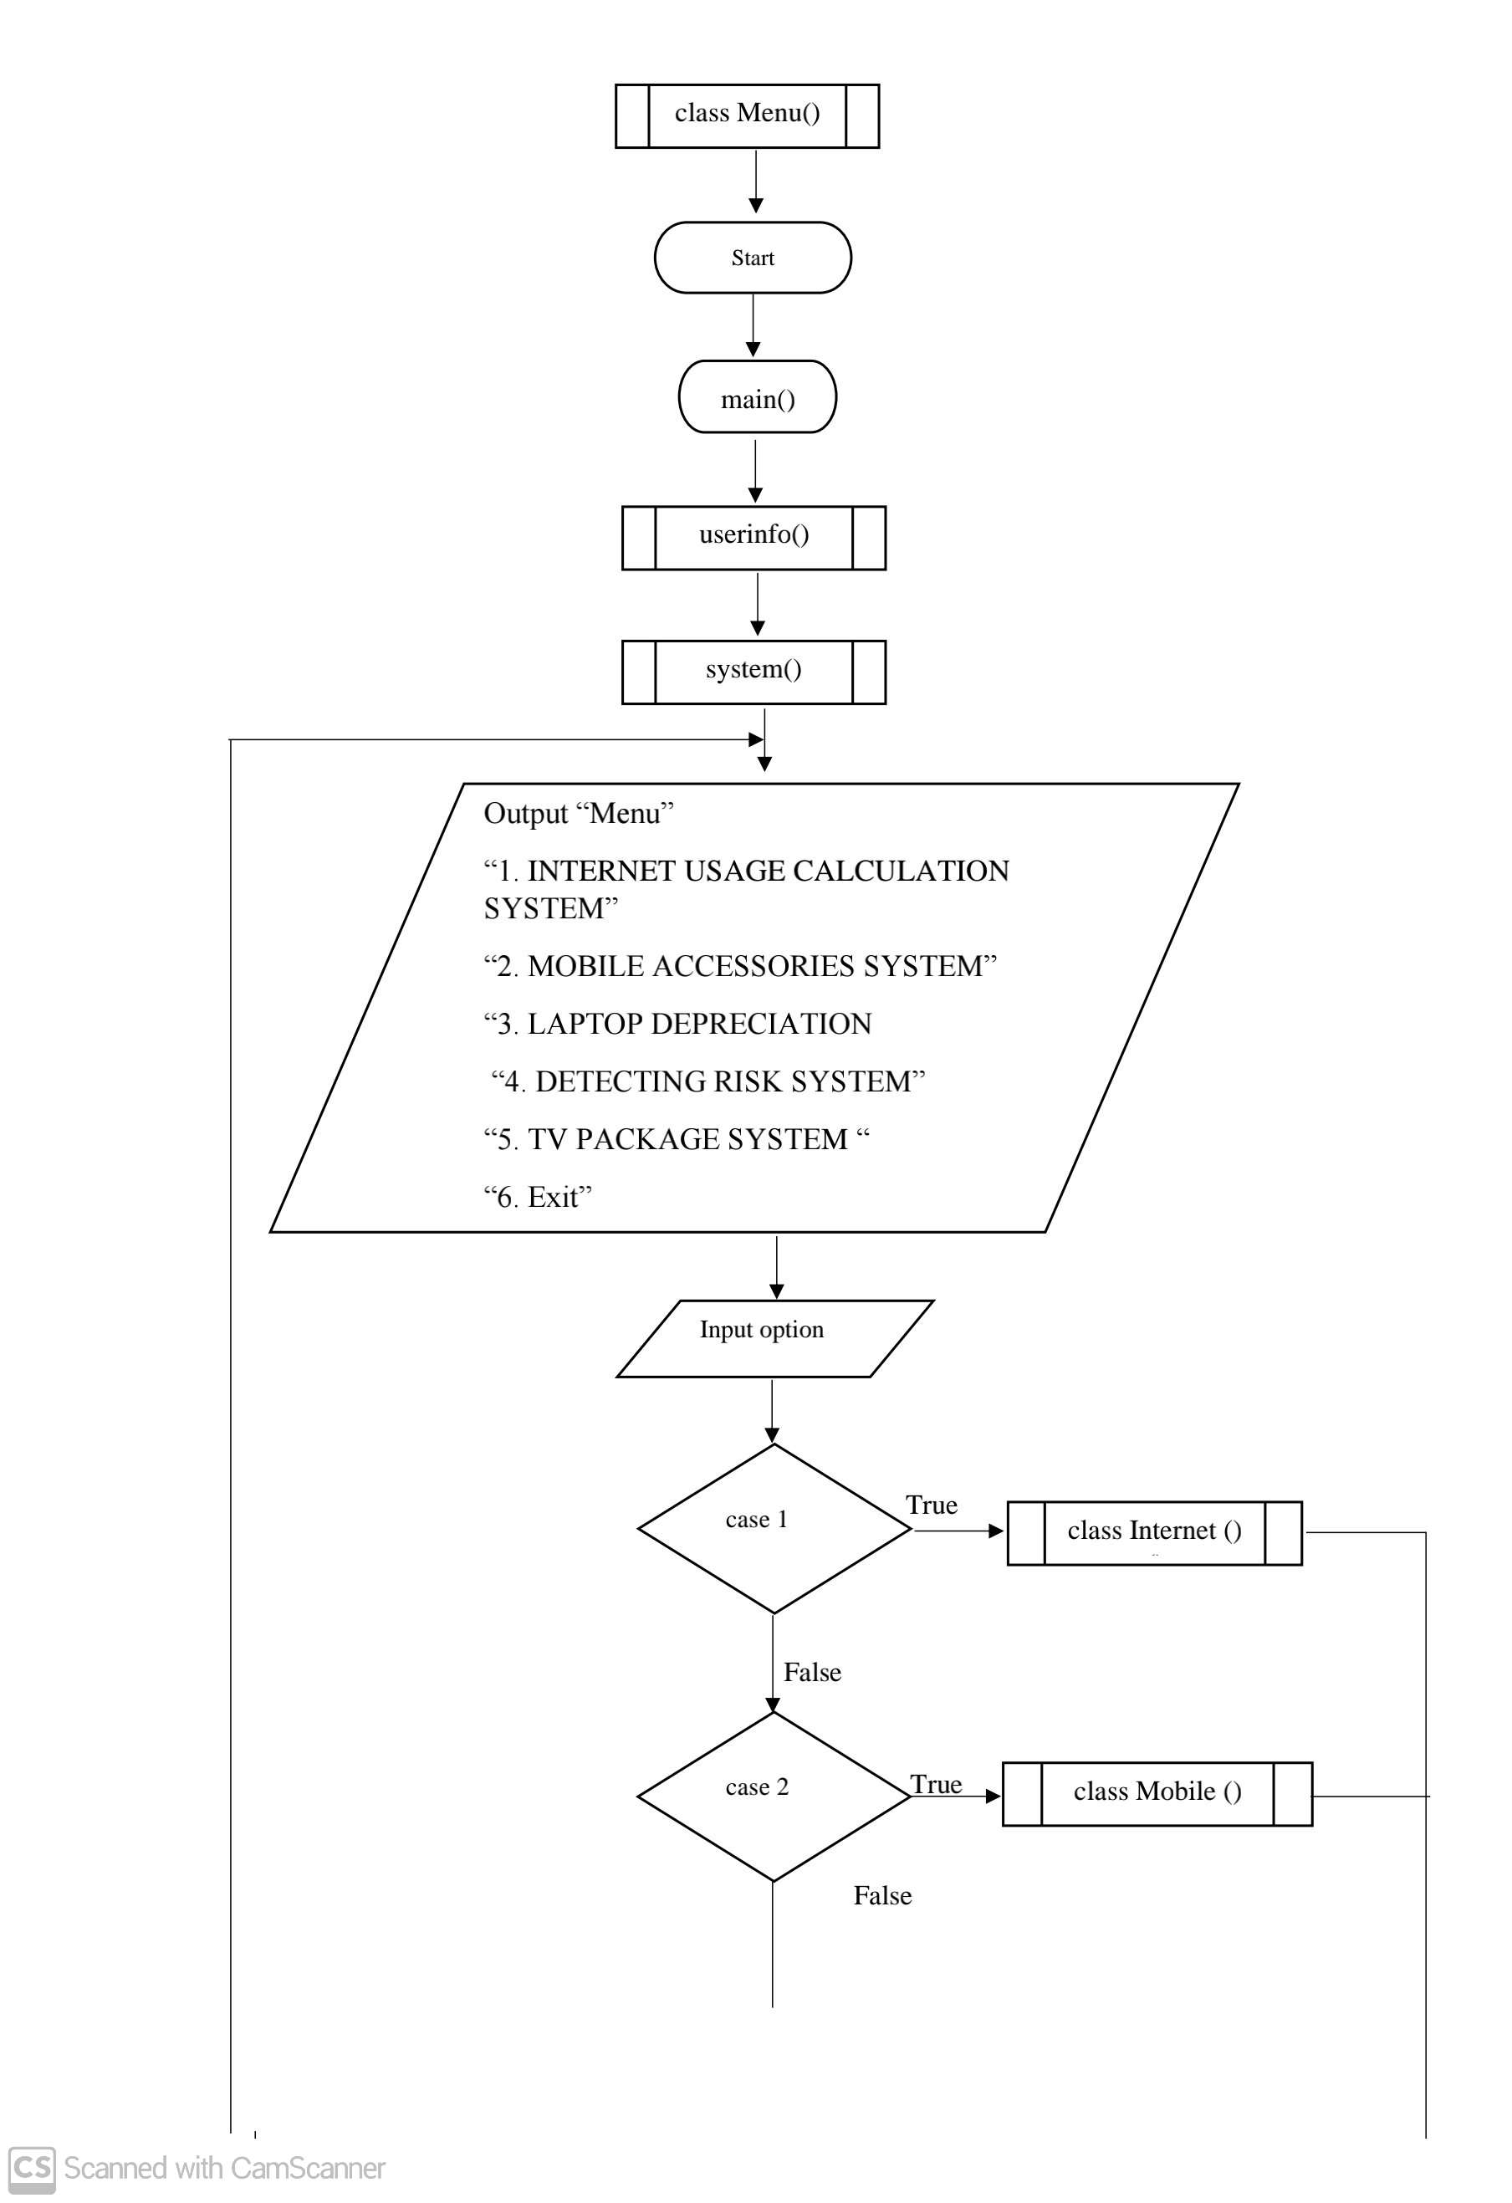

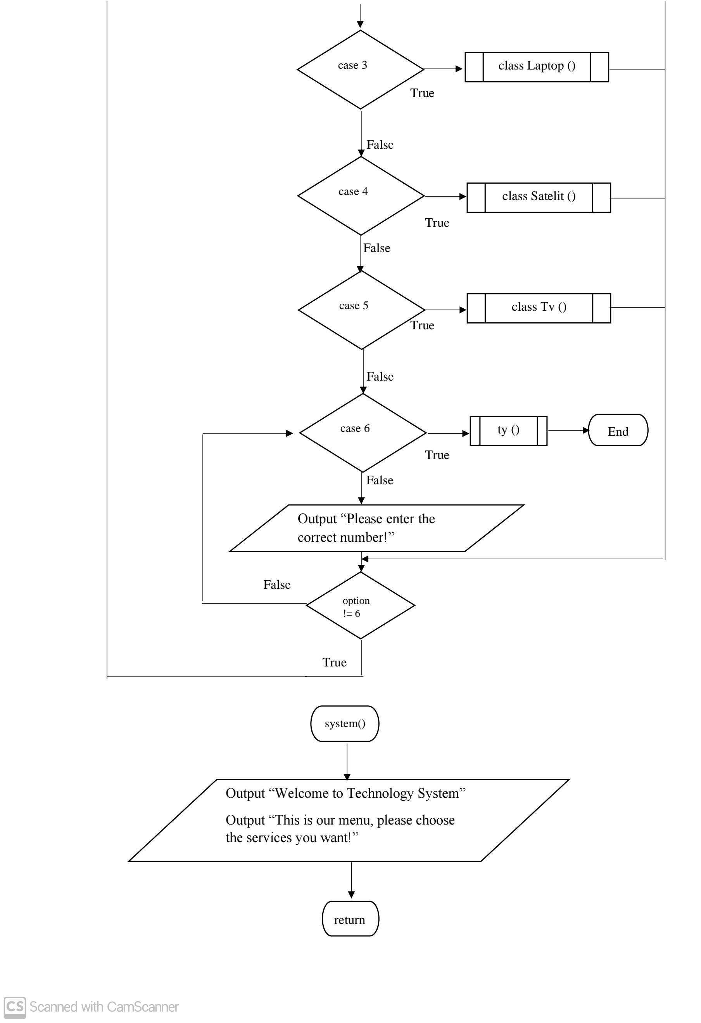

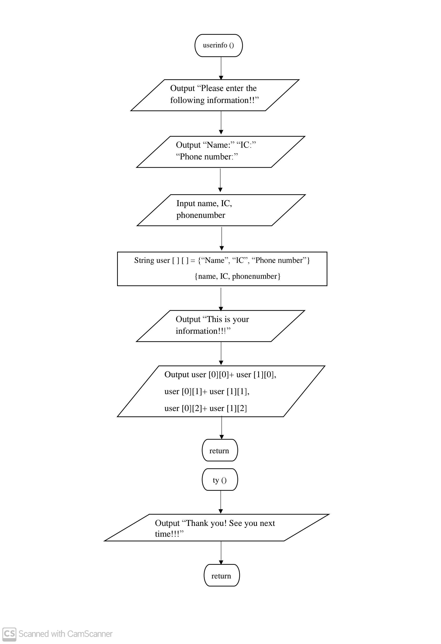

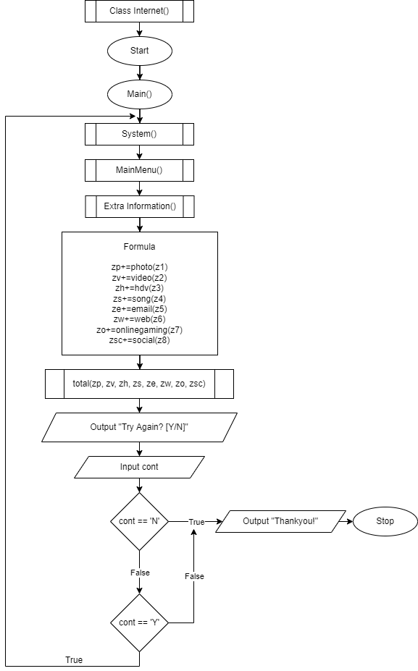

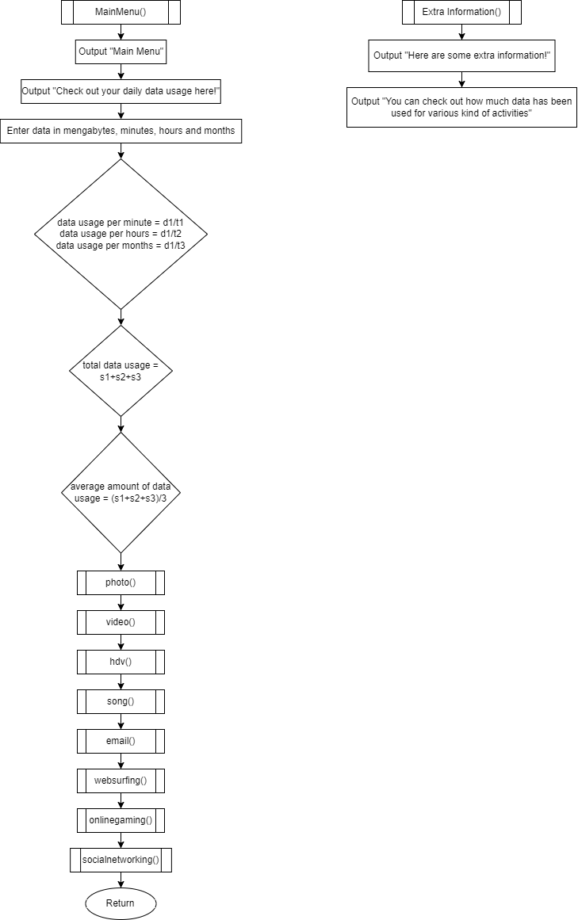

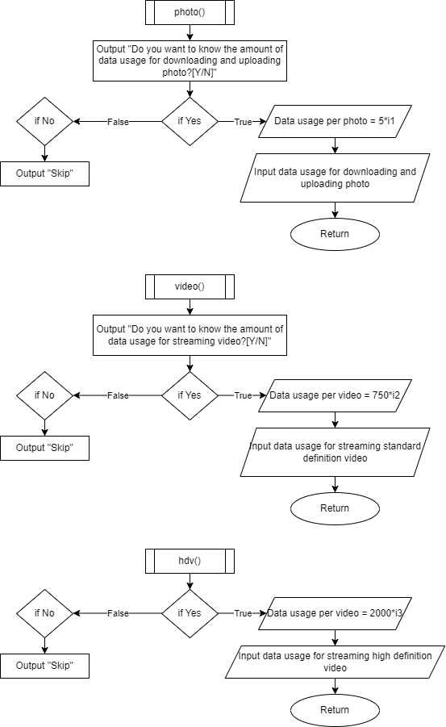

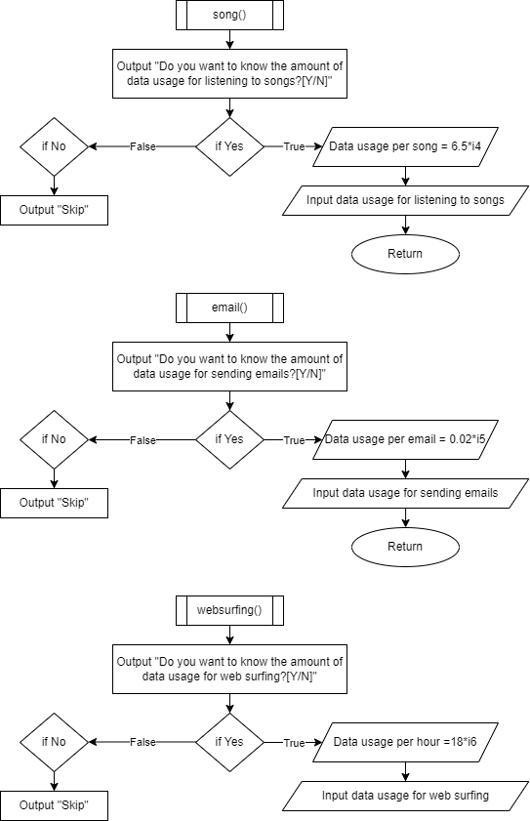

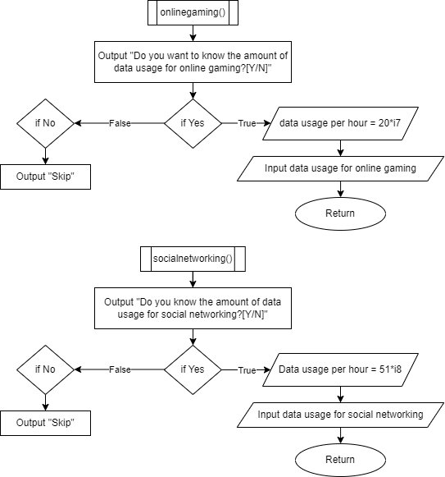

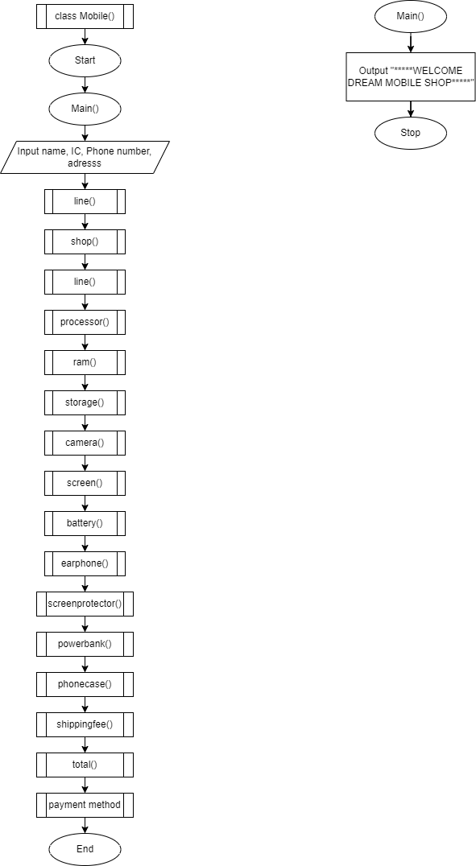

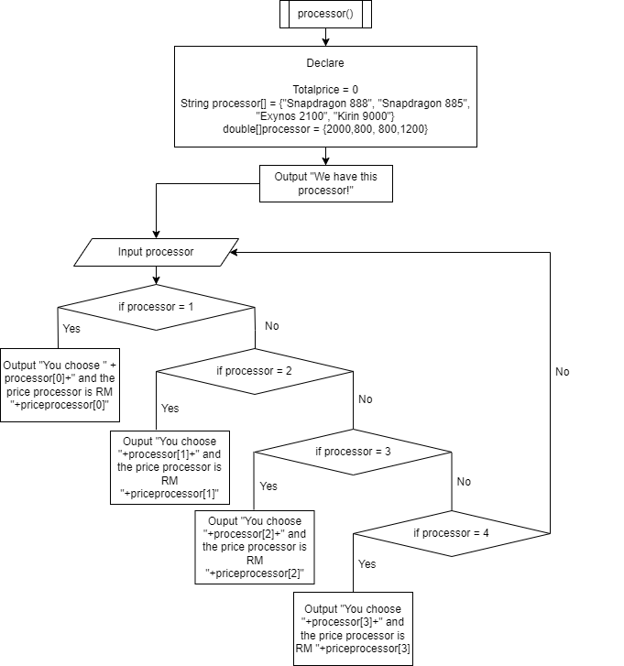

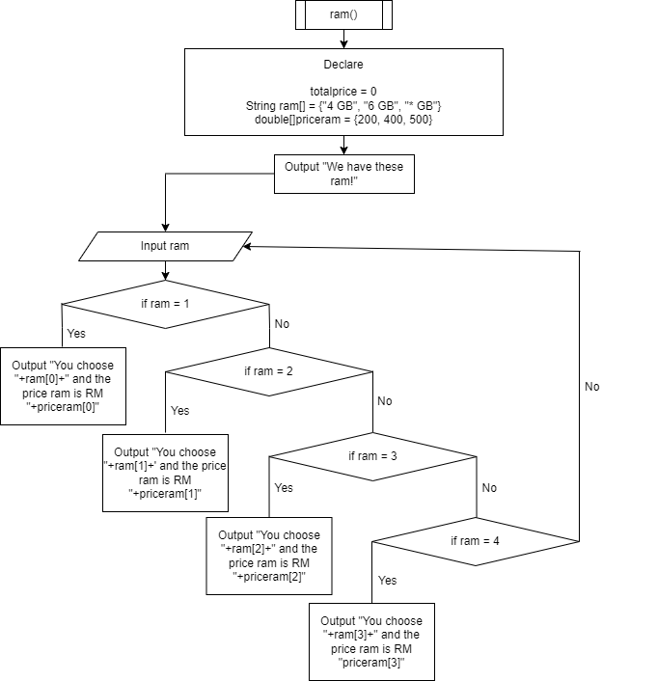

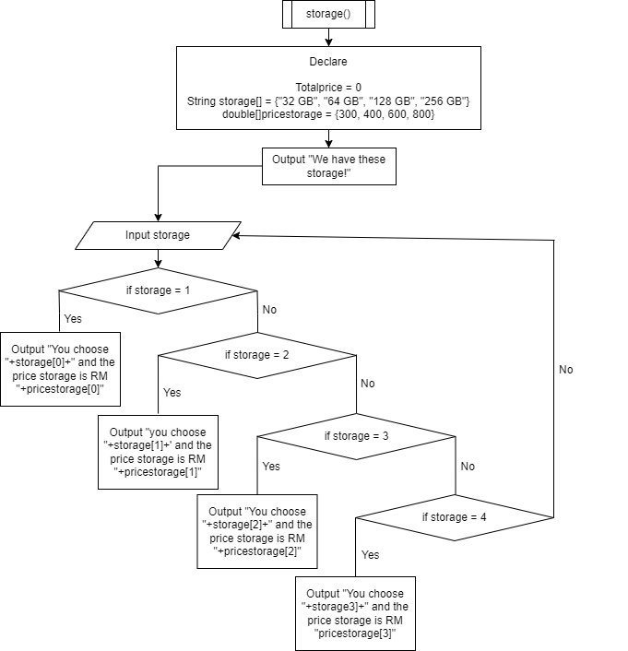

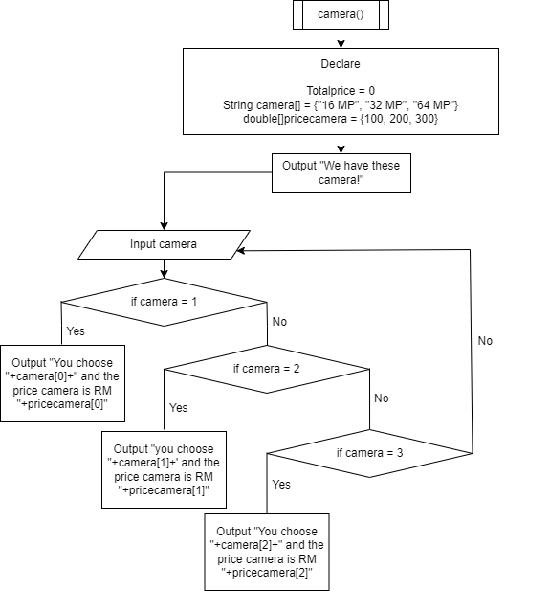

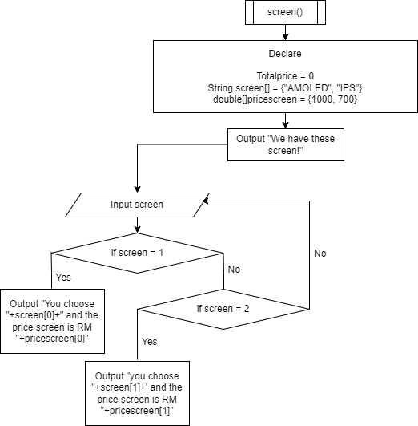

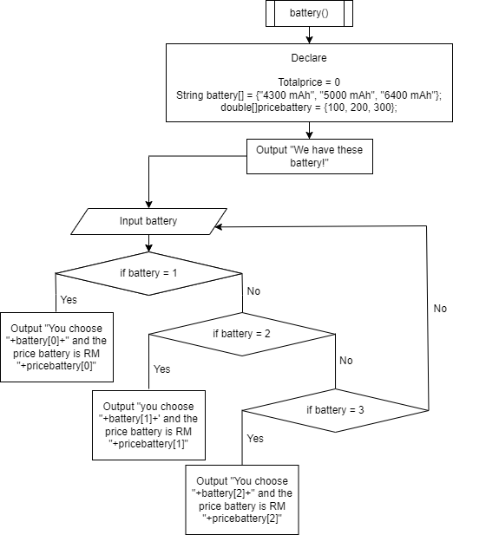

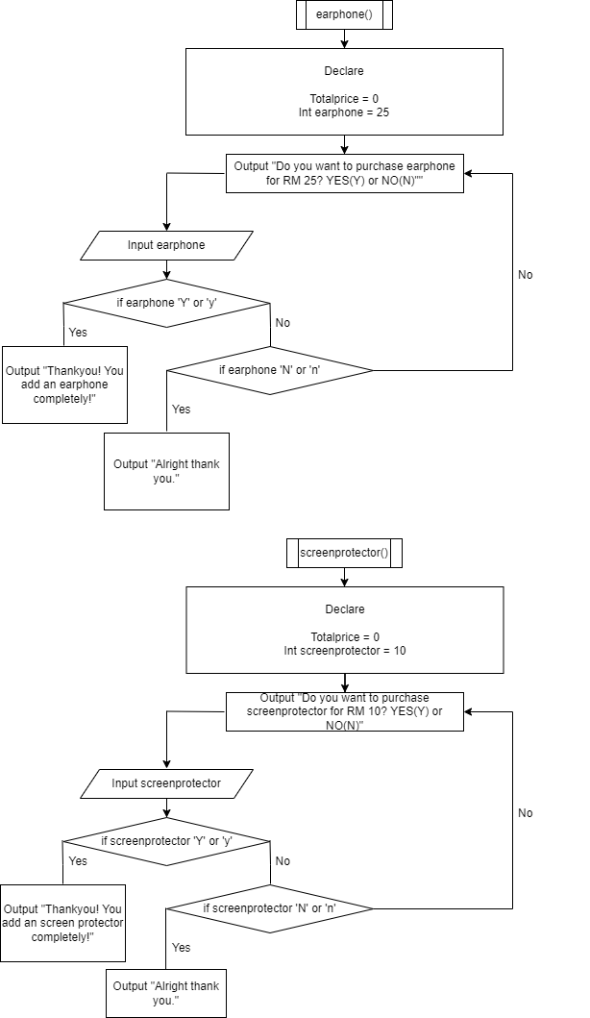

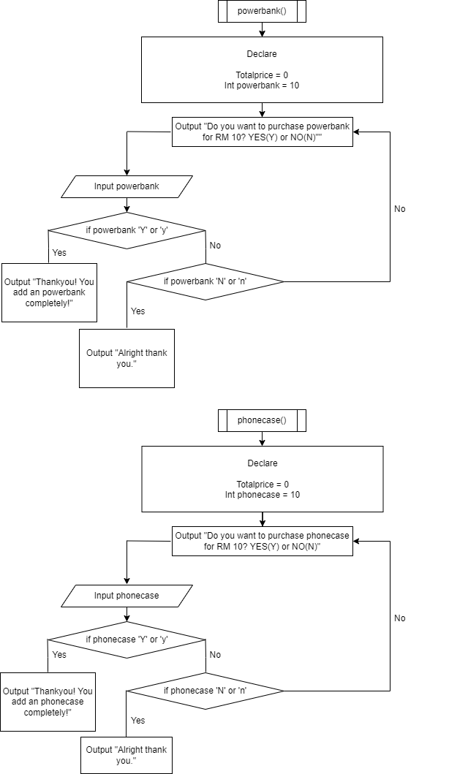

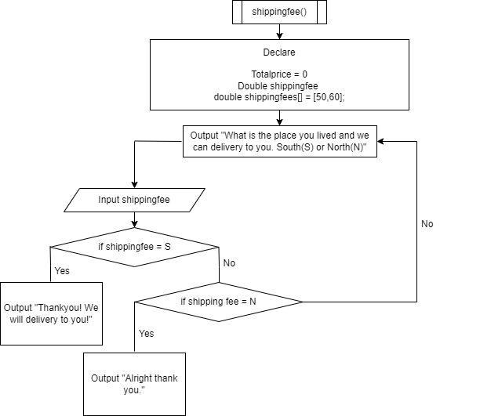

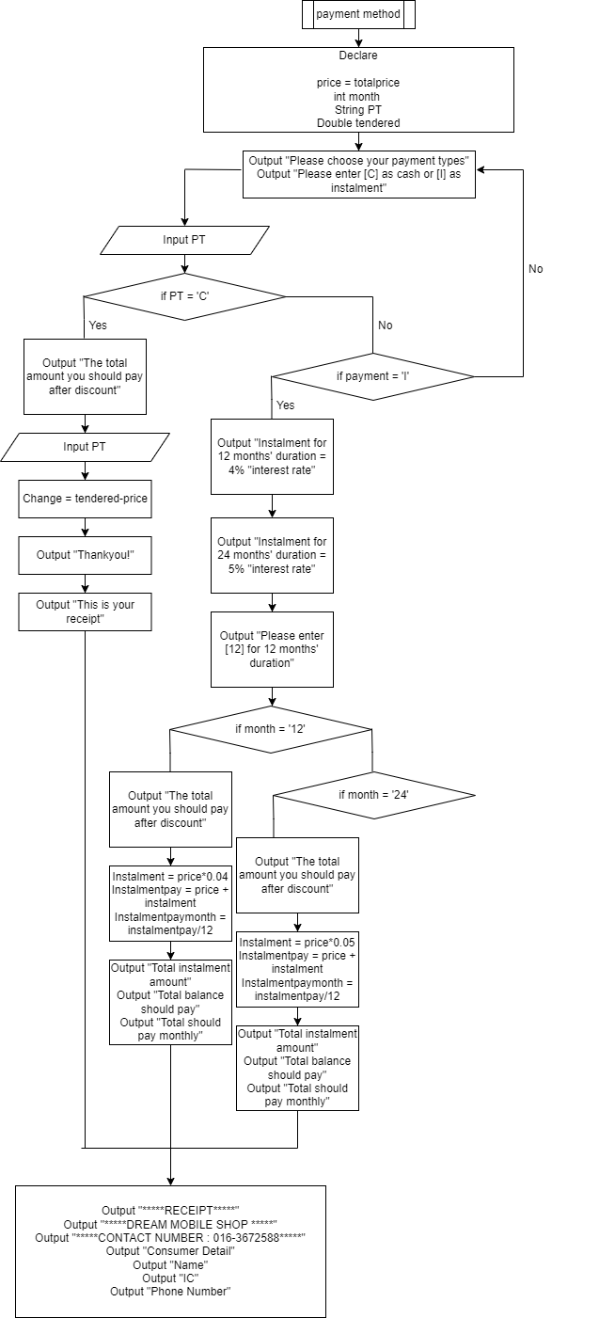

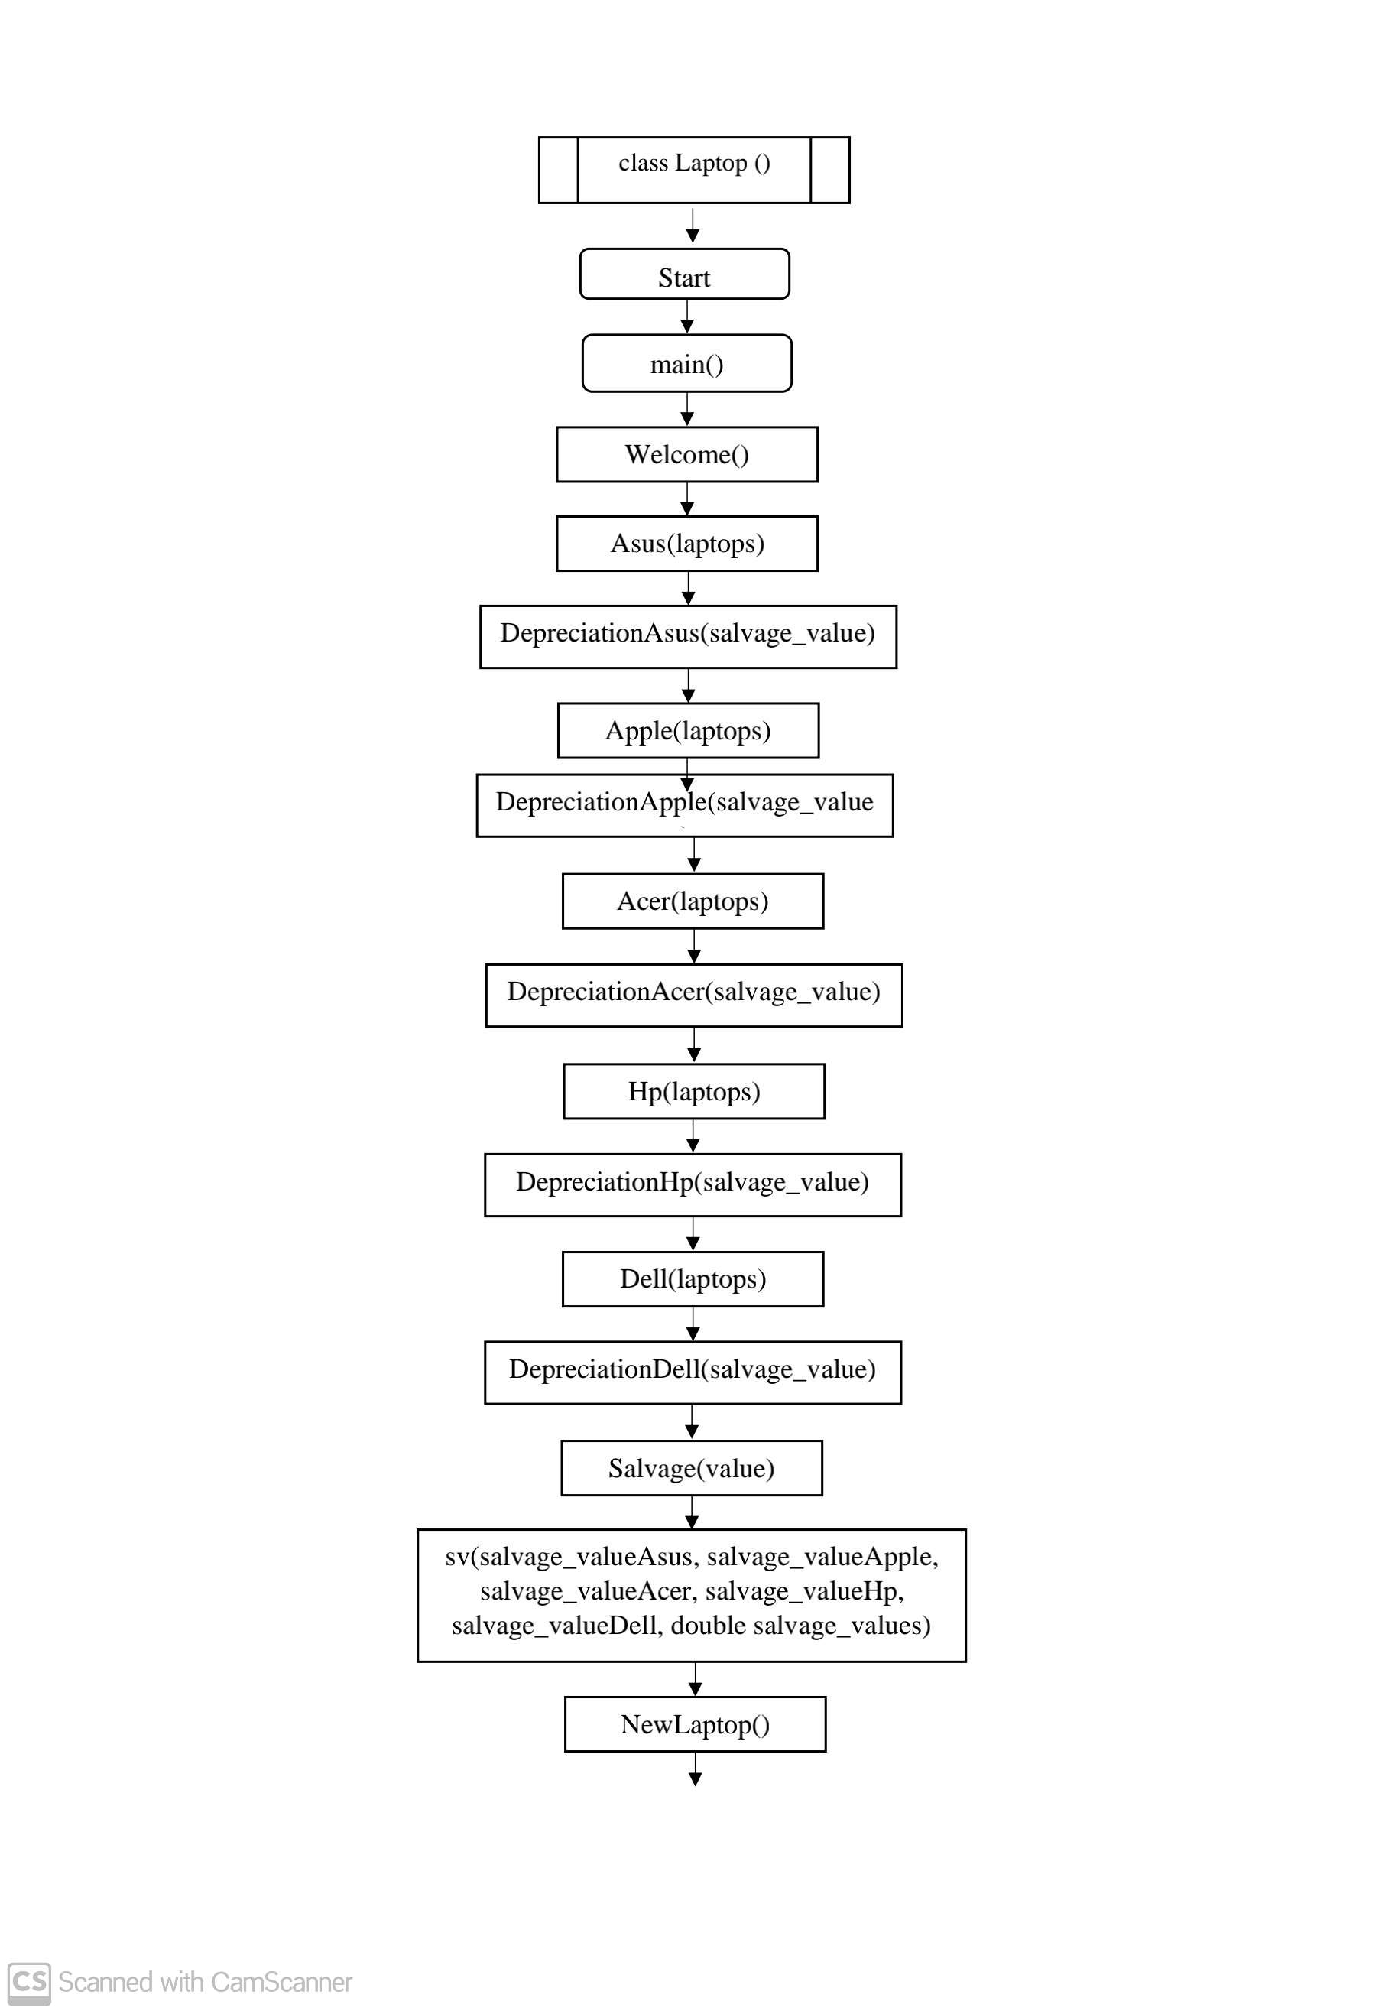

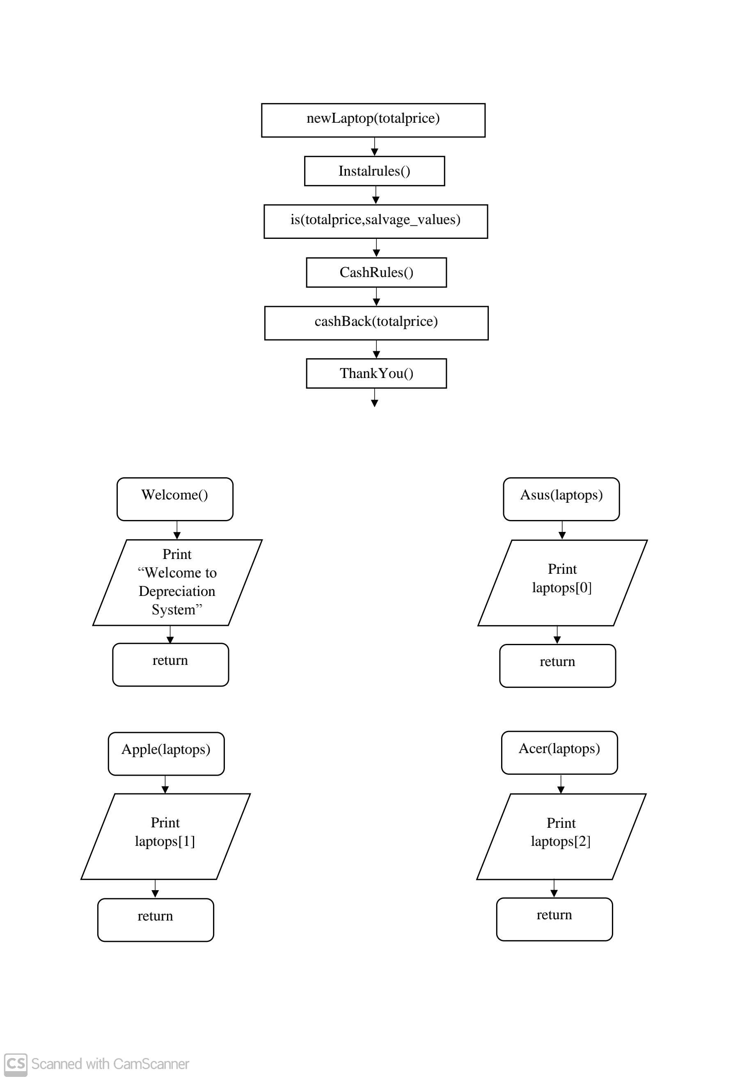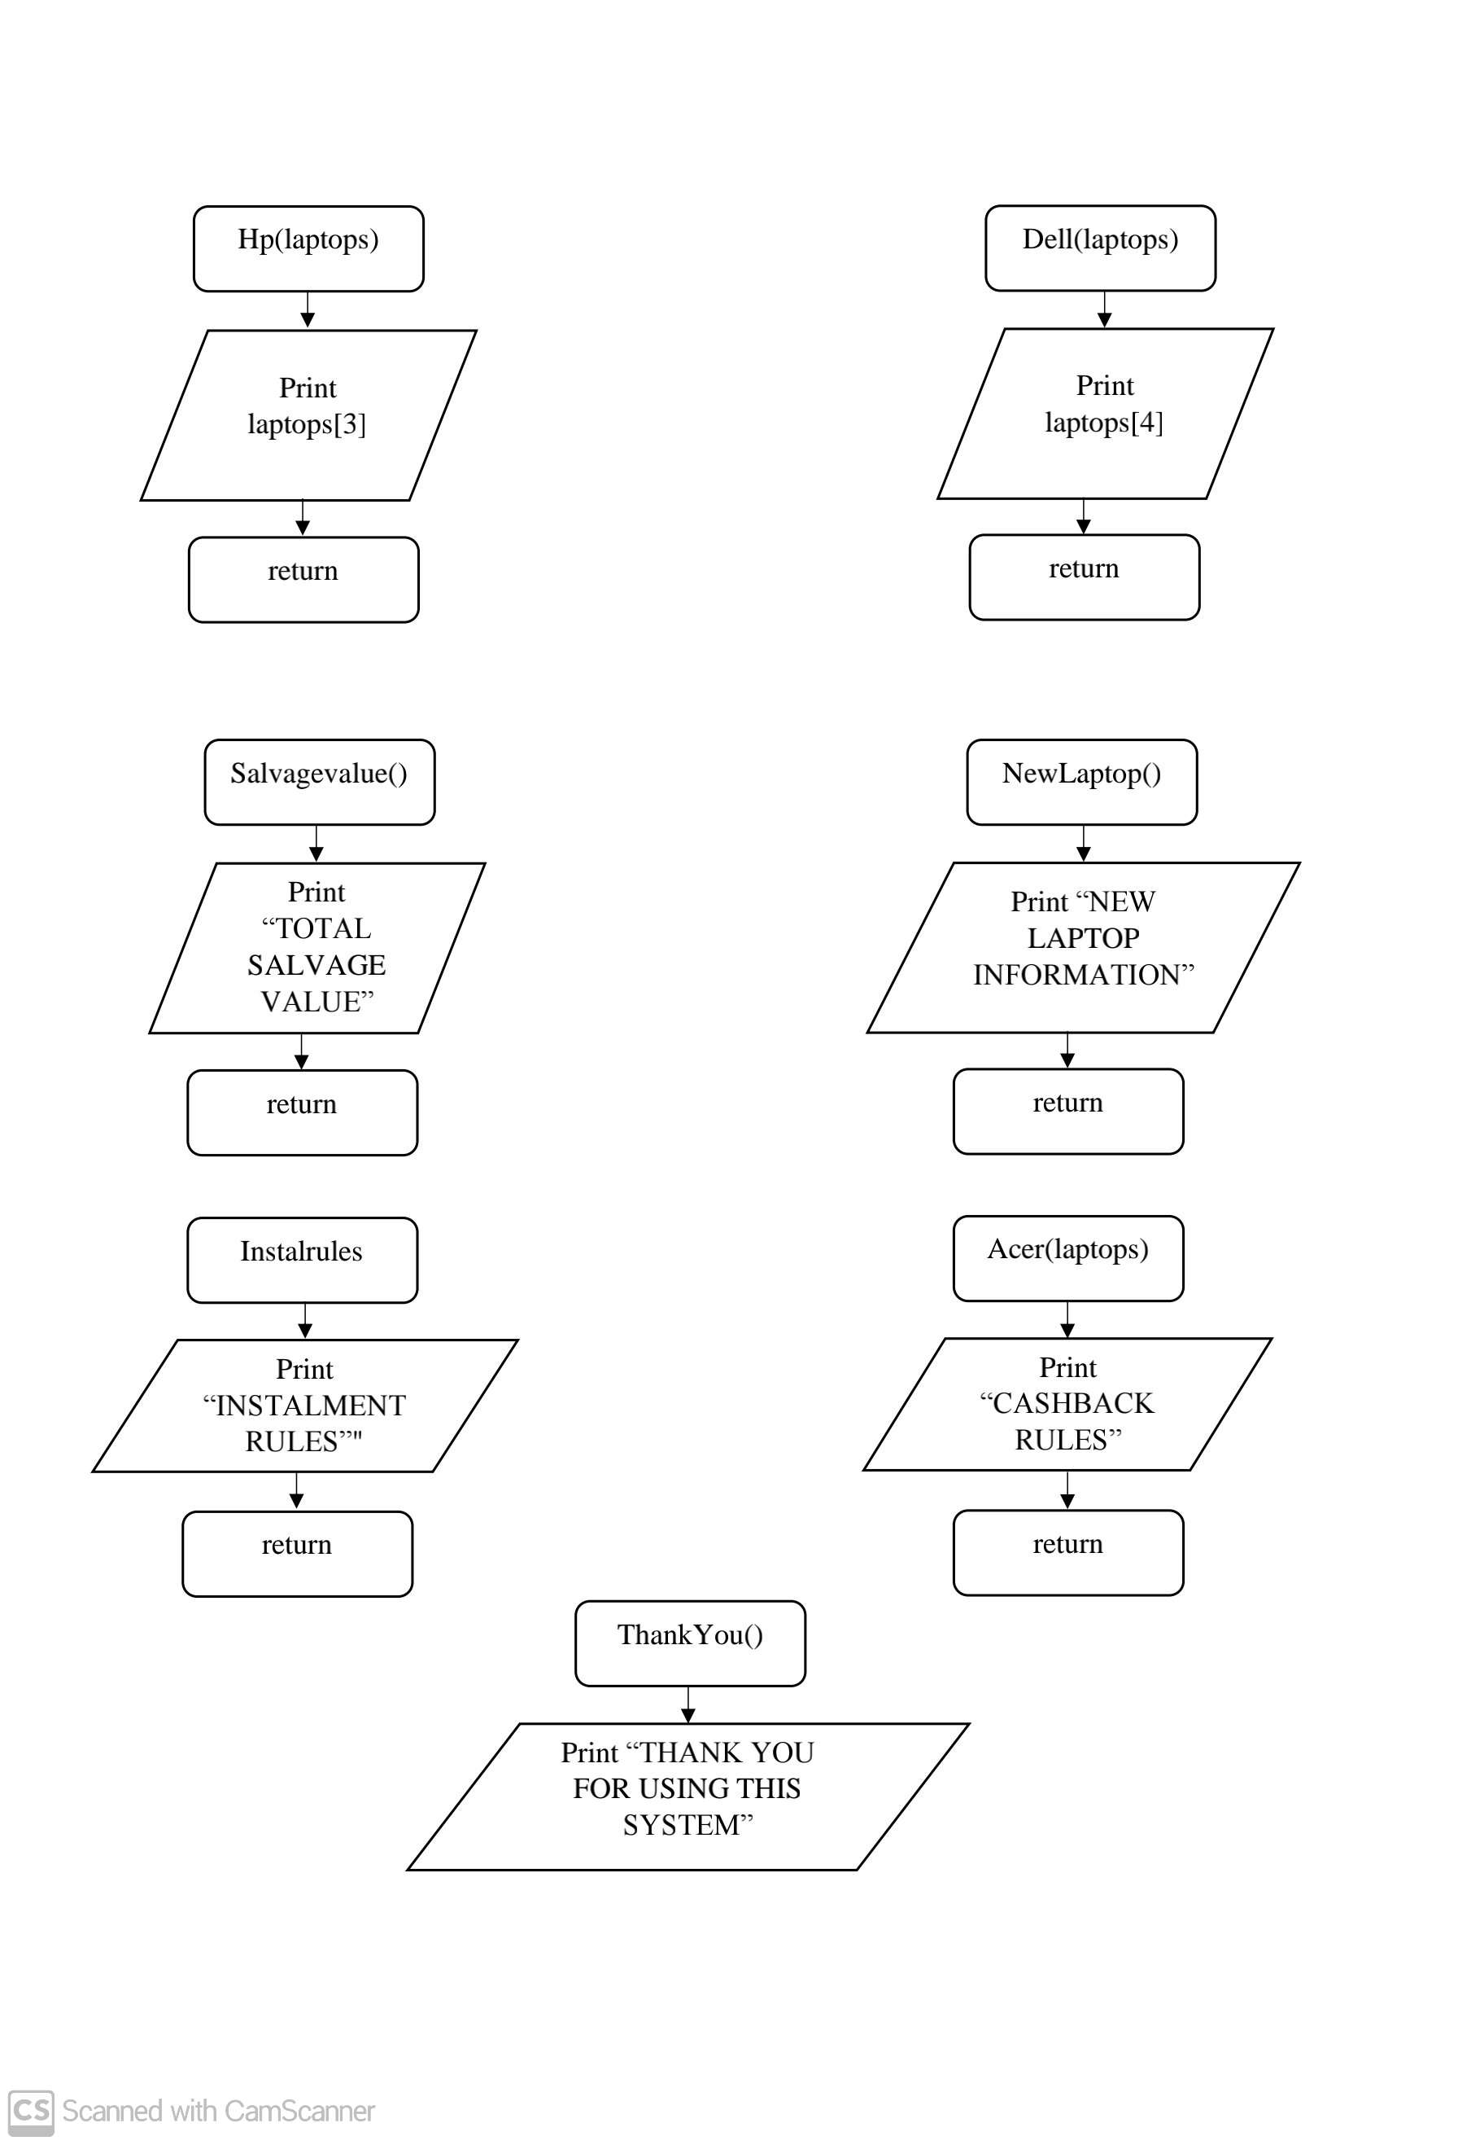

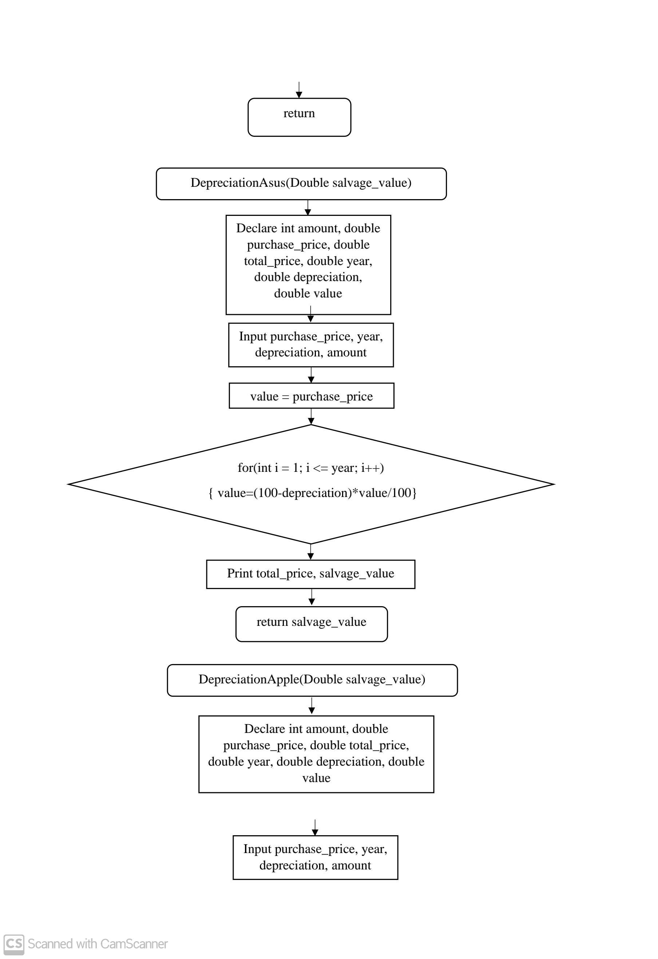

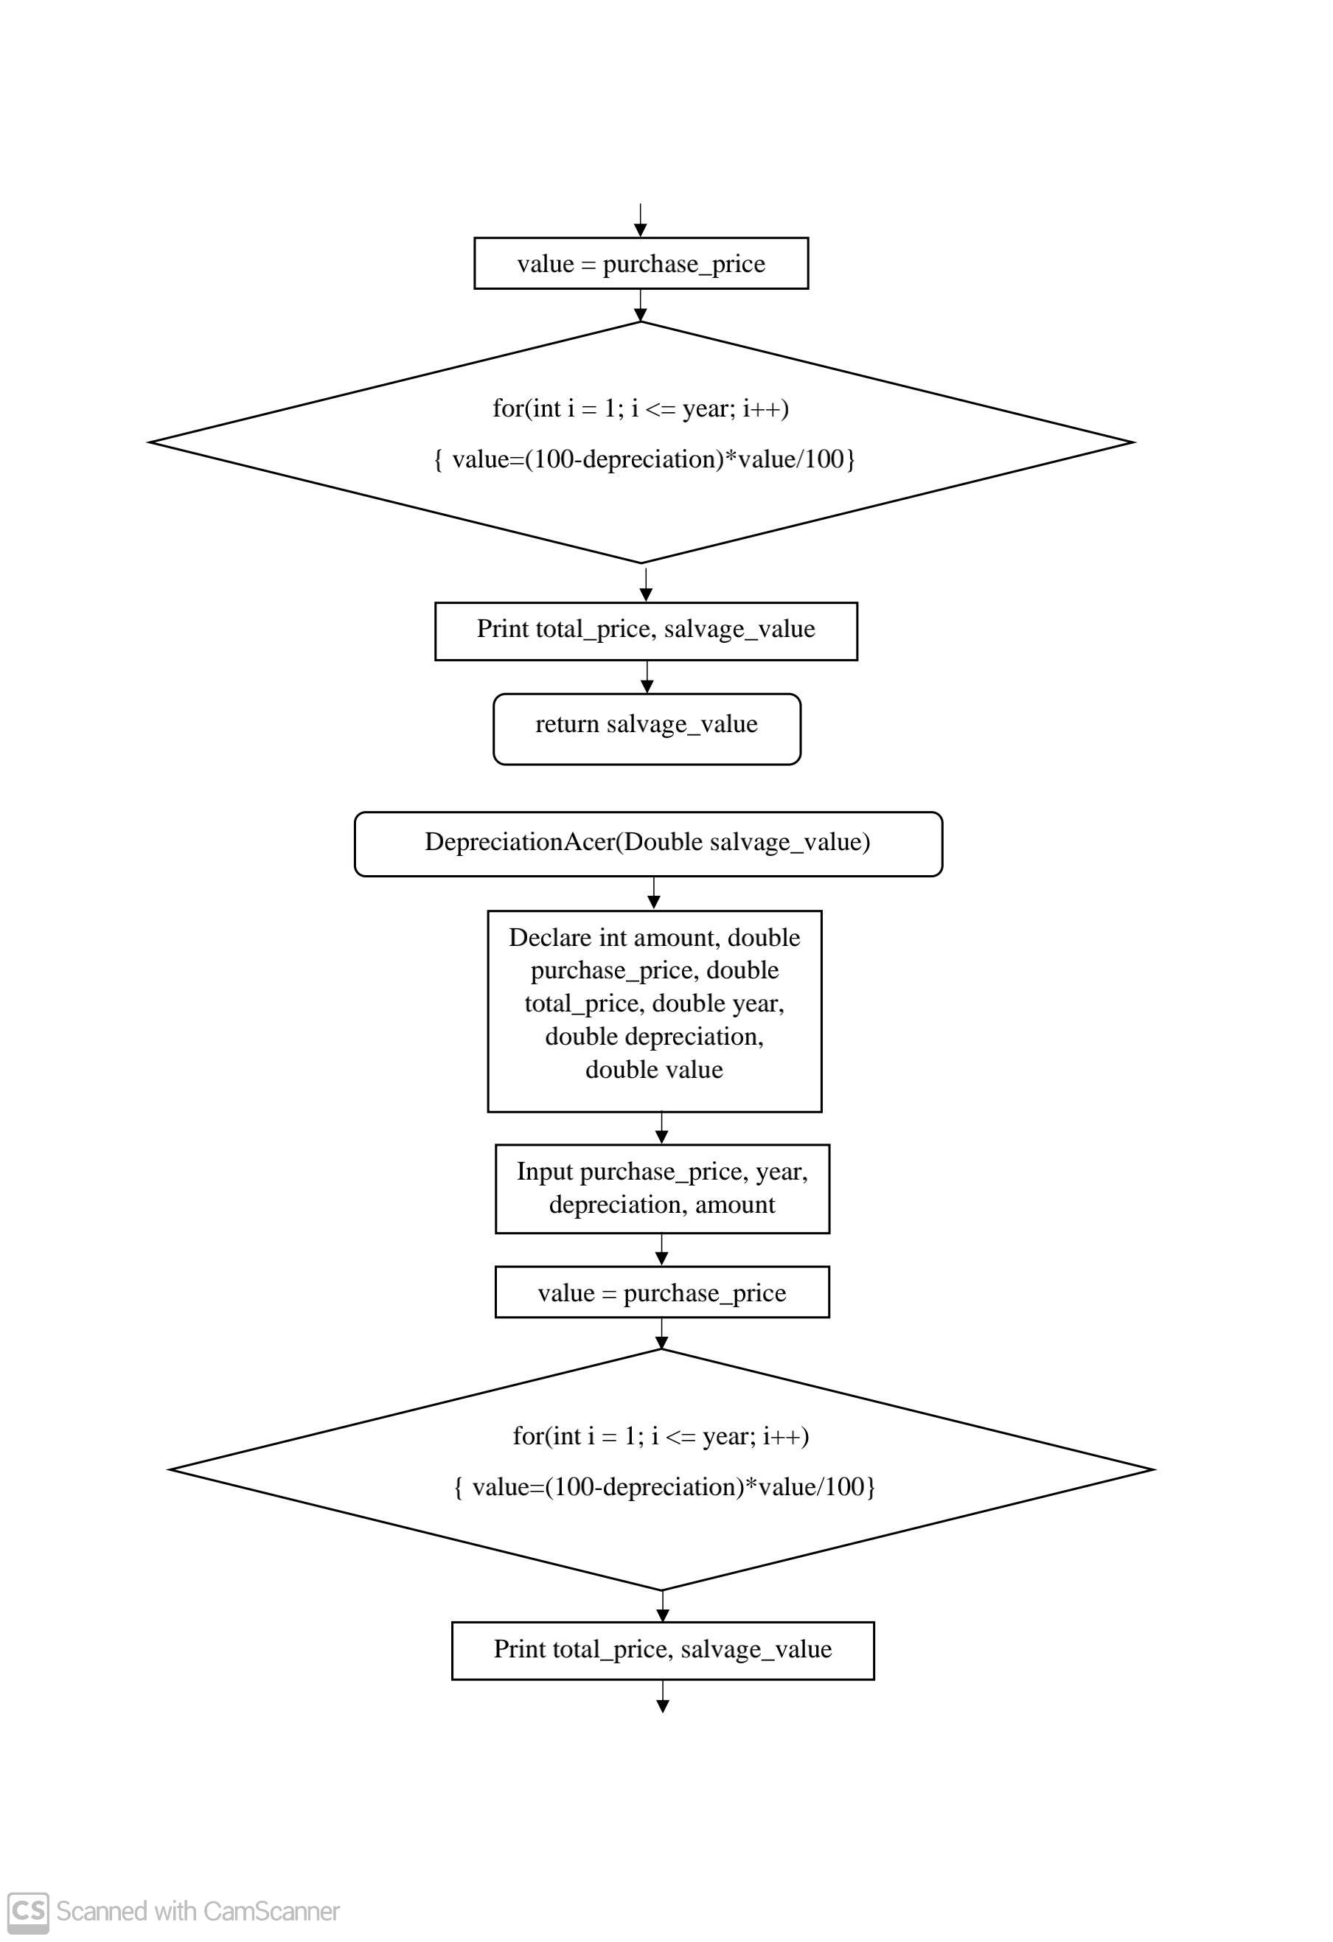

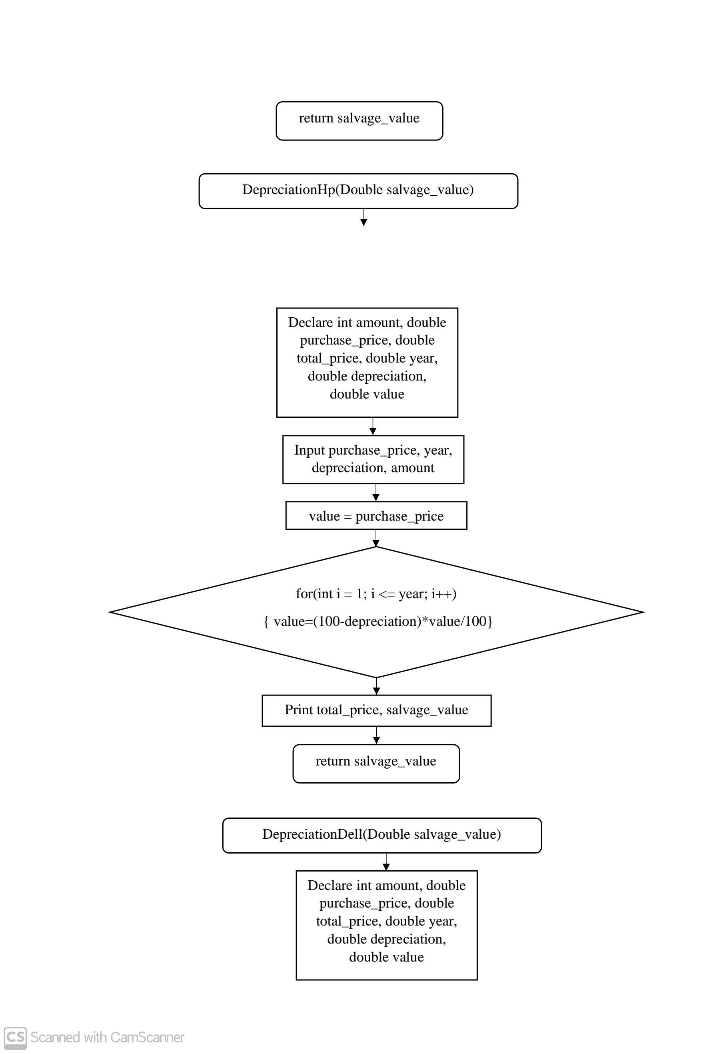



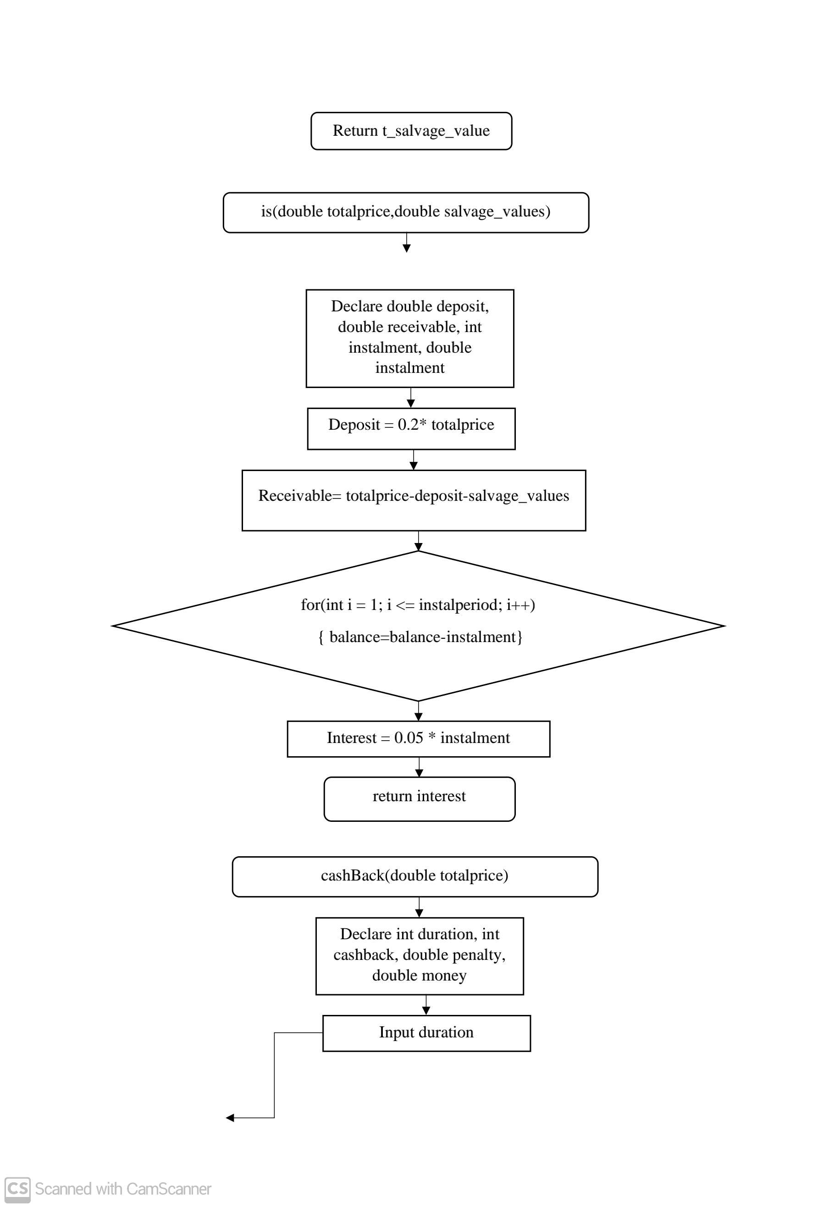

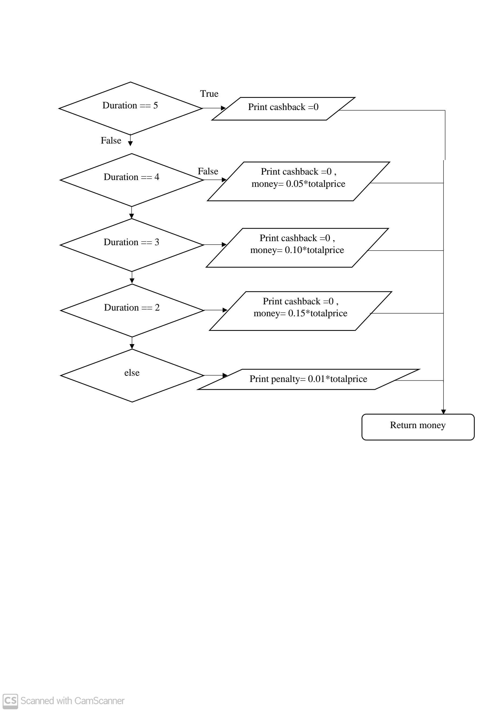

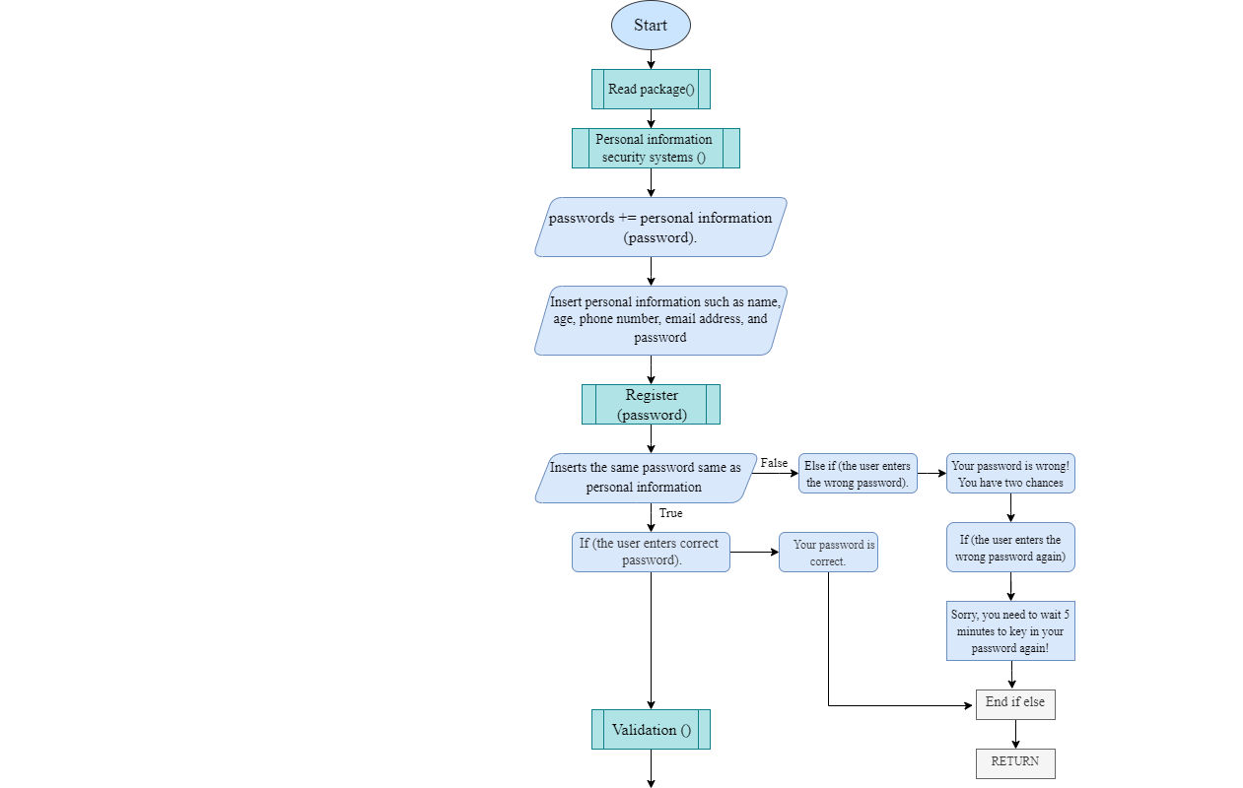

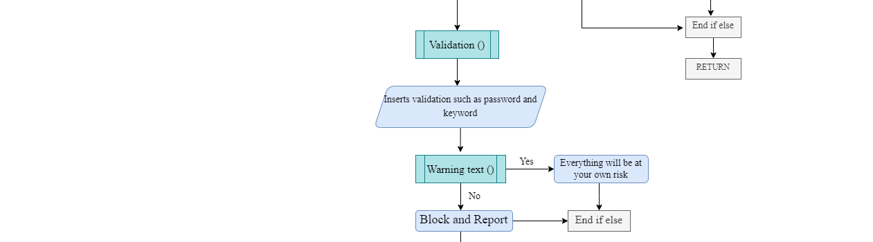

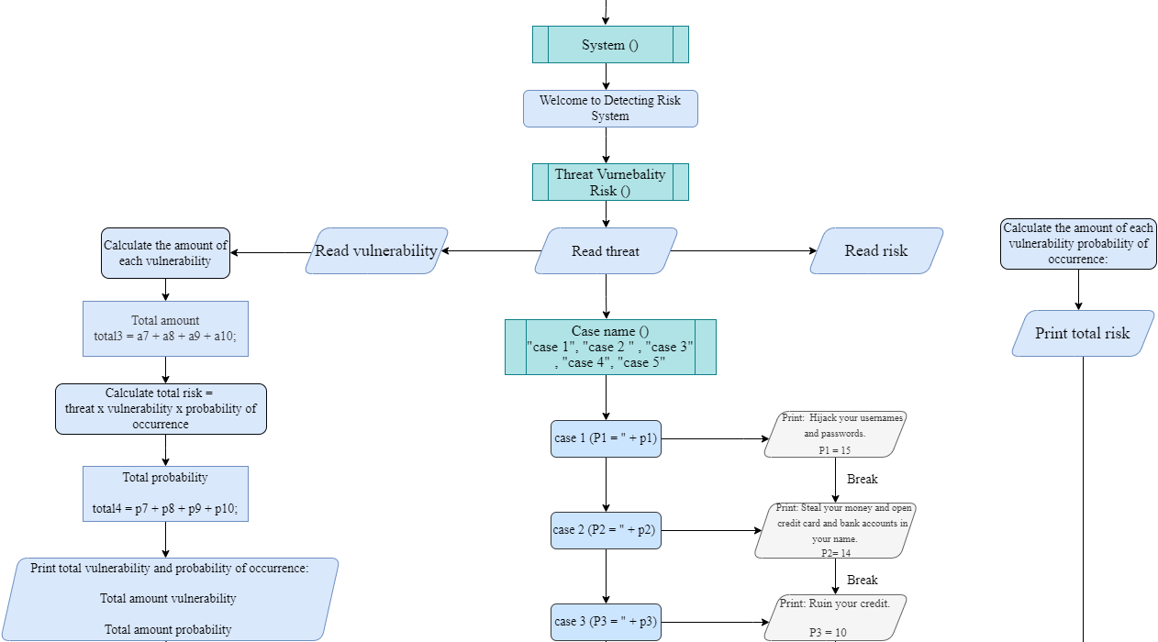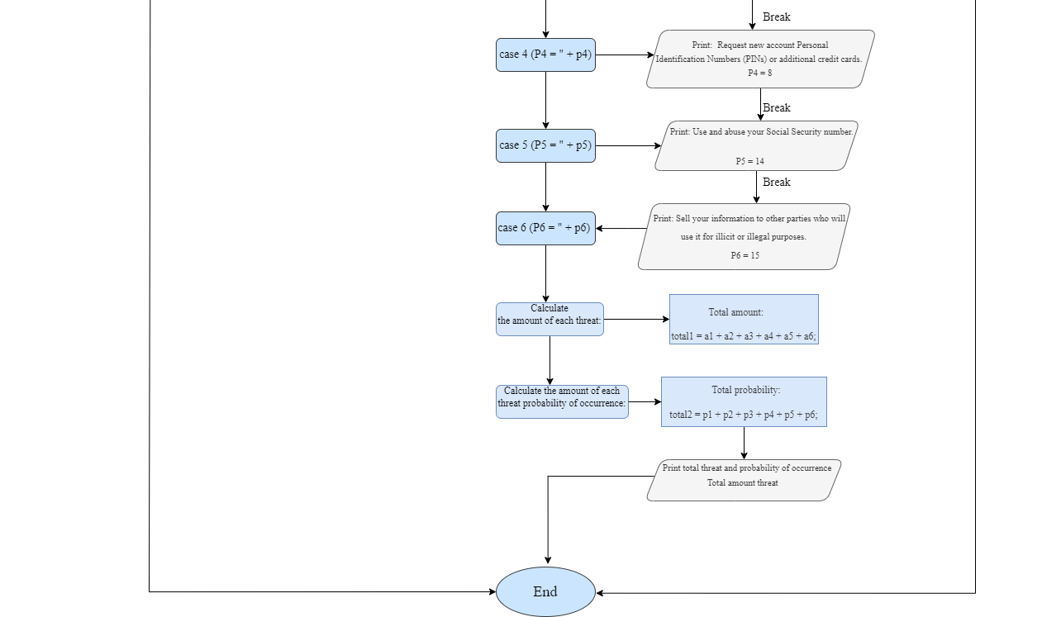

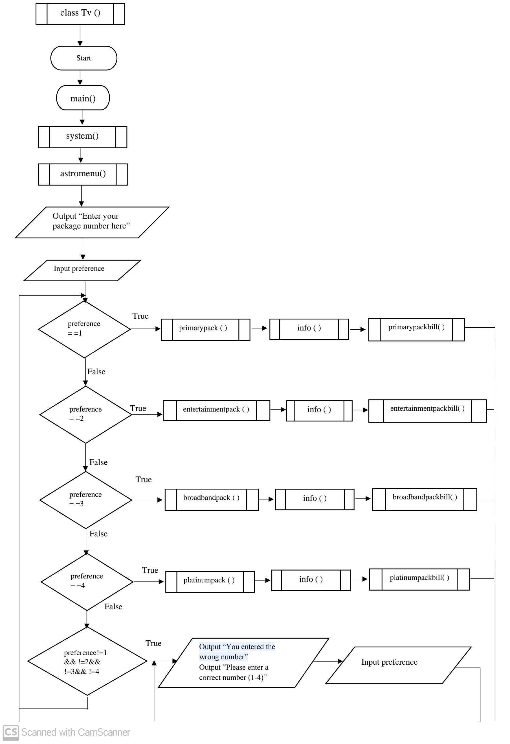

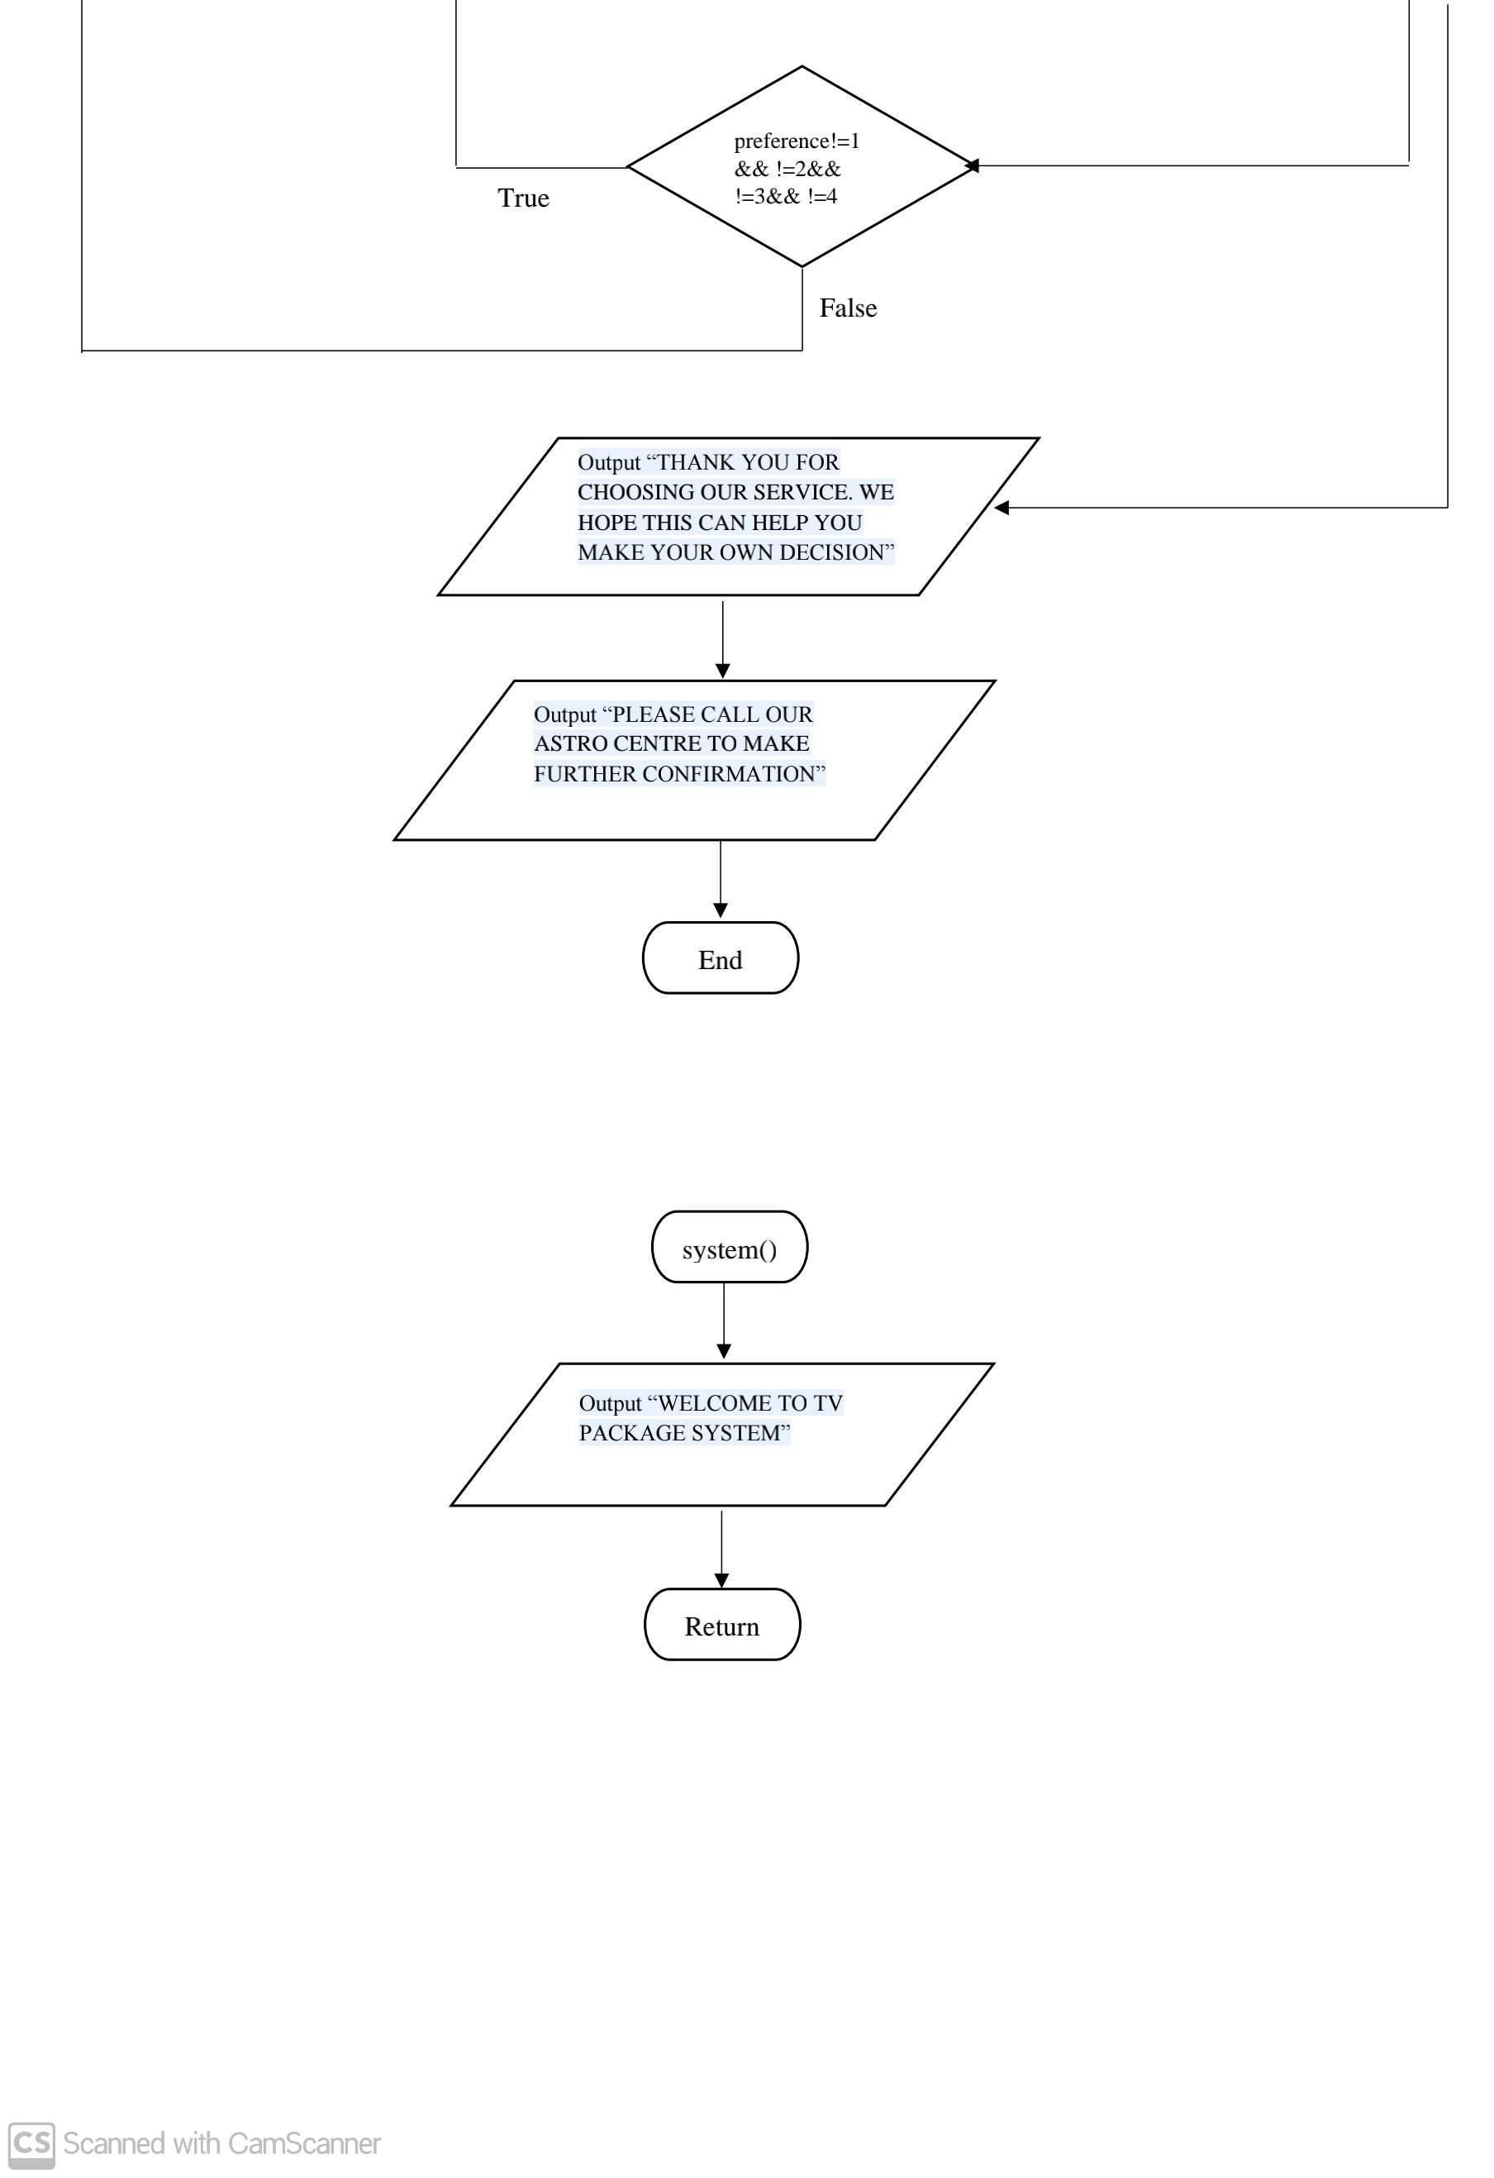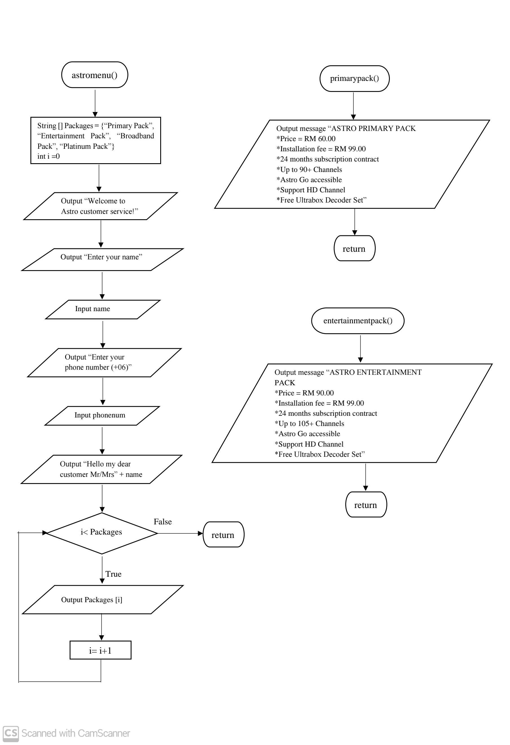

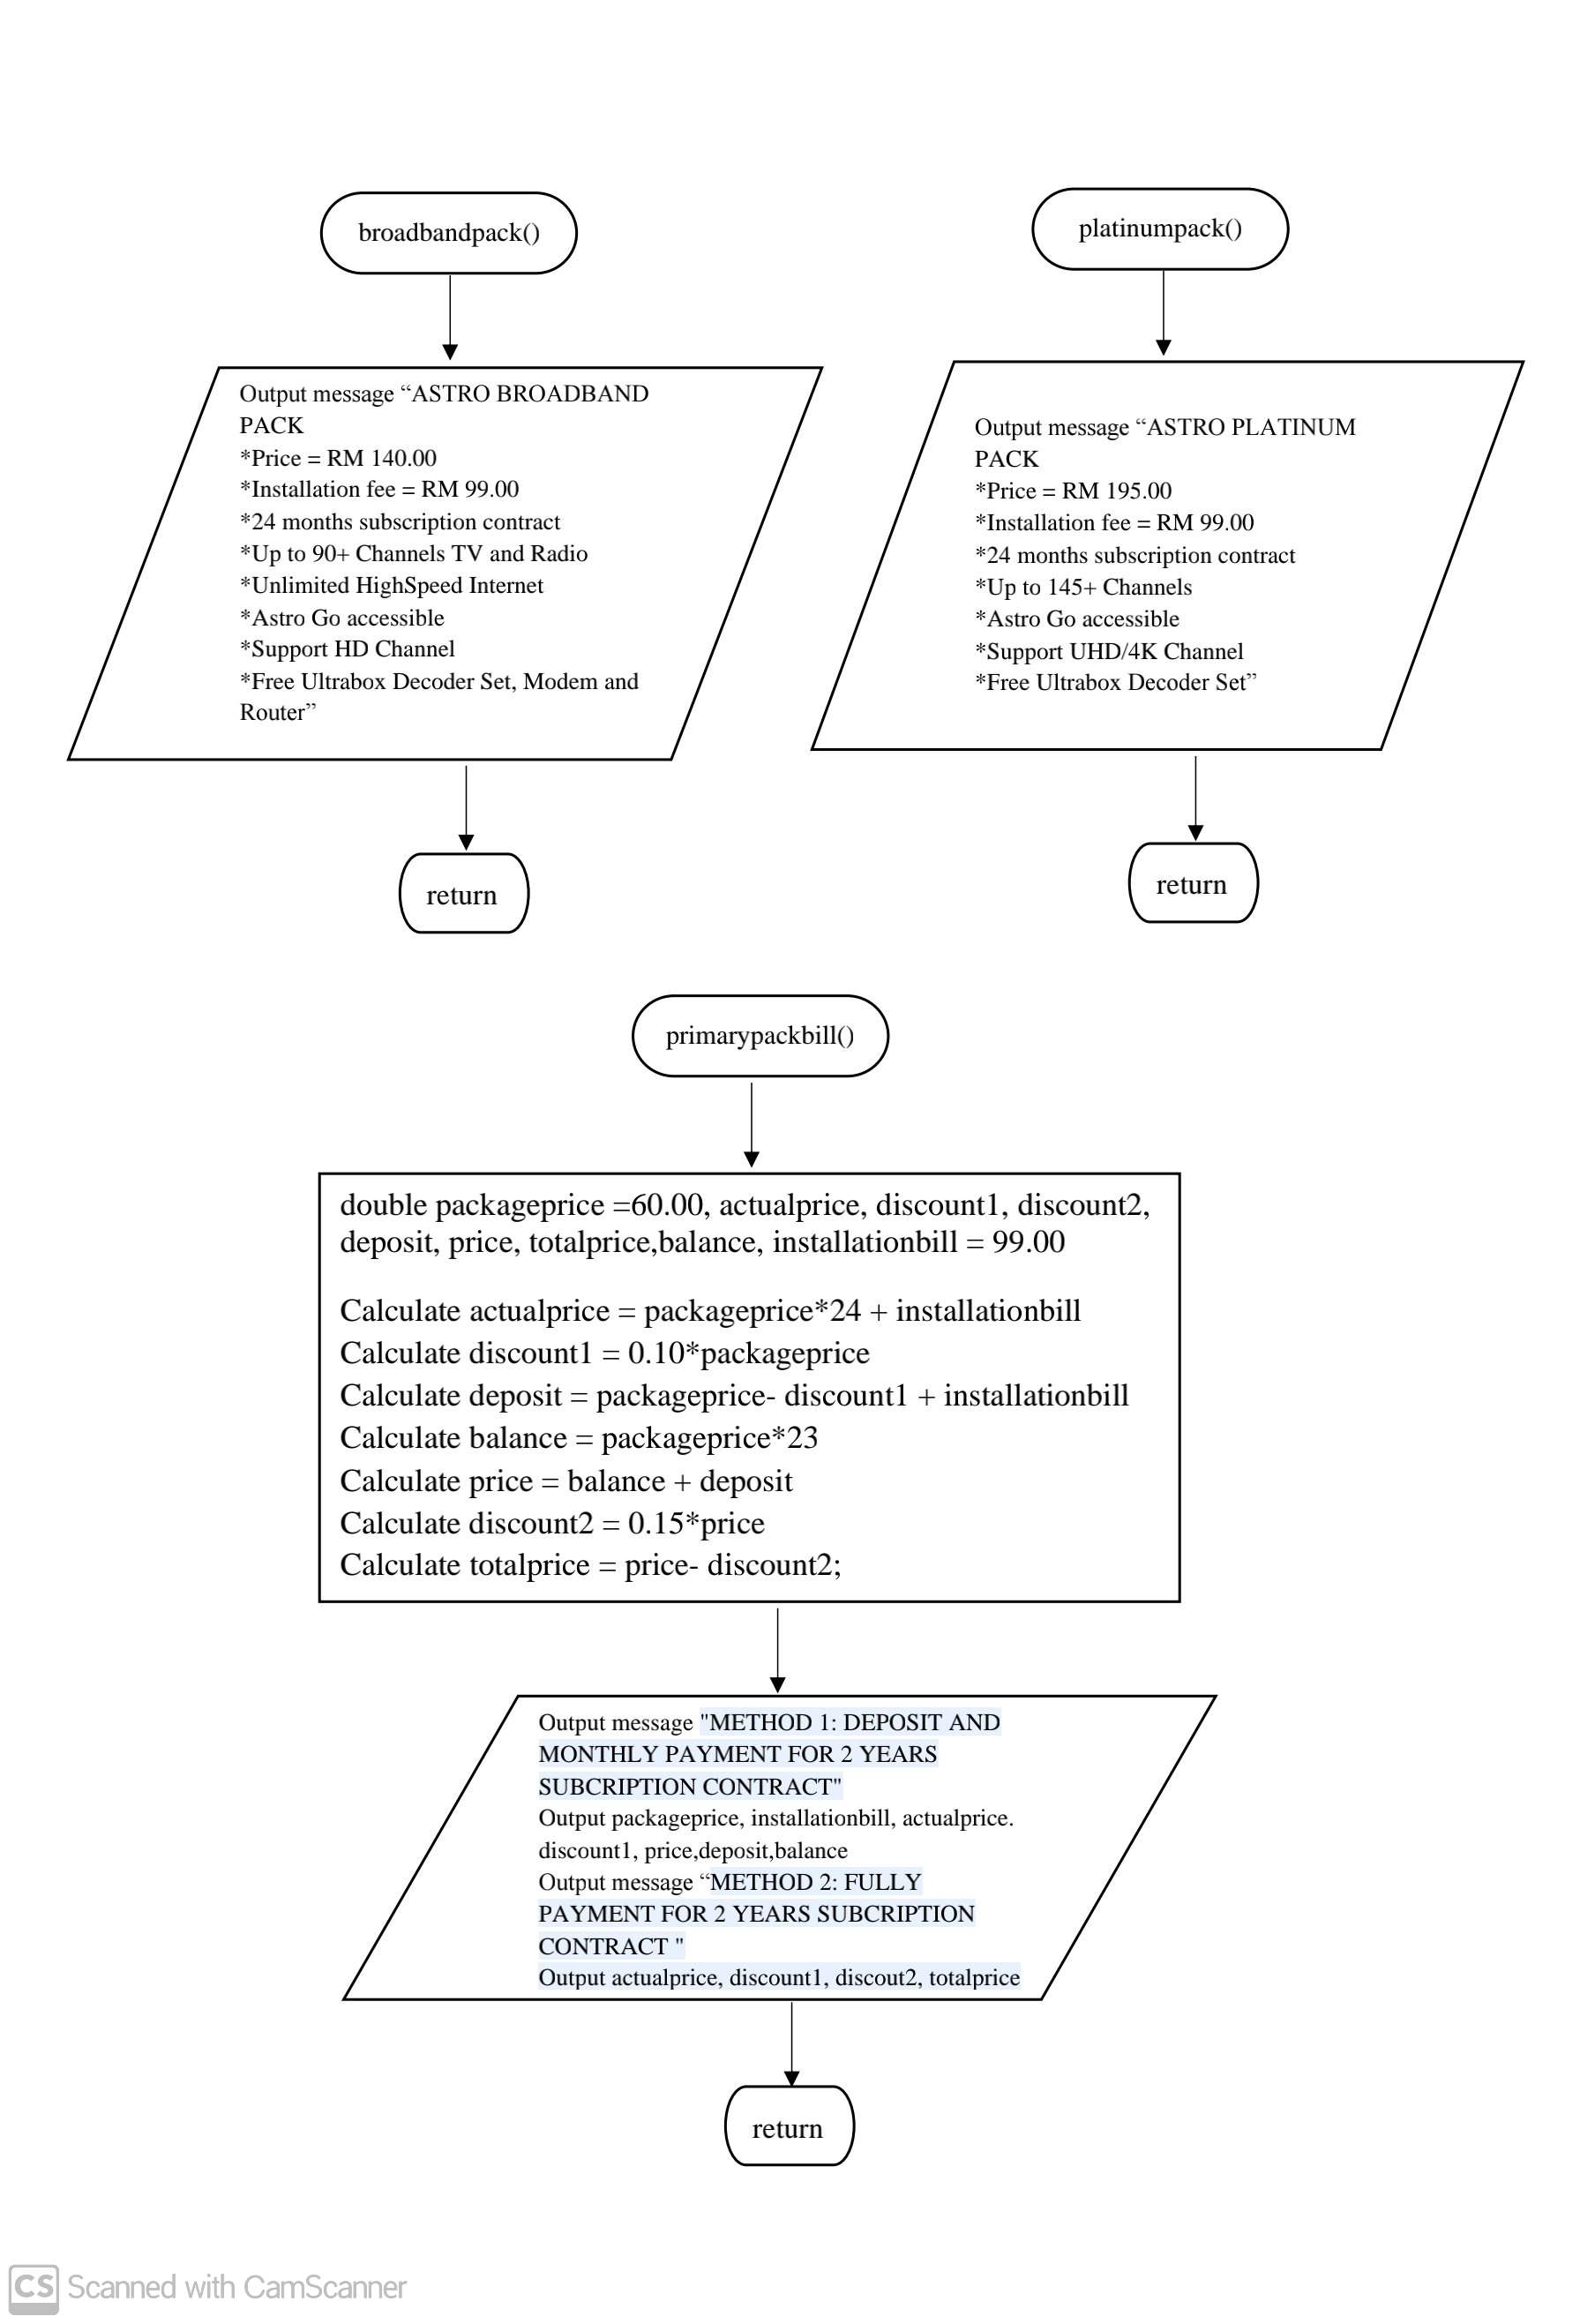

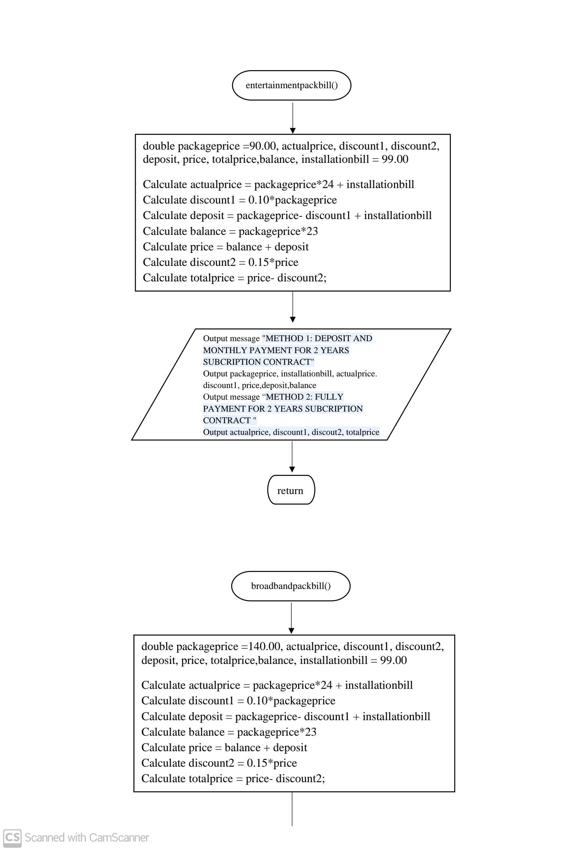

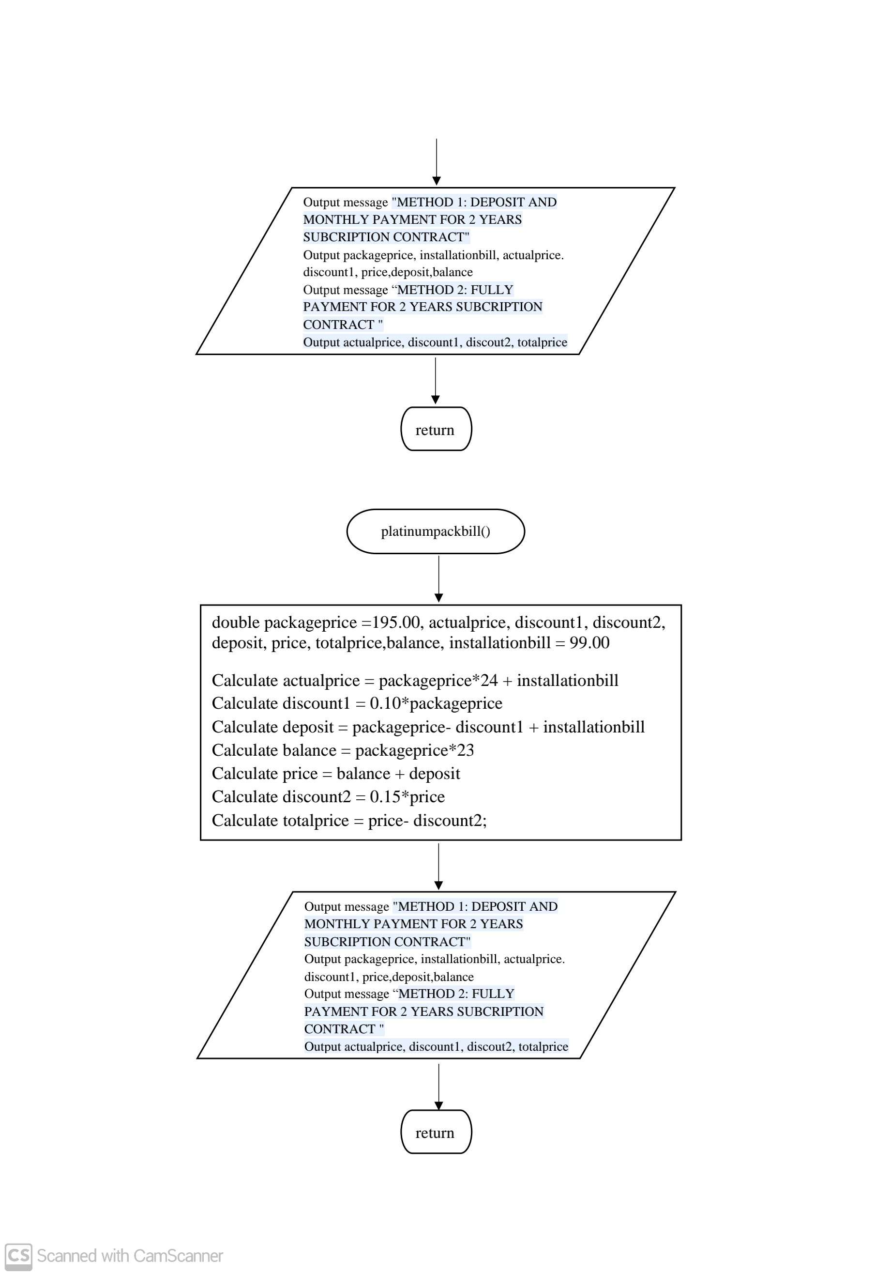

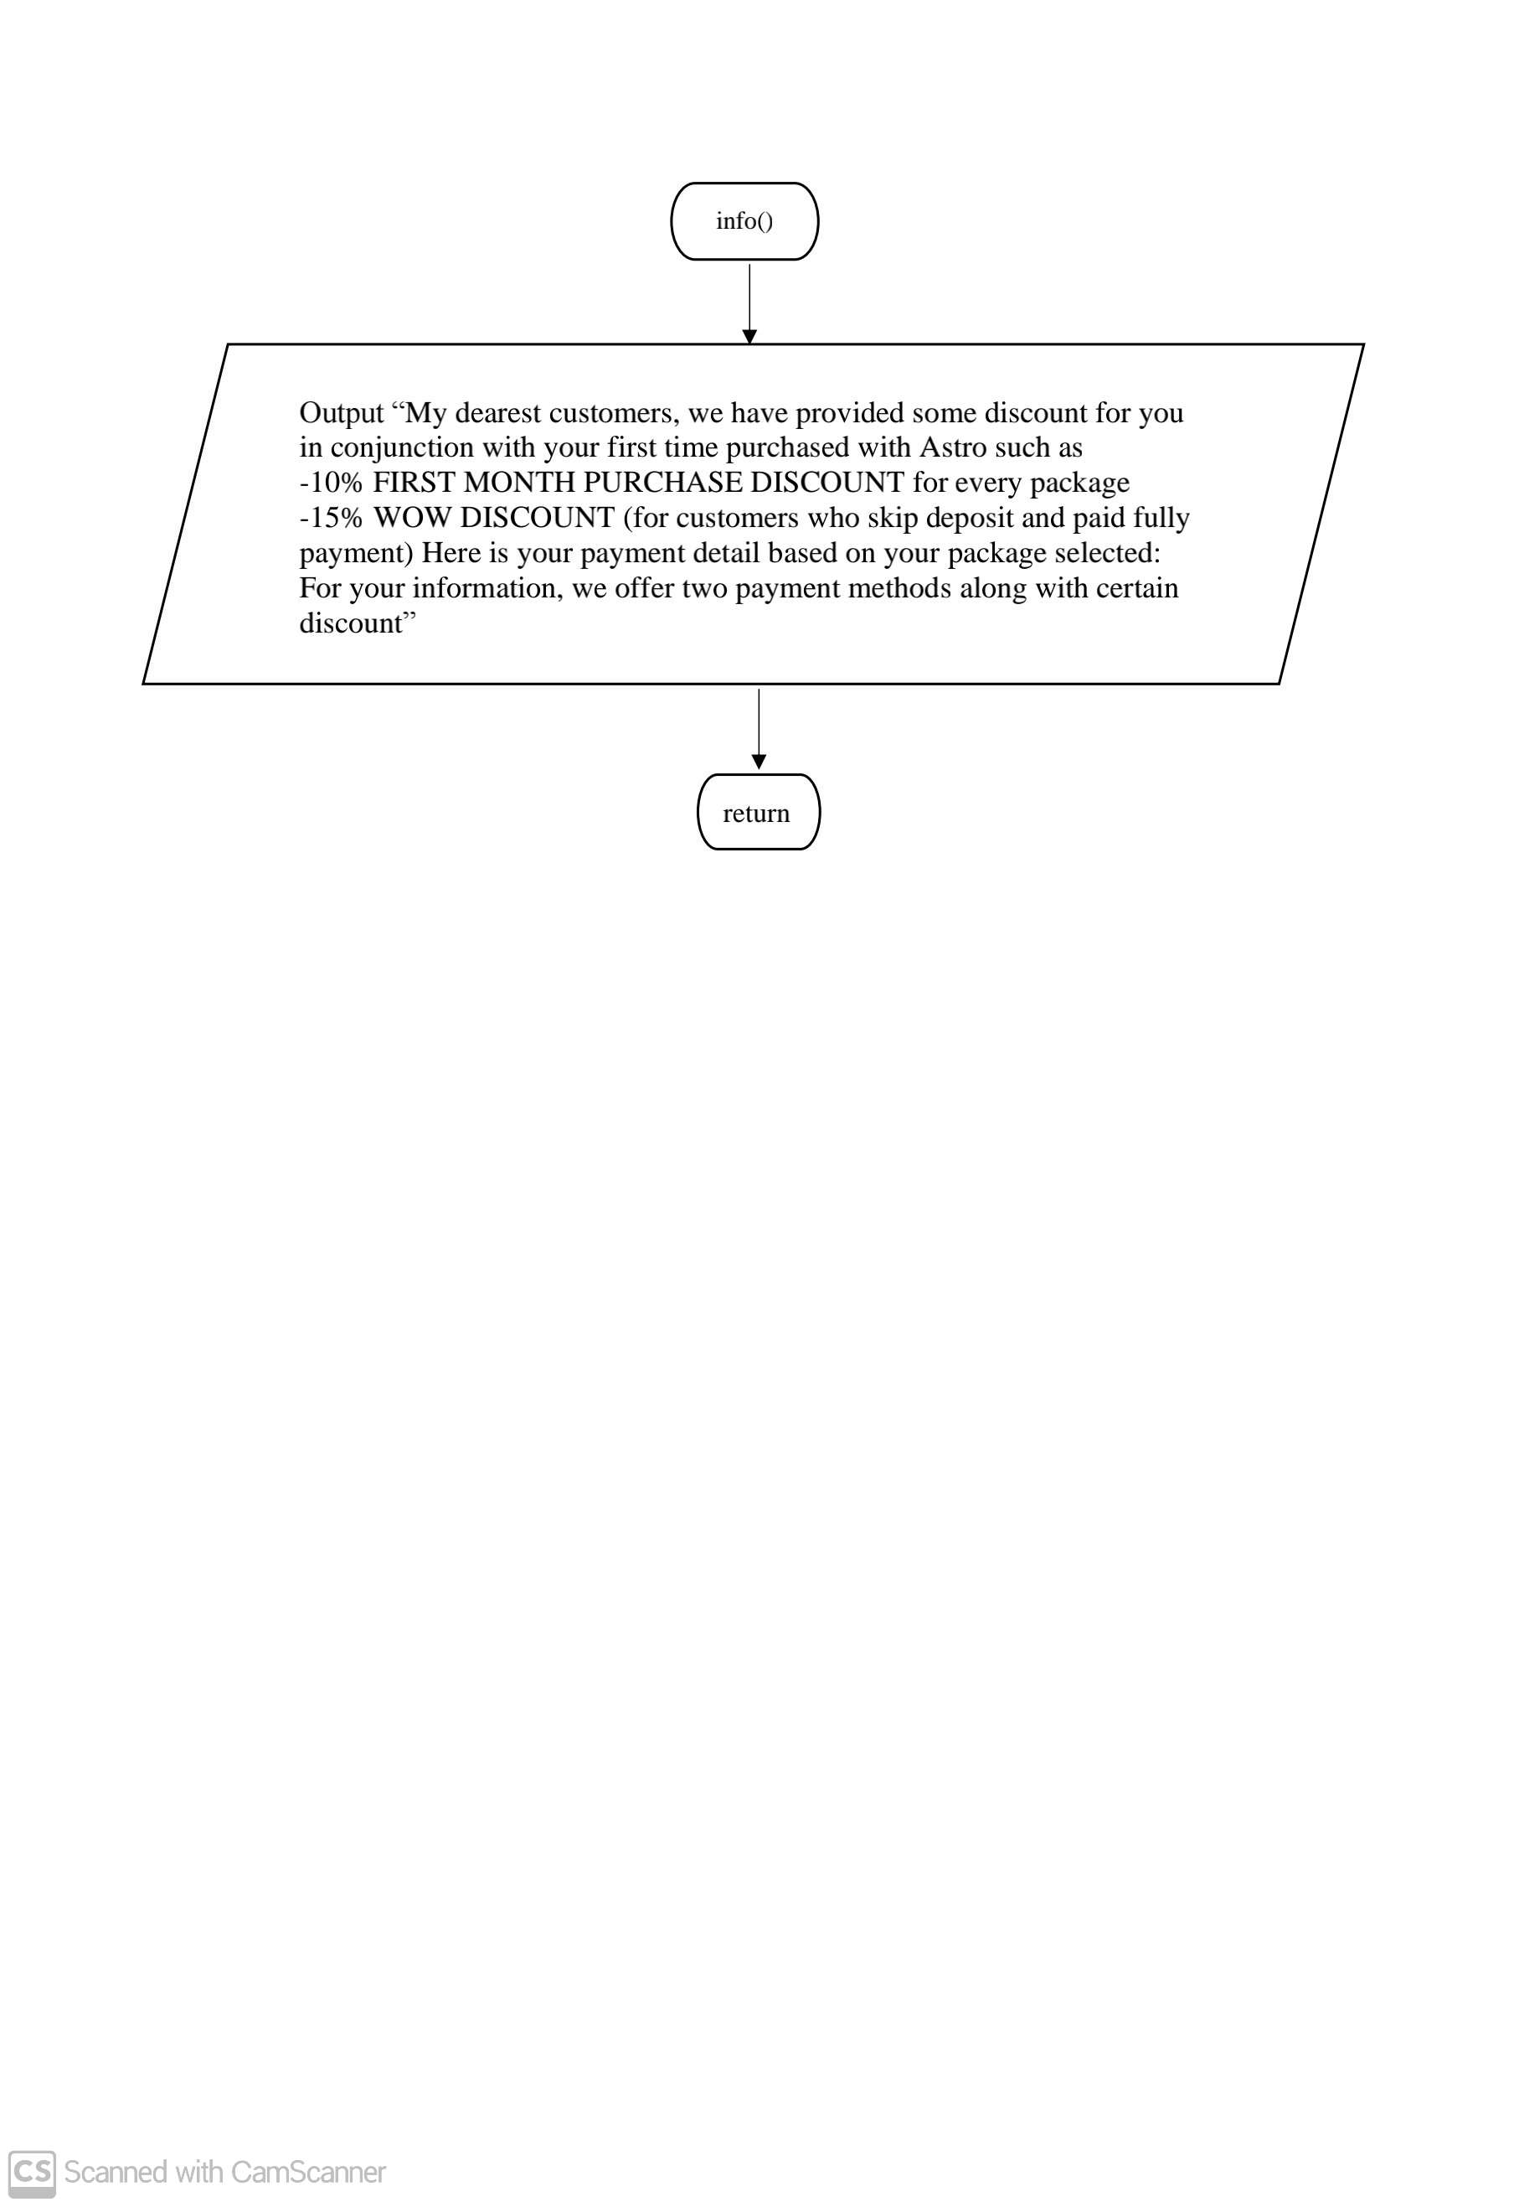

**3.0 CODING**

**3.1 Main Menu**

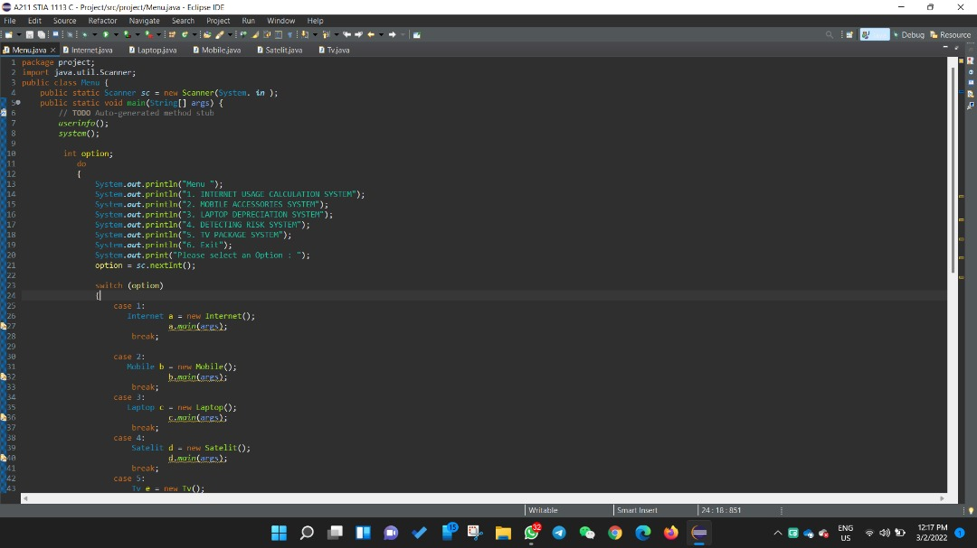

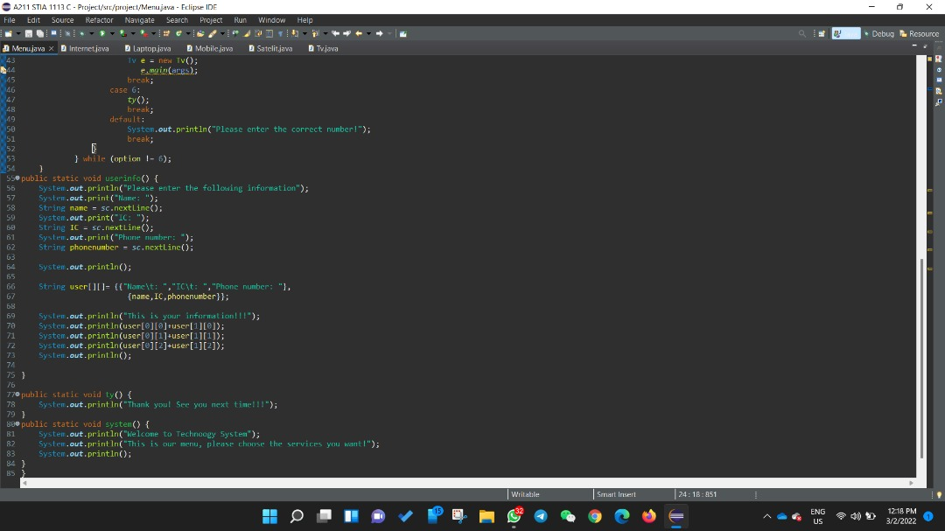

**3.2 Internet**

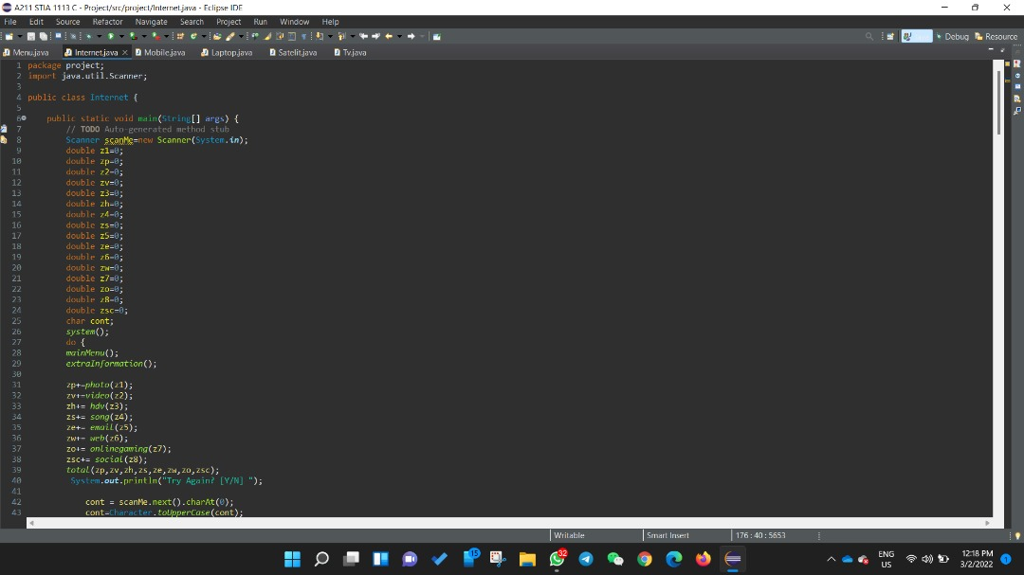

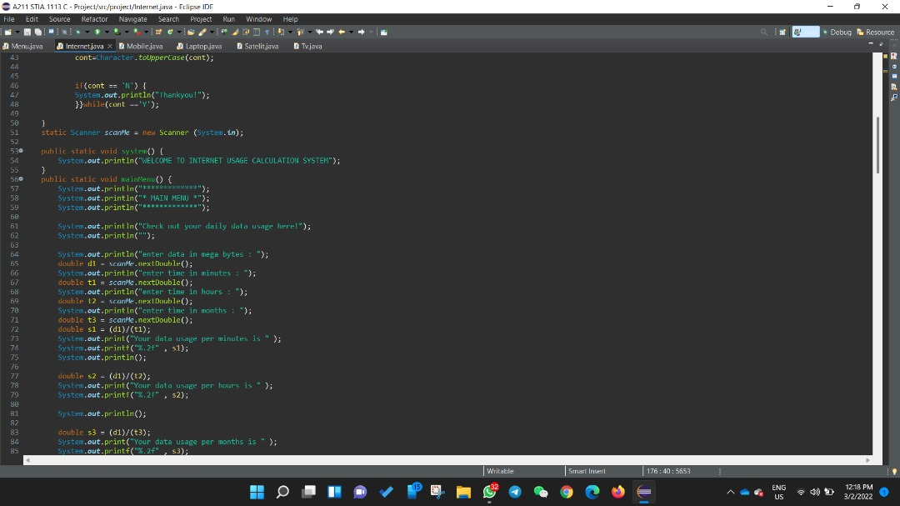

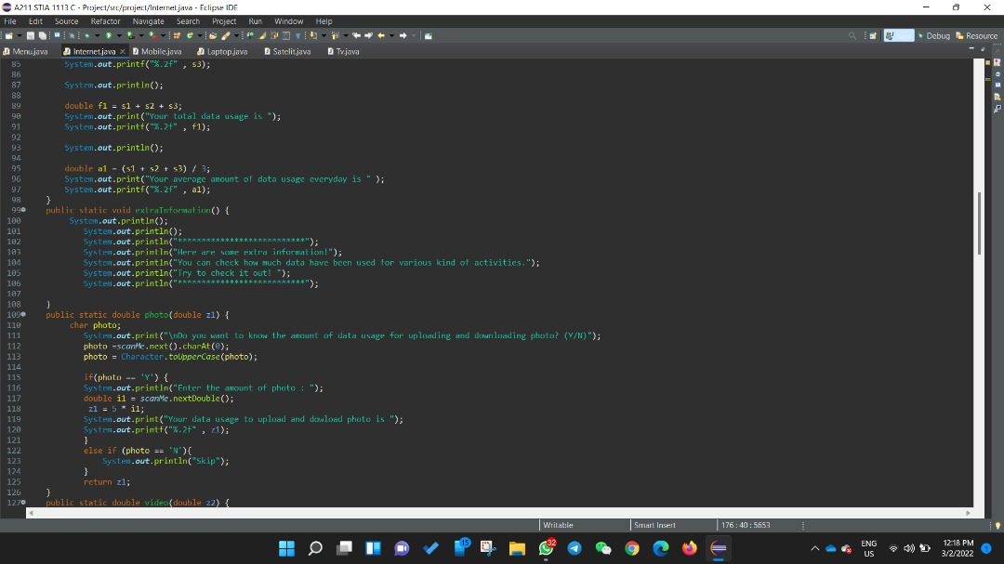

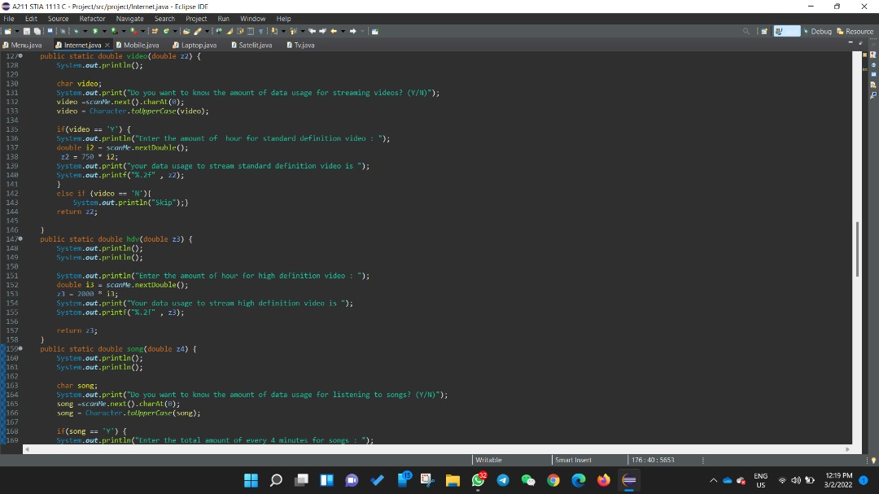

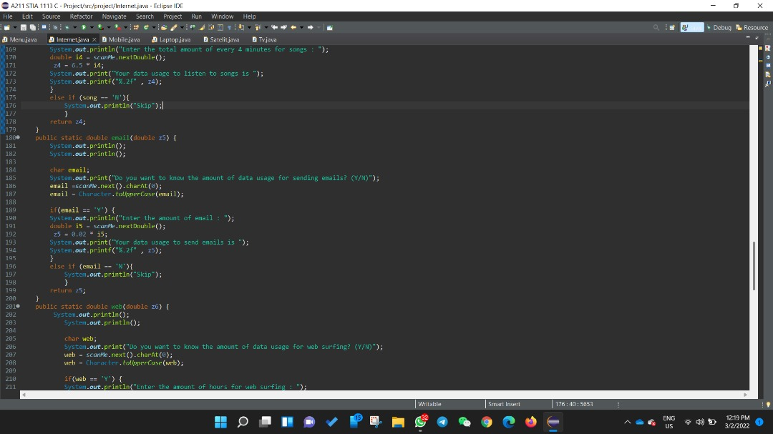

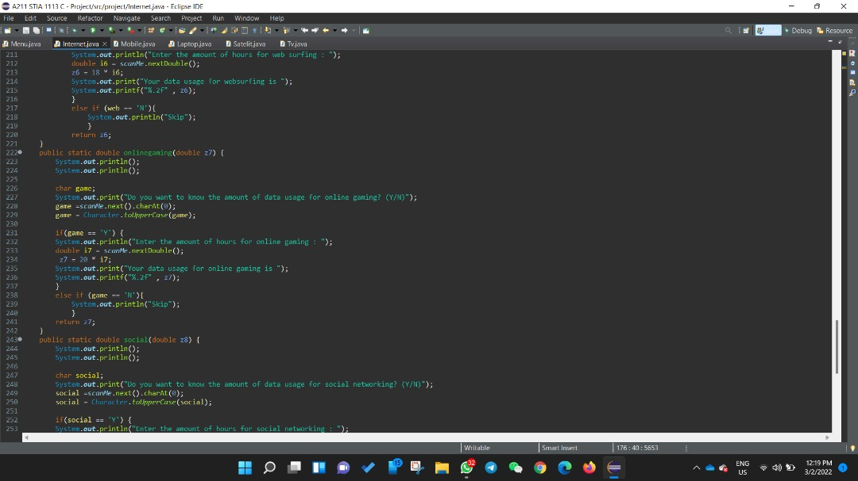

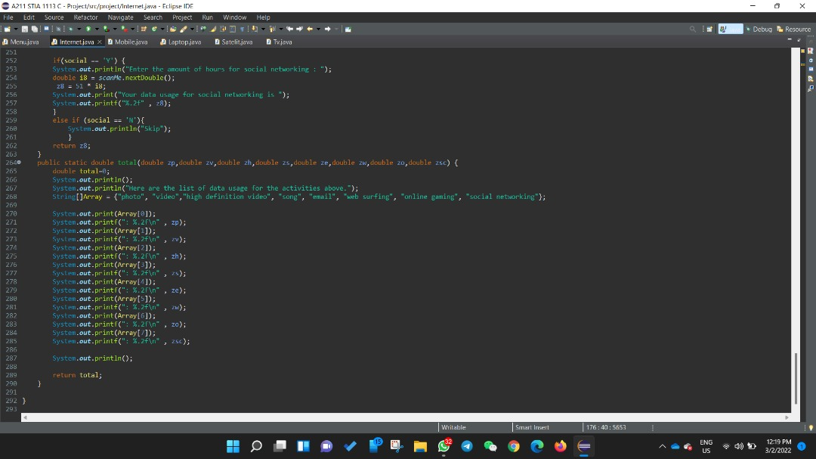

**3.3 Mobile Phone**

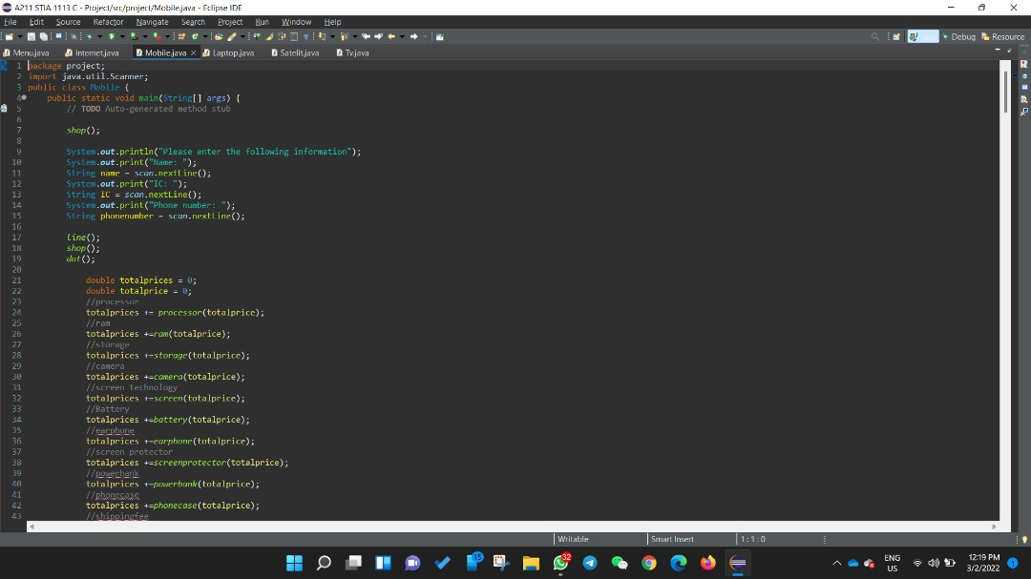

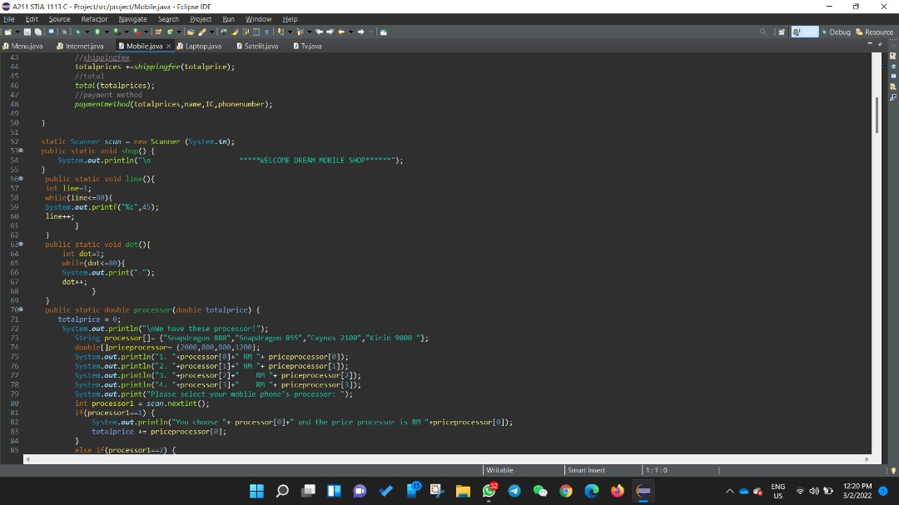

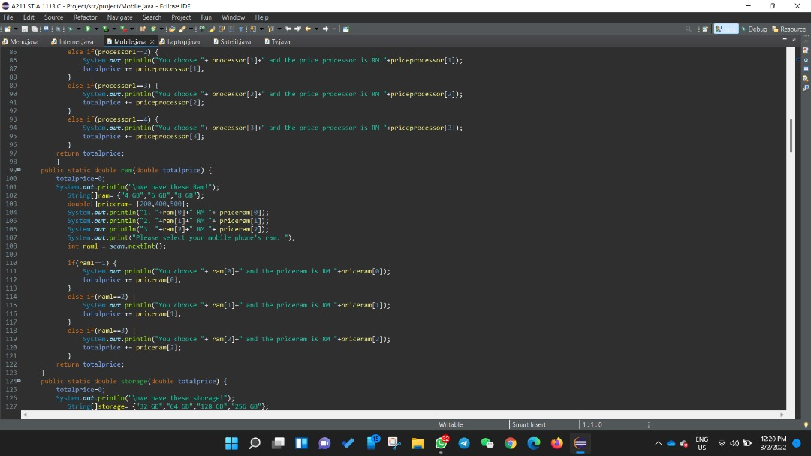

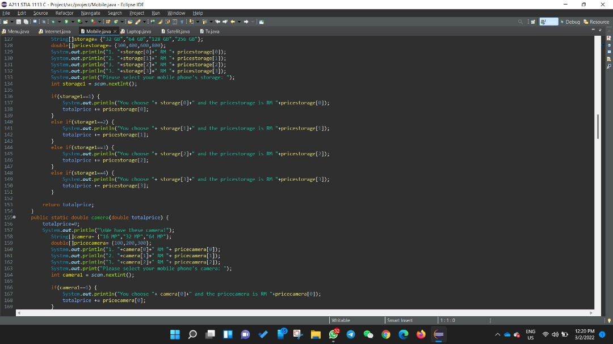

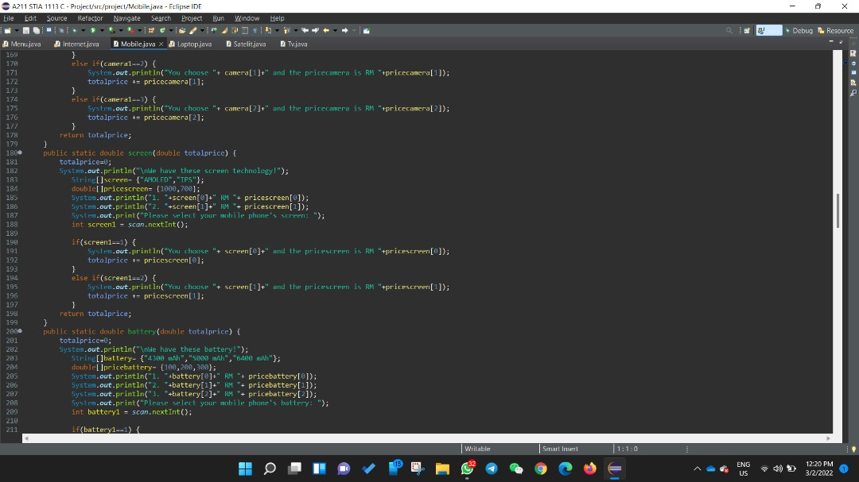

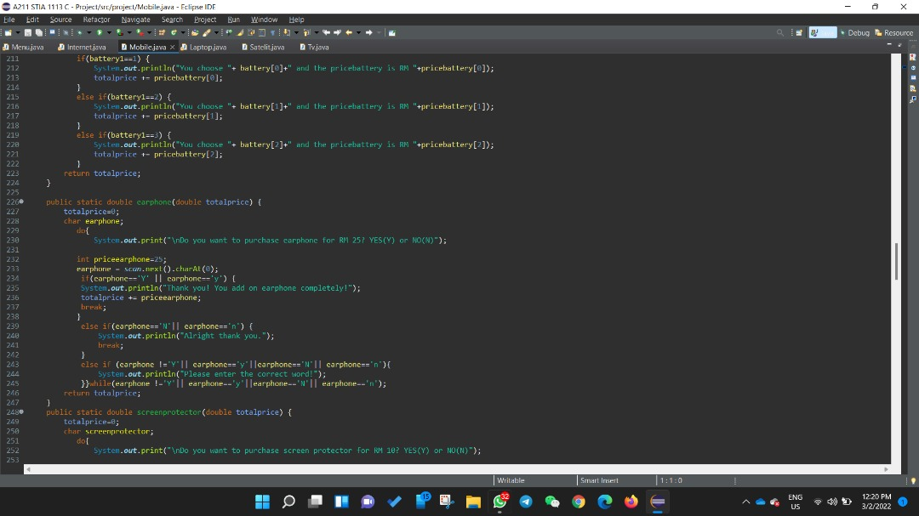

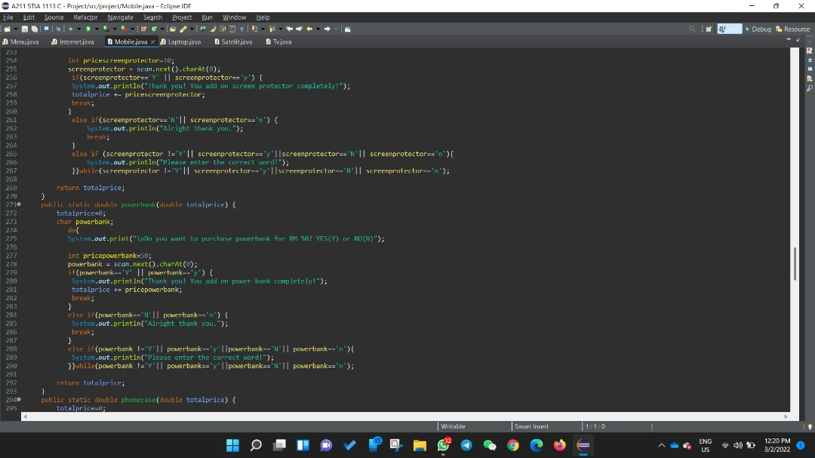

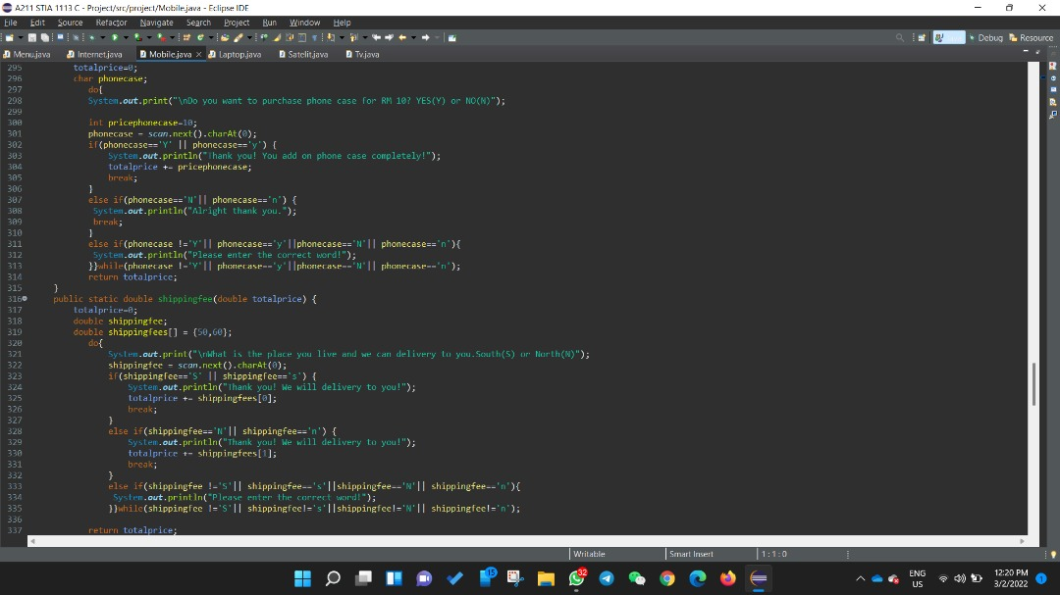

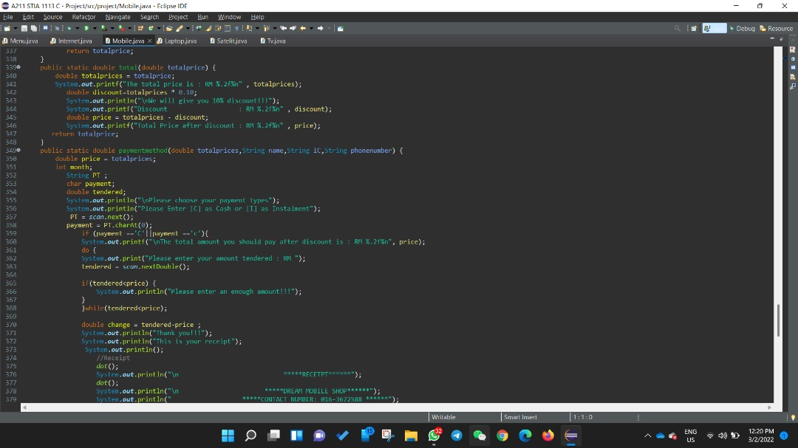

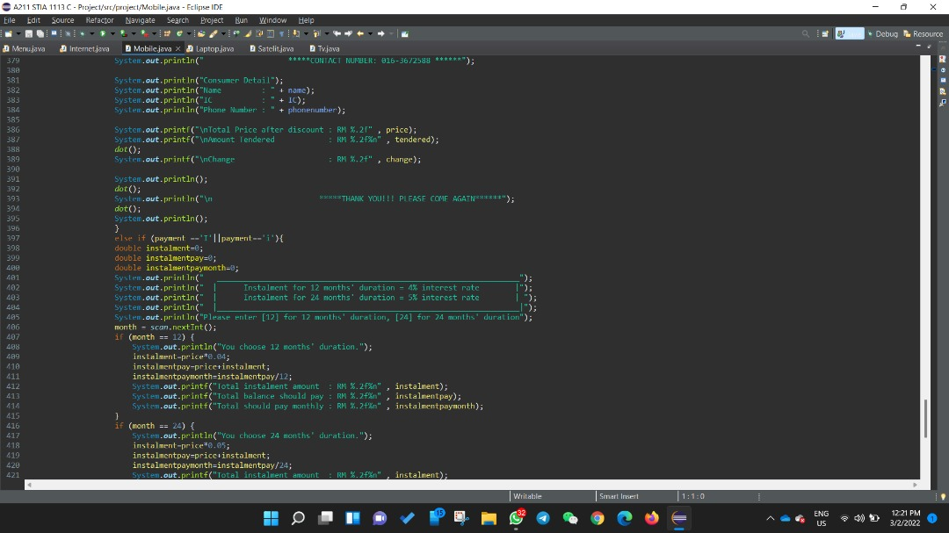

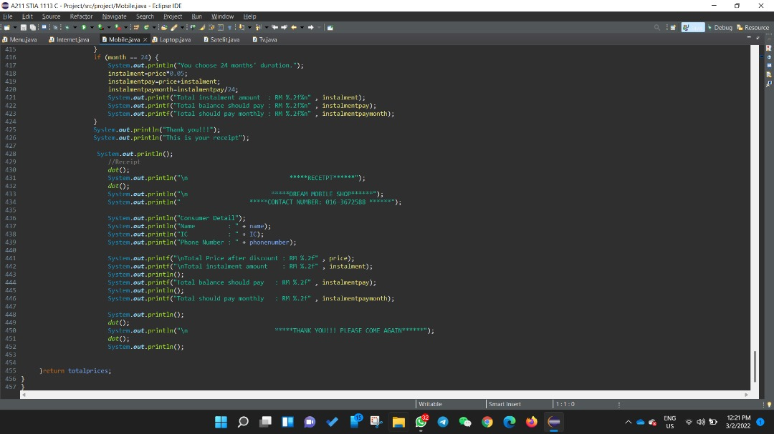

**3.4 Laptop**

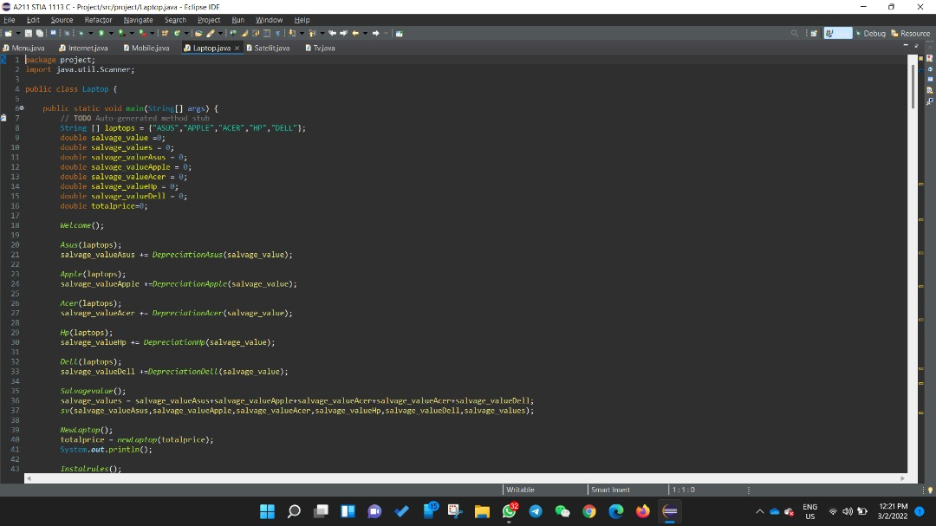

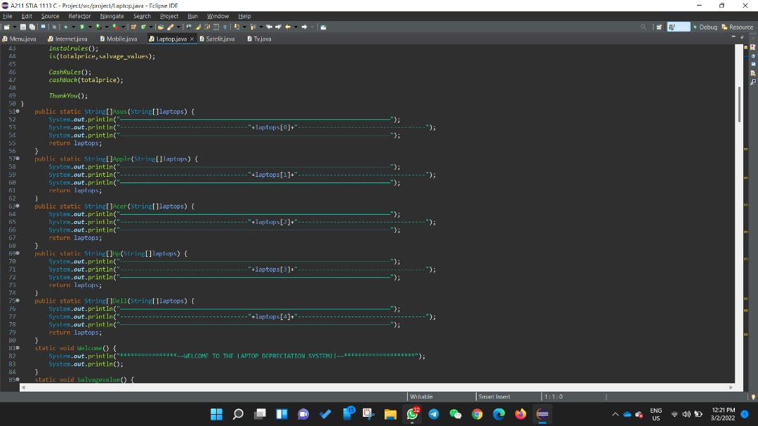

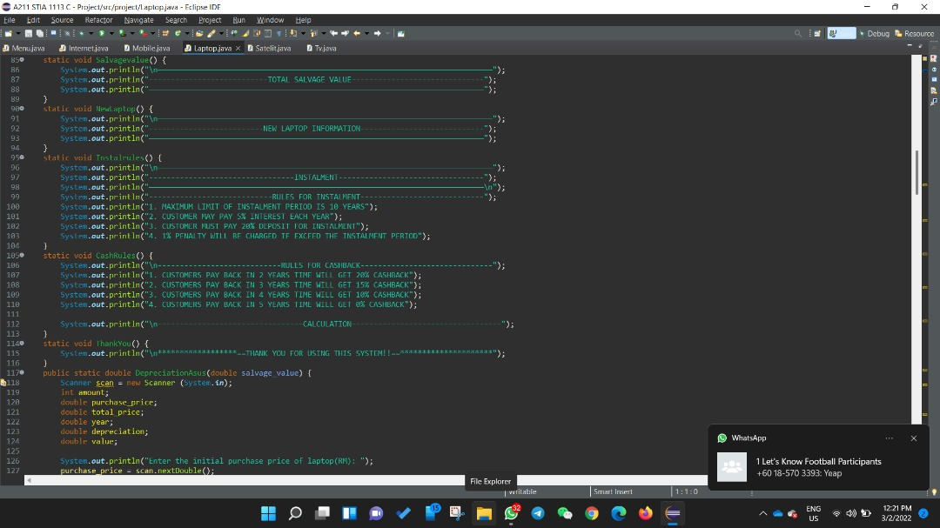

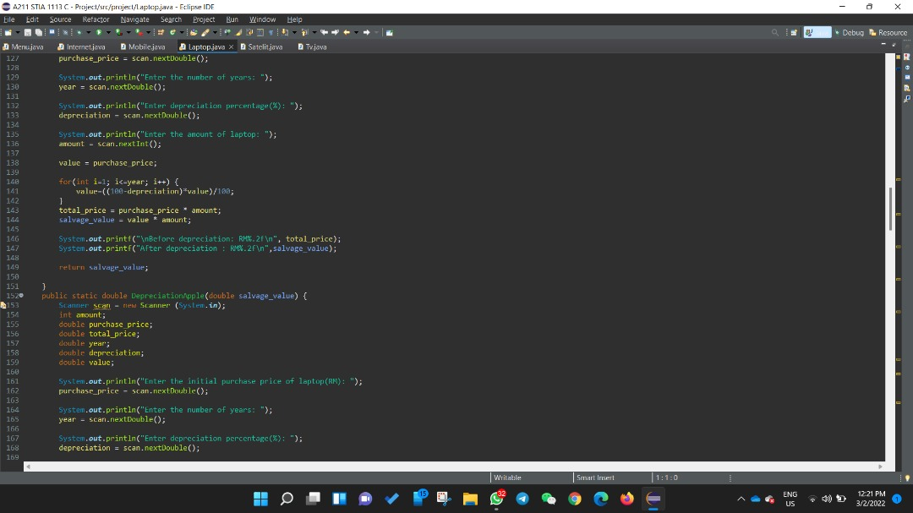

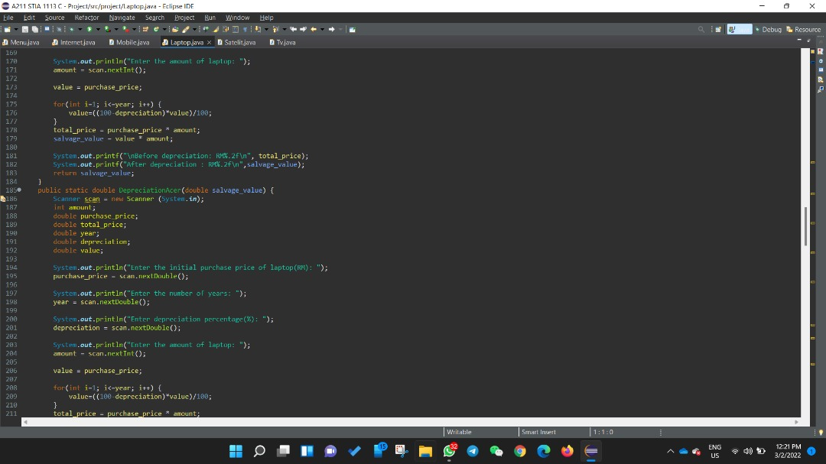

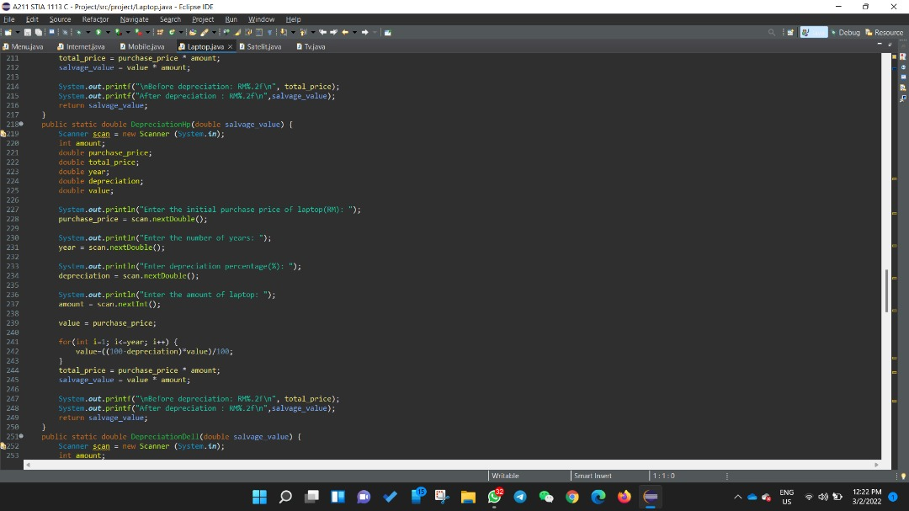

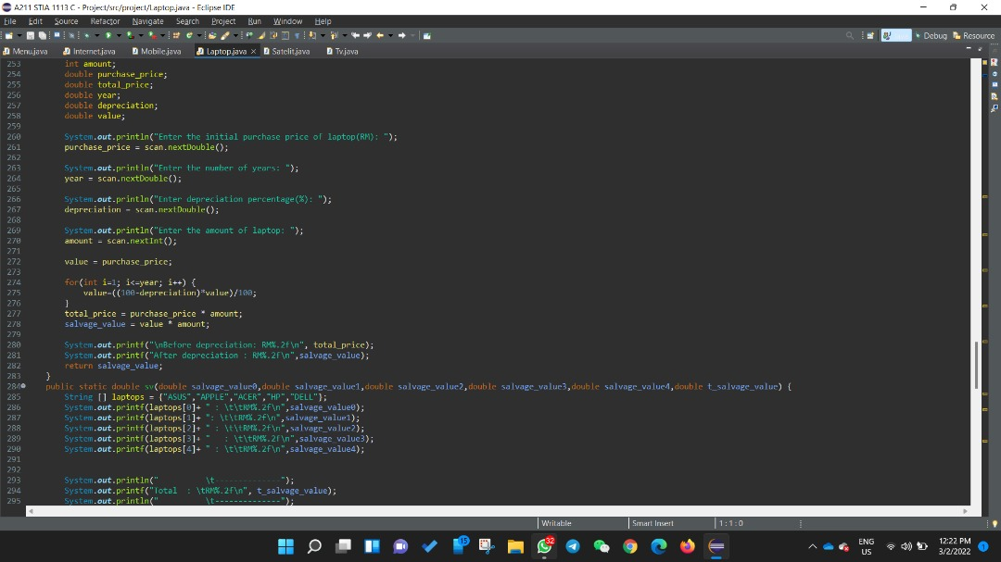

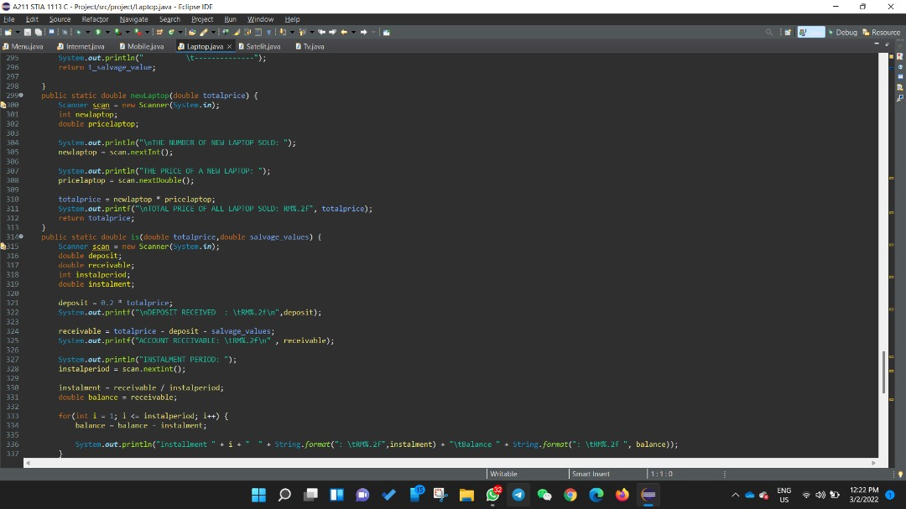

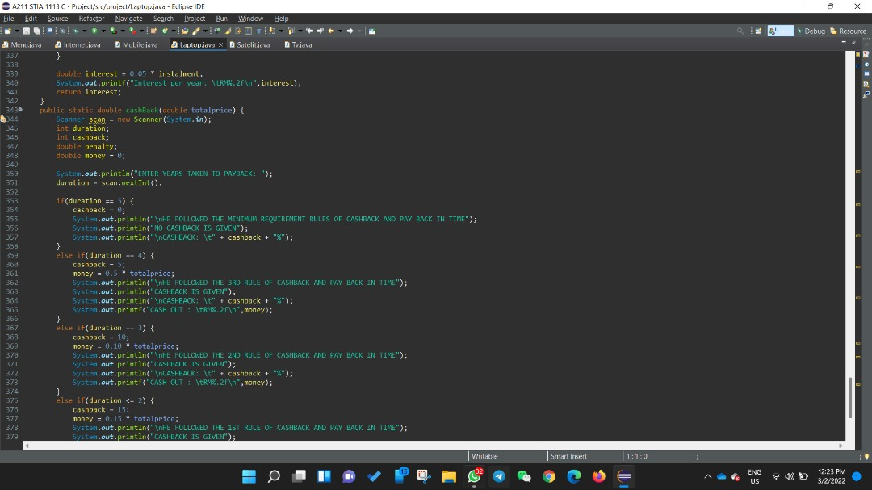

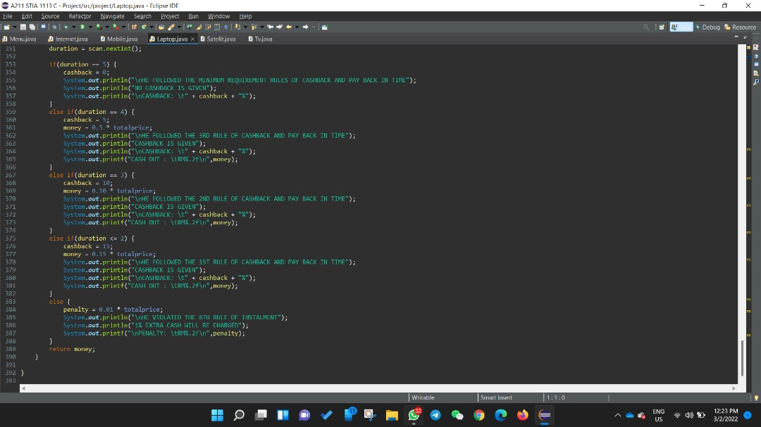

**3.5 Satellite**

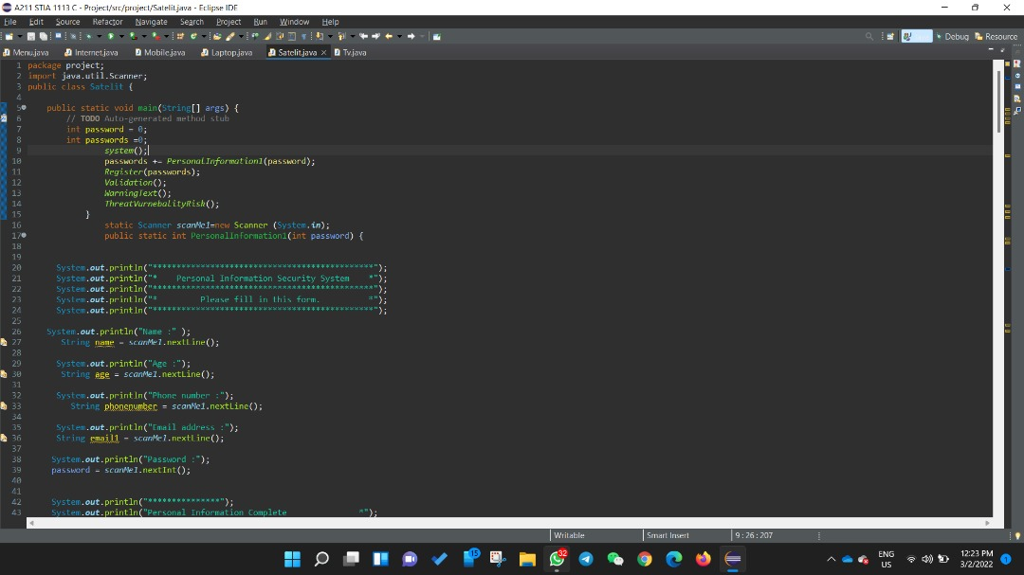

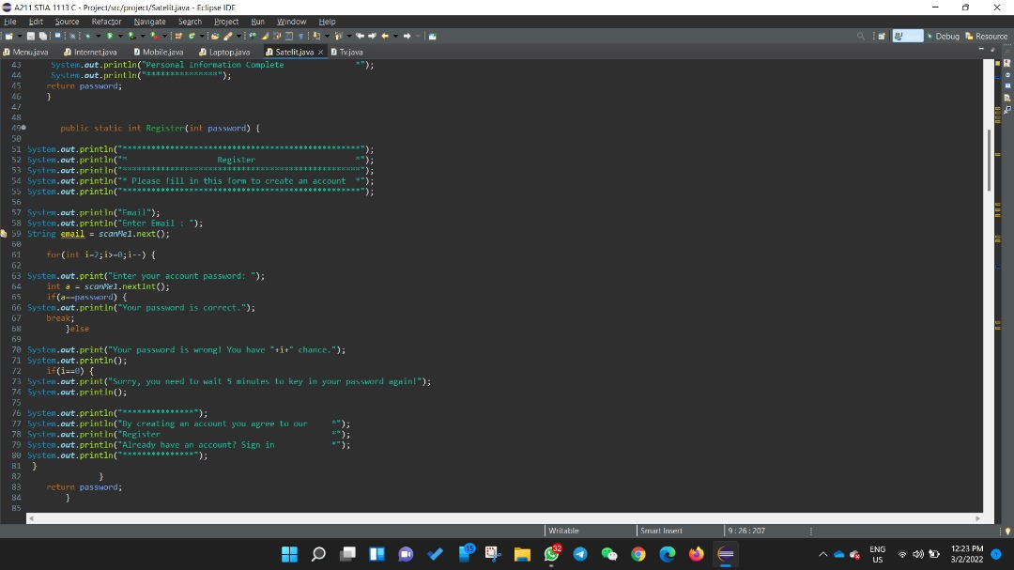

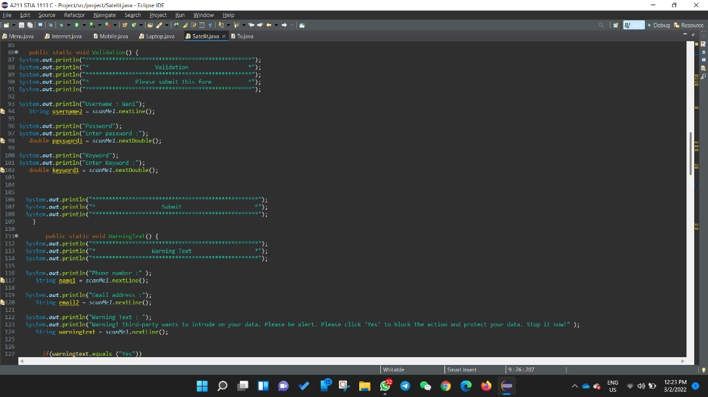

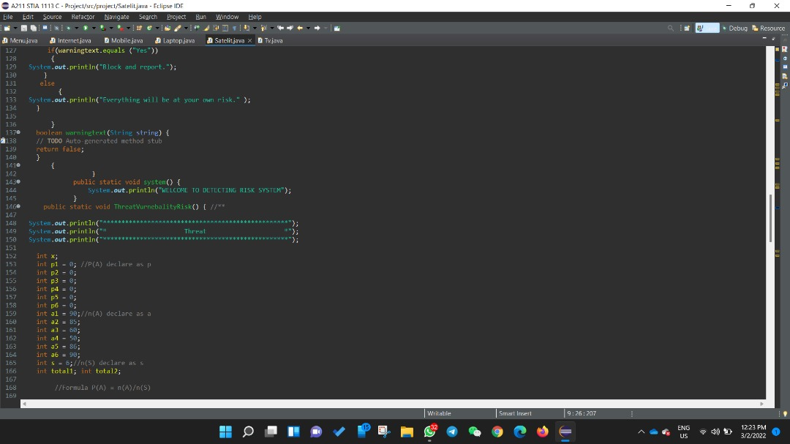

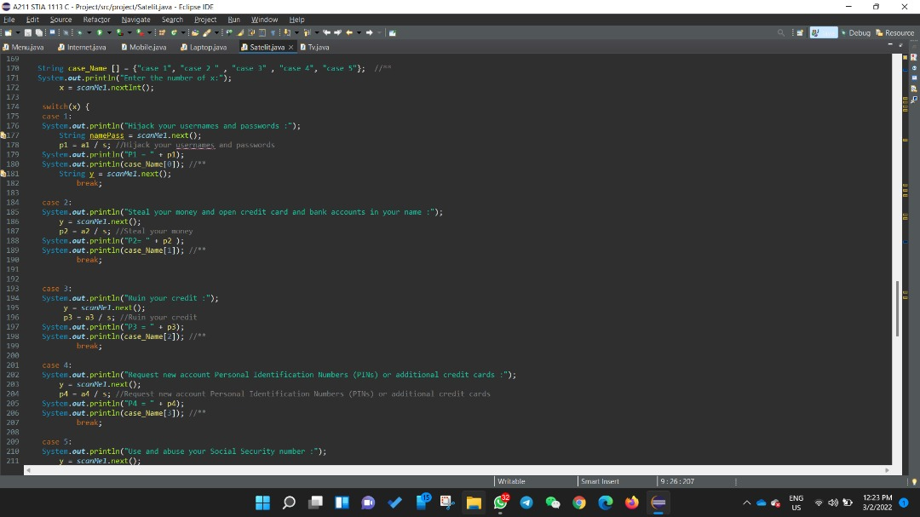

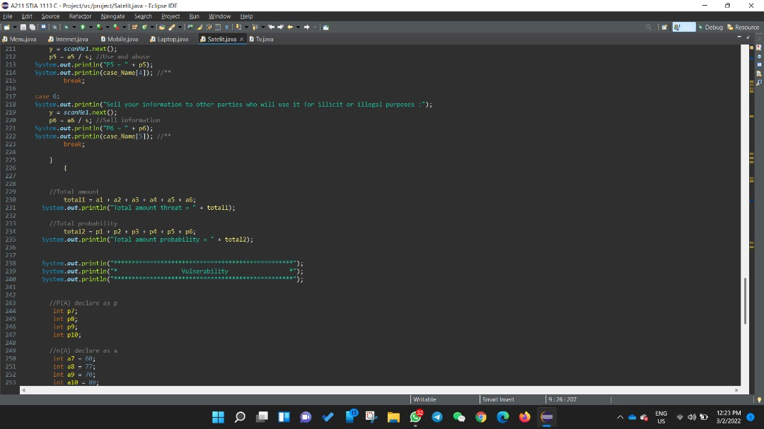

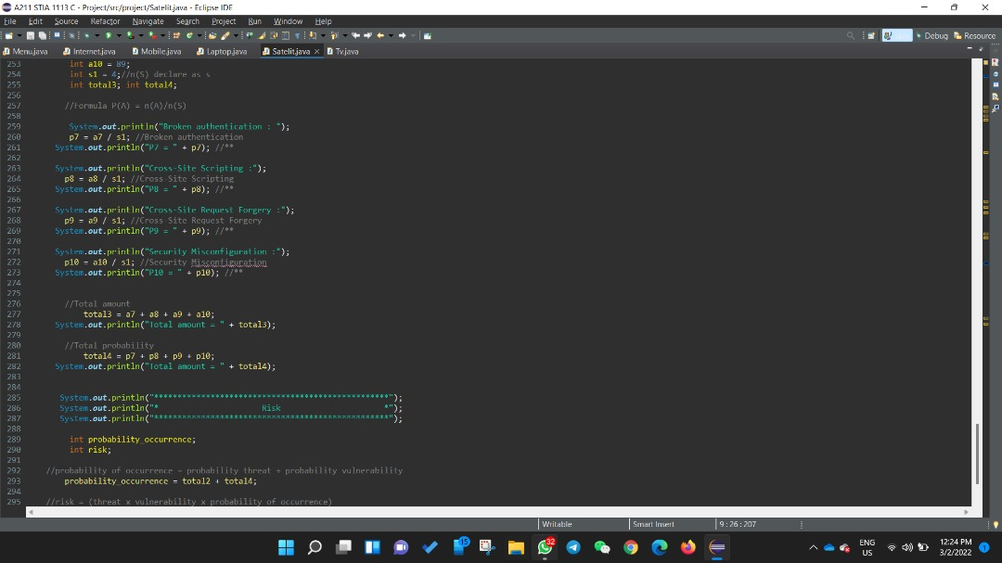

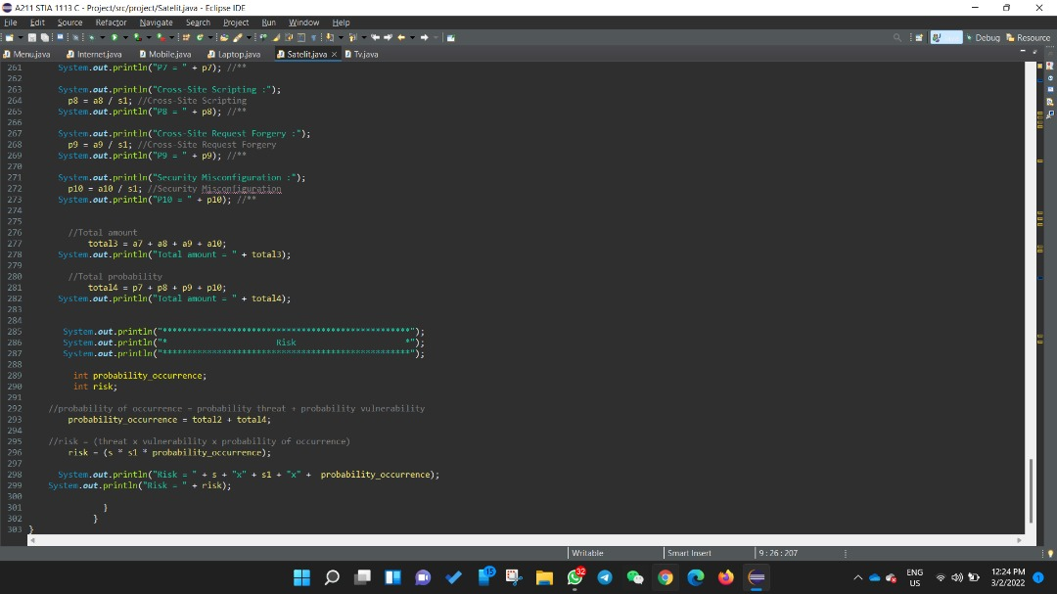

**3.6 TV**

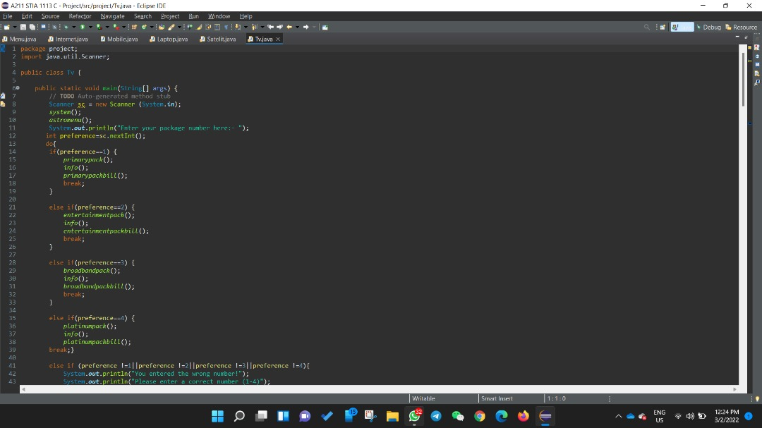

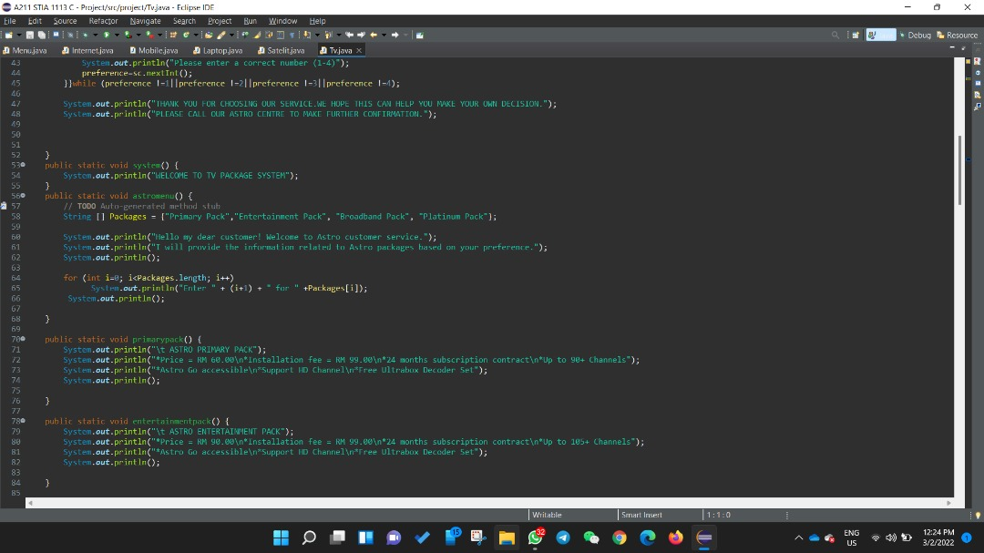

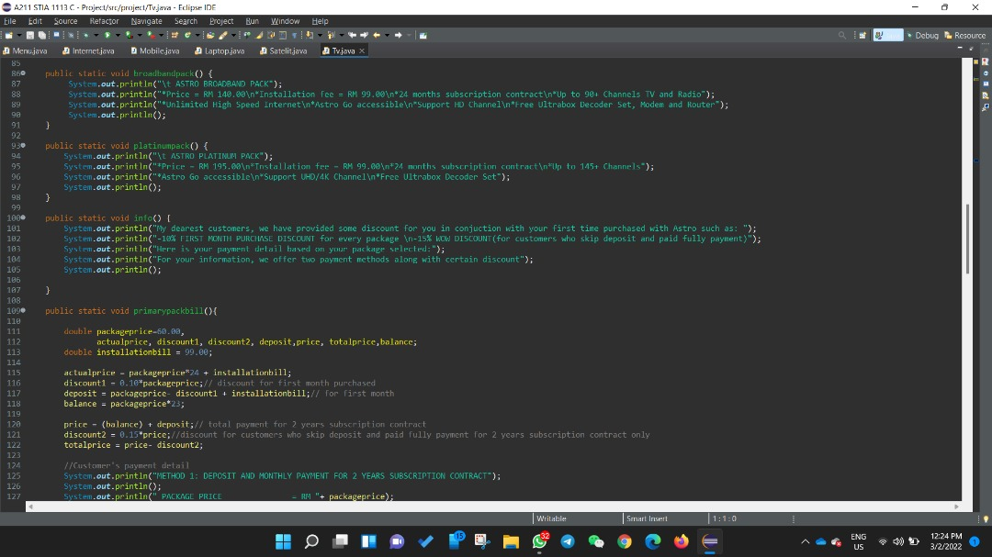

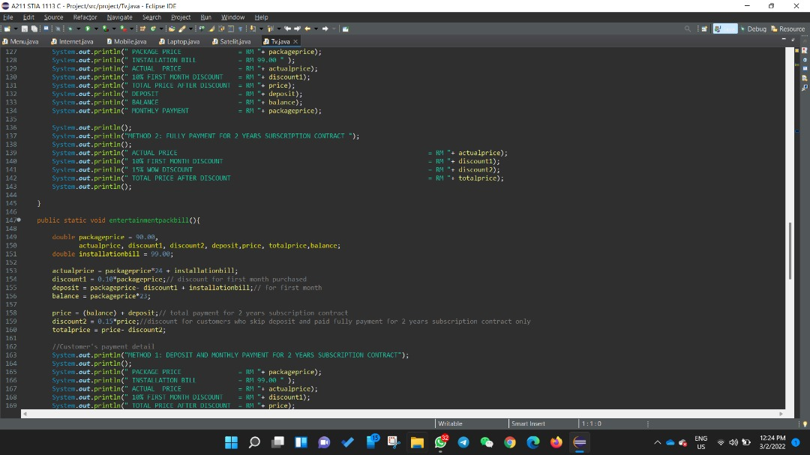

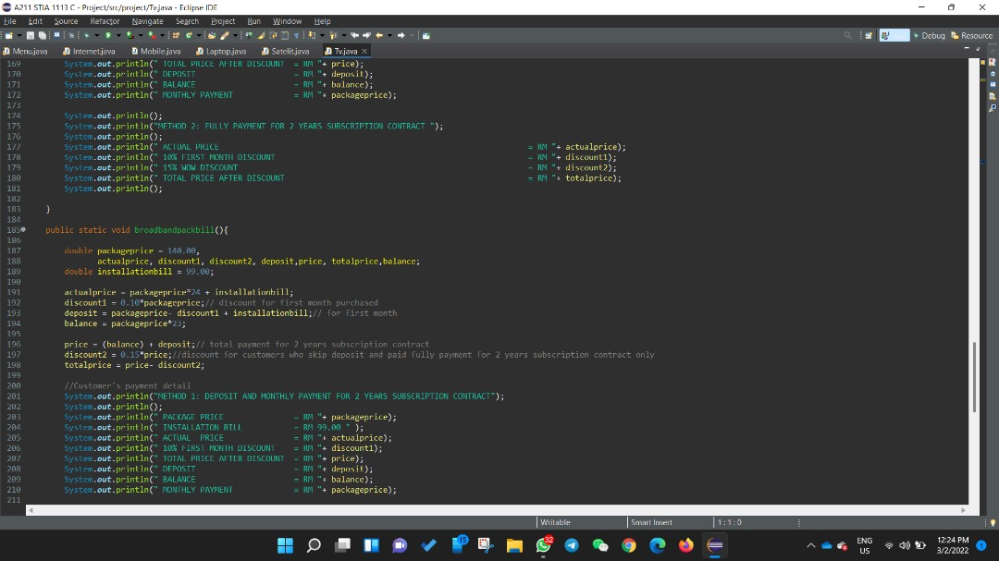

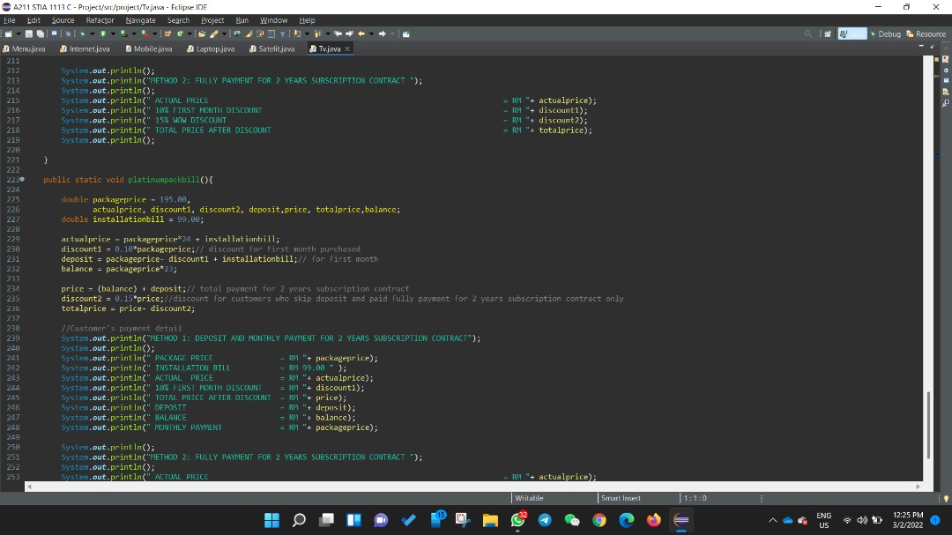

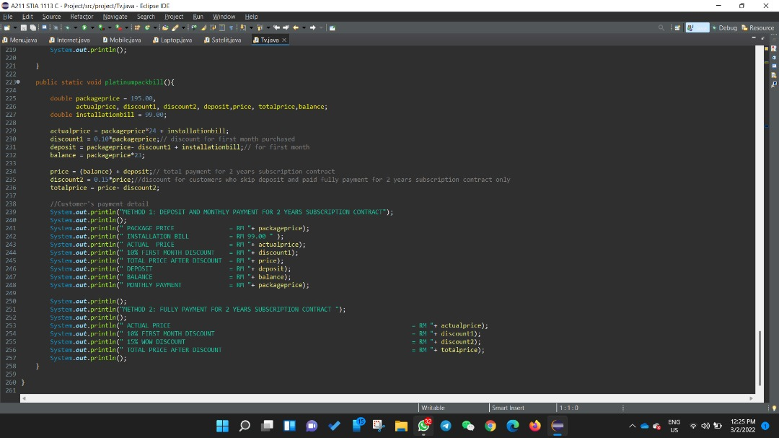

**4.0 SAMPLE RUN**

**4.1 Main Menu**

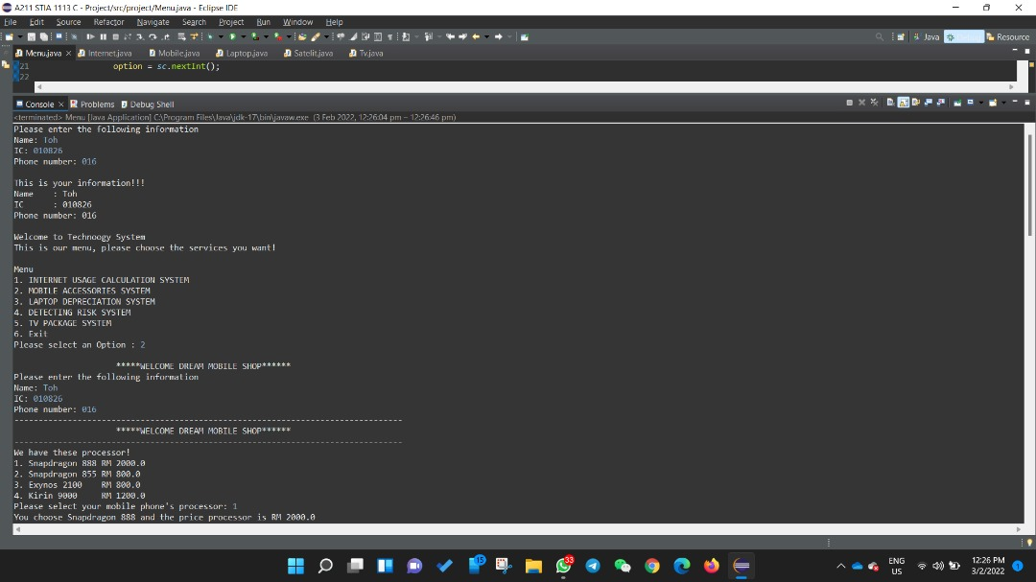

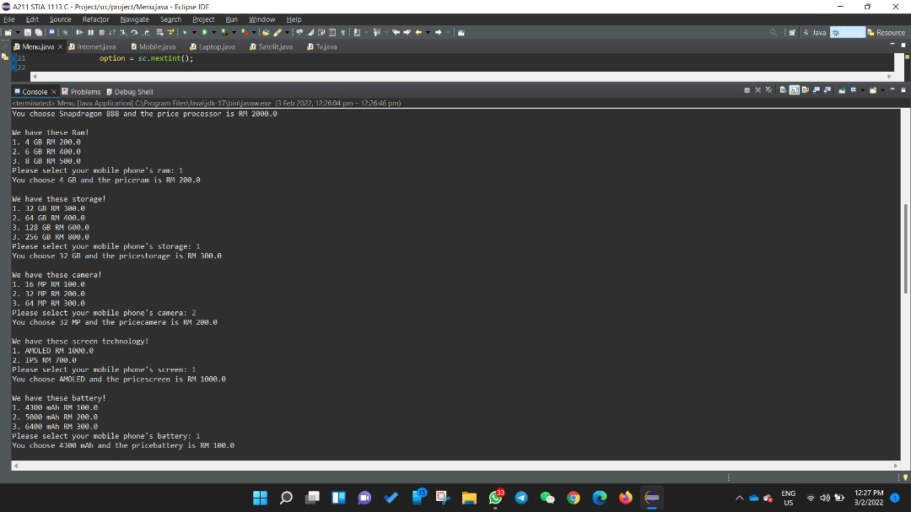

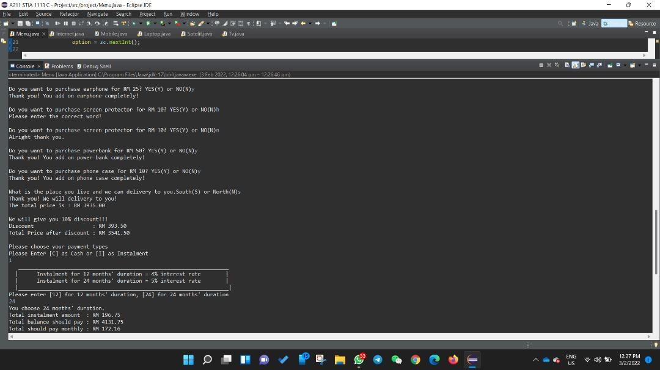

**,**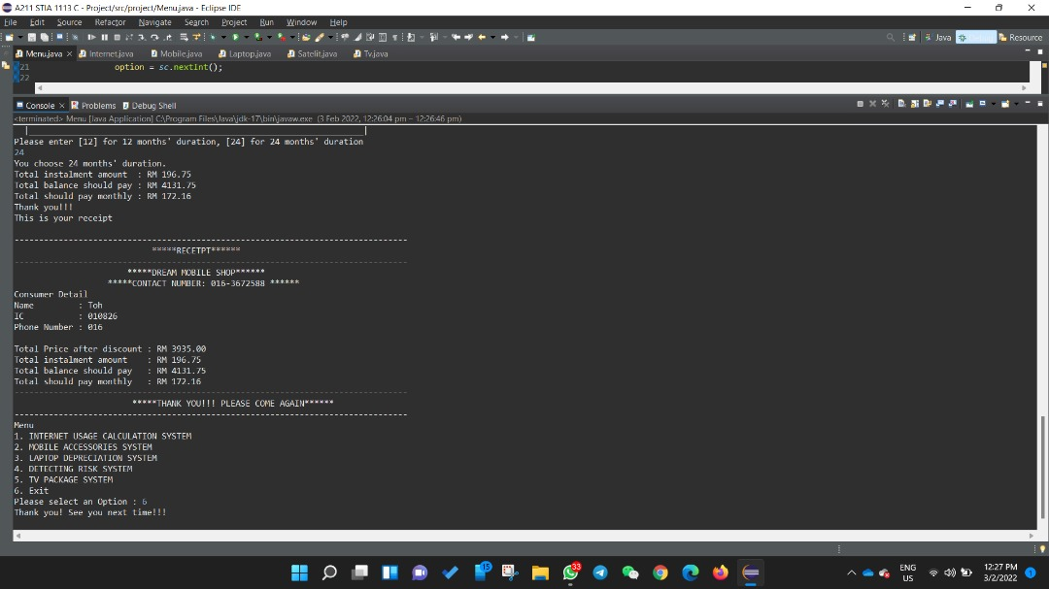

**4.2 Internet**

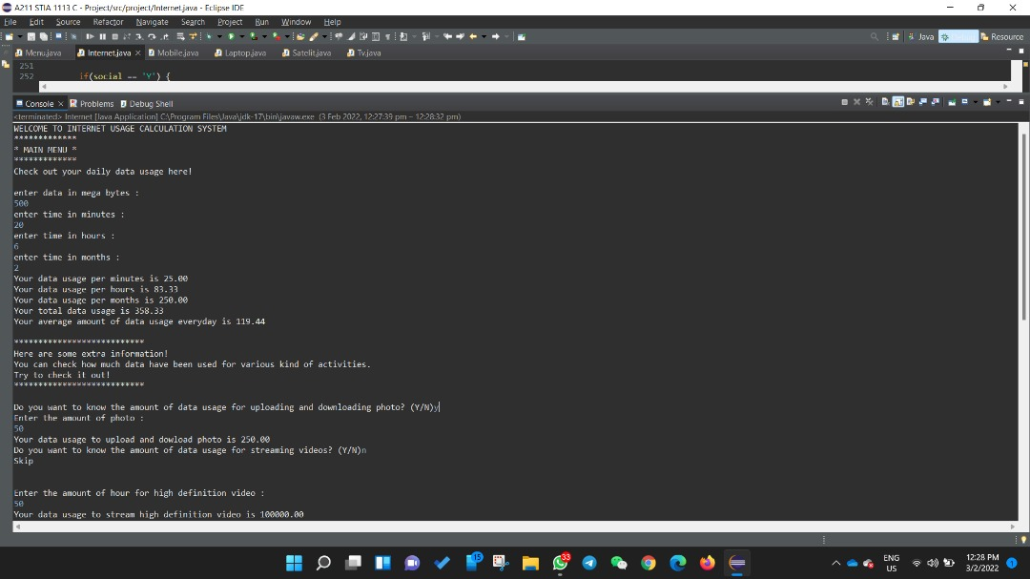

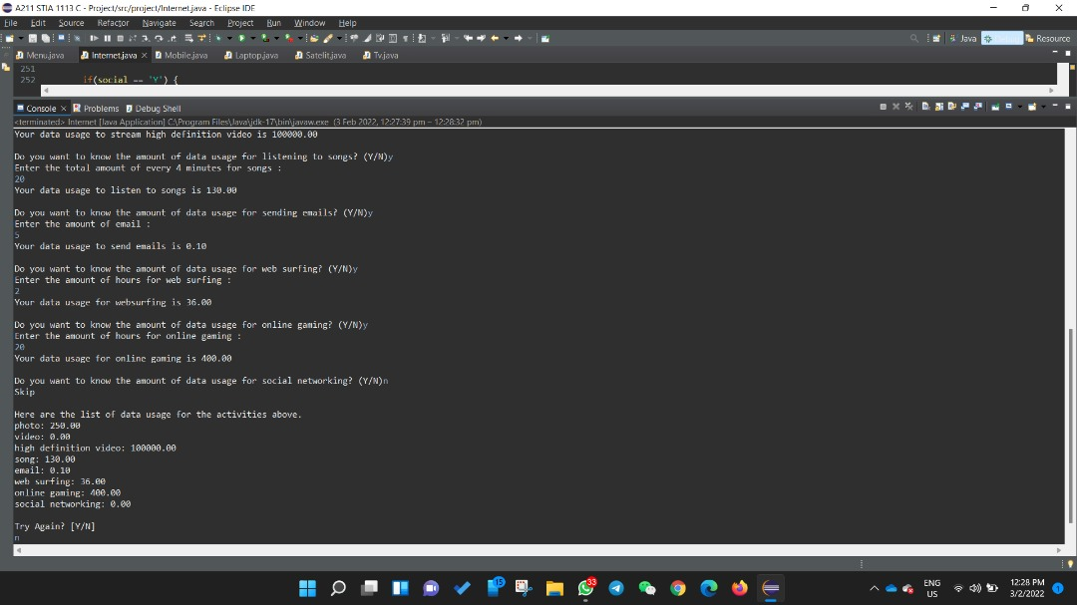

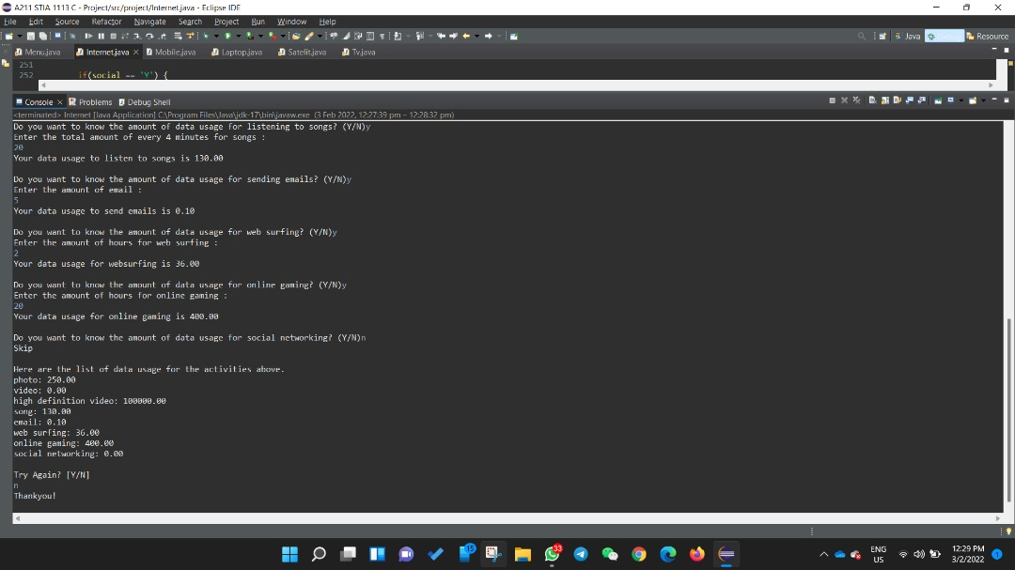

**4.3 Mobile Phone**

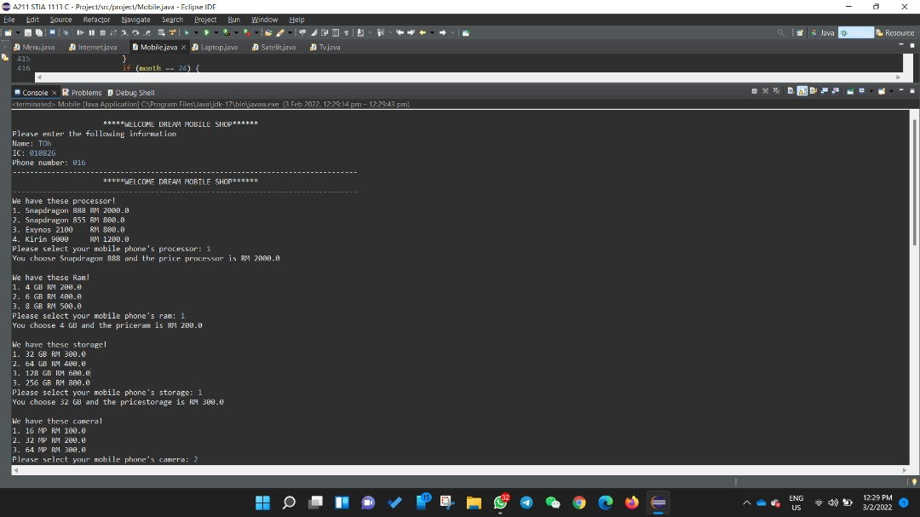

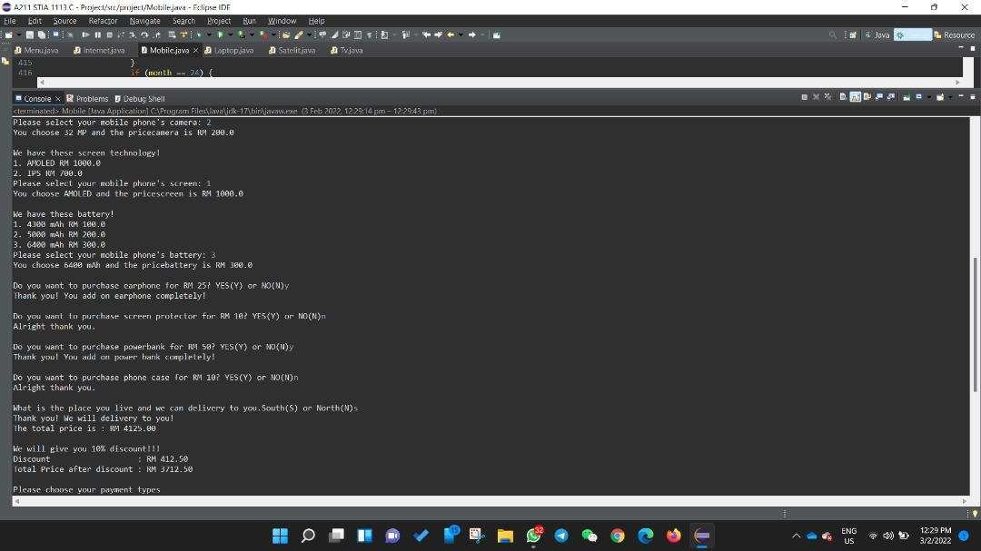

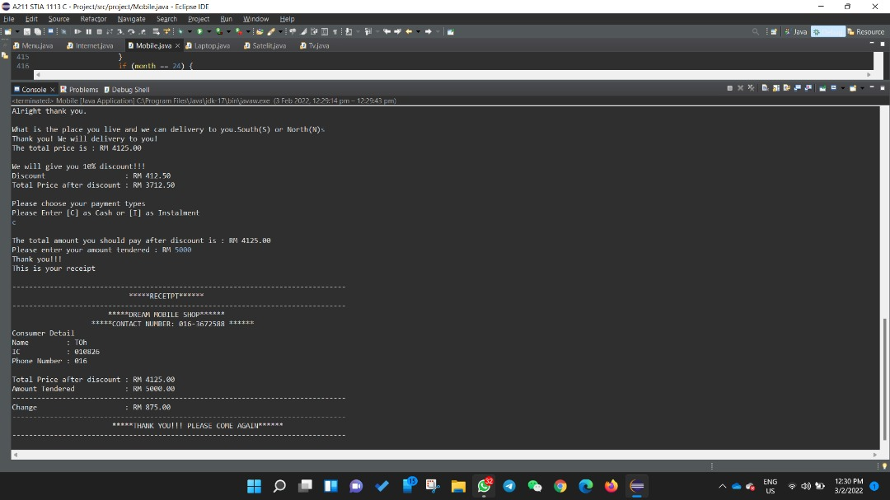

**4.4 Laptop**

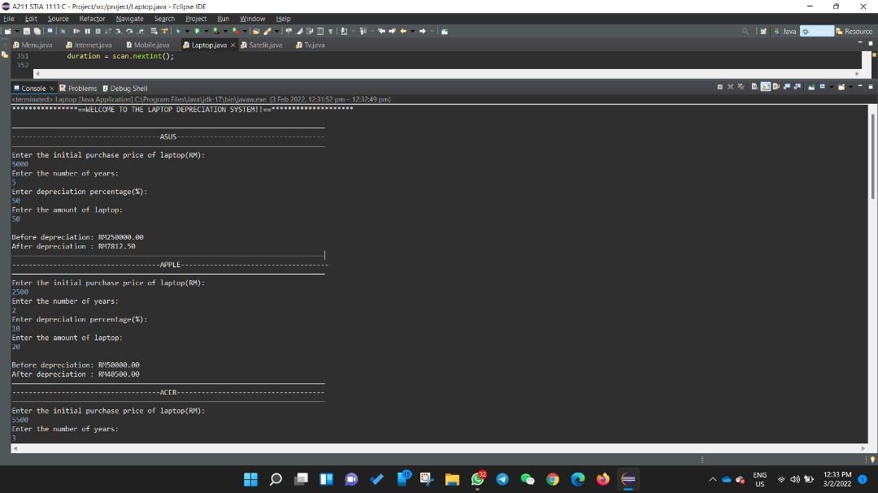

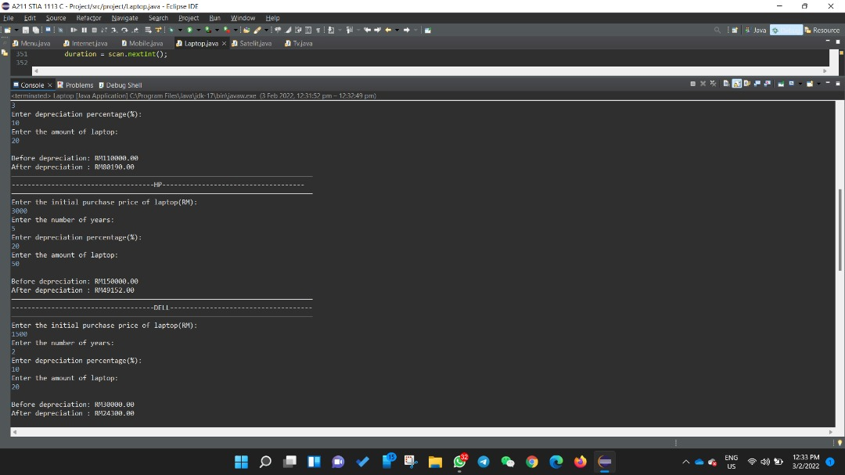

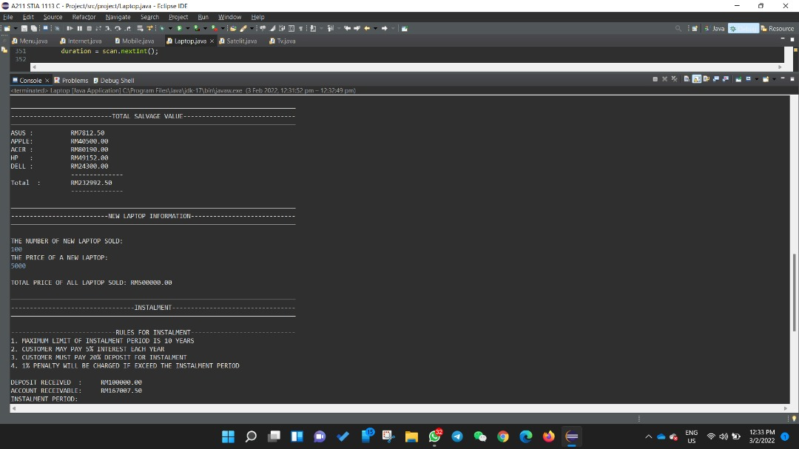

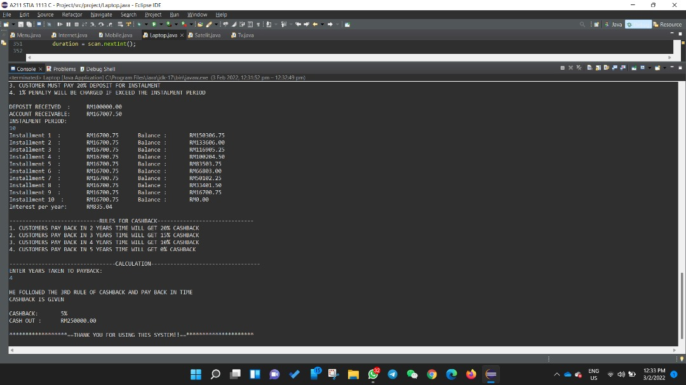

**4.5 Satellite**

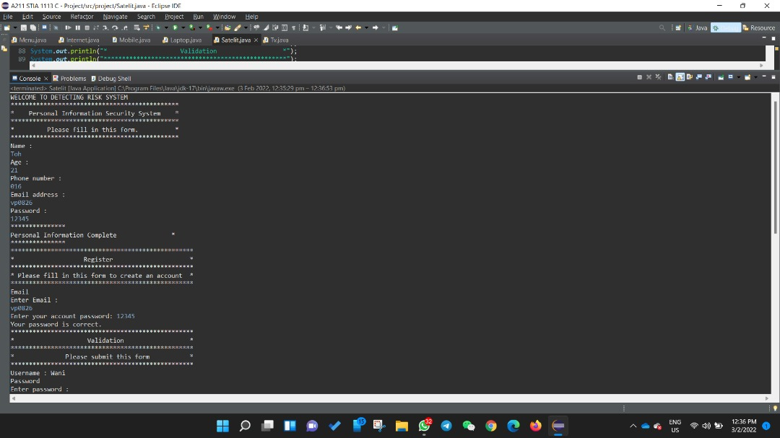

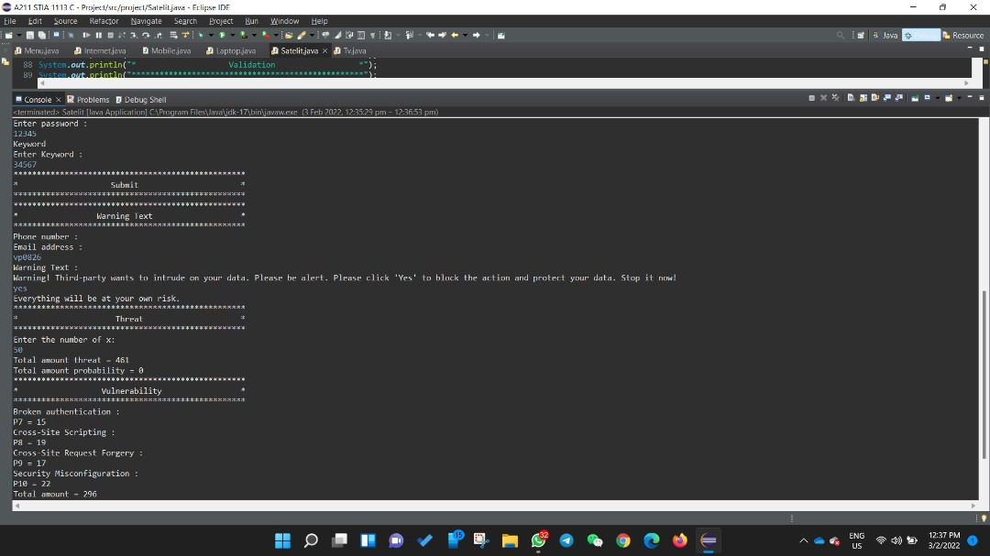

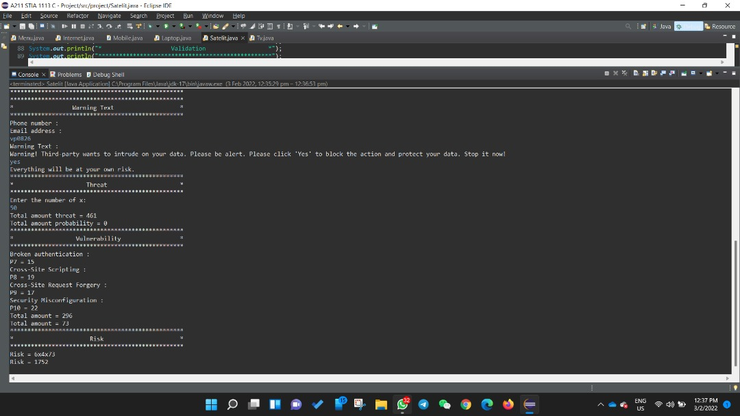

* 1. **TV**

